Living Hope High School
P. O. Box 2376
Bungoma,
Kenya-50200
Email: marilynkuhl59@gmail.com
info@livinghopehighschool.org
Website: www.livinghopehighschool.org

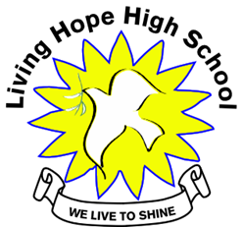
January/February 2019 Newsletter

Team of Ten Travel to Living Hope High School from
West Virginia and New Jersey Conference
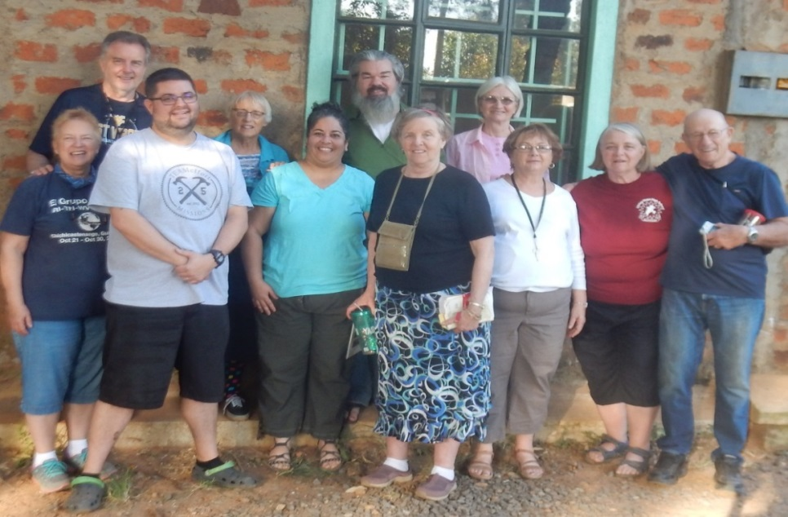

Top Row, Left to Right: Paul
Binotto, Sarah Fletcher, Kenneth Post, Donna Simmons
Bottom Row: Sandy Binotto, (Team Leader) Rev. Jeremy Daniels, Teresita Matos-Post, Helen Markwell, Joanna Lowers, Marilyn Uhl (Director of School) and Vernon Lowers.

A trip to Living Hope High School, Bungoma Kenya is a long one, but worth it all! Getting a group ready for the journey takes patience, perseverance and commitment. There are many logistics to put together. Travel dates, plane fare, hotels, food, in-country travel, shots and Visa’s to mention a few things. All of the scheduling and organizing of a team and those who will host us on the other side is very important for a successful trip.
The journey and team was wonderful. Having had training and past VIM experience helped a lot.
The mornings consisted of Helen’s Kings Daughters class which taught the girls about becoming a woman, body changes, how to pick a good husband and being a young woman of God.
Other team members helped with new student profiles, pavilion construction or other odd jobs until their afternoon workshops. The afternoon workshops gave the students opportunities to learn new skills or crafts. They consisted of games, jewelry making, tin punch and origami, sewing, learning guitar, choir, puppetry and evangelism. The students really enjoyed the classes and learning new things. The team members also enjoyed teaching the students in their classes. The Saturday before the team left there was a parent’s day where the parents or relatives of the students came to see and hear what they had learned from the team. It was a day of joy and fun.

The team also worked into their schedule time to visit some of their sponsored students’ family, visit nurse Catherine’s Women’s ministry, walk to the new bridge and taking the Evangelism Class to the Market Place at Bukembe. Here they prayed for people and gave out Gideon Bibles. It was a great day. The team also visited the old school where Living Hope got its start and heard the story first hand from Mum Marilyn how LHHS began. It brought back many memories for her and several of the graduates that got their start at the school.

Once again we took time out to visit the Victory Primary School nearby taking the students new backpacks and a suitcase full of shoes. While there the team played music, read stories and played games with the children! Fun was had by all.

The evenings were full with each team member doing a Bible Parable, peanut shelling, testimonies, a movie, and celebrating Mum Marilyn’s birthday with cake, music and dancing. To say we went to bed full of the spirit, joy in our hearts and happy dreams is an understatement. Memories we will carry with us for a long time!

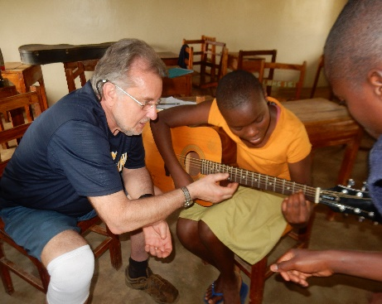
Before heading home we always make time for a Safari, shopping and debriefing in Nairobi. We were blessed to have lunch with several of the graduate students attending college and catching up with them and how they were doing. They were so happy to visit with us as us with them. A big thanks goes out to all the sponsors who fund and take care of the students and to those who made the backpacks for the Victory School and those who sent hamper bags and artist aprons. We also thank those who sent items not mentioned that we packed to bring to the school before we left and for the funds for the pavilion. The pavilion turned out beautifully and will be used for many events and is a place for students to study, pray and visit with each other. We thank God for a wonderful trip and for being able to once again serve the Lord in such a special way. He Calls us to go into all the world to share his love and redemption.
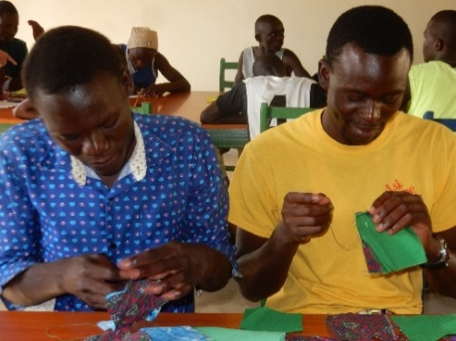
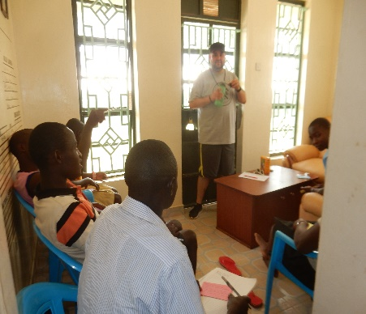
Just a few pictures of the classes. There are too many great ones to include.

Visiting the first LHHS and sharing a memory of its creation. Nick standing where he slept, while attending there. It now is vacant and some rooms are used for storing bricks.
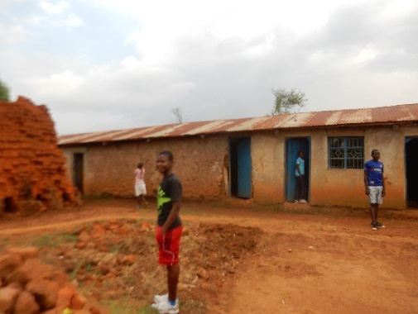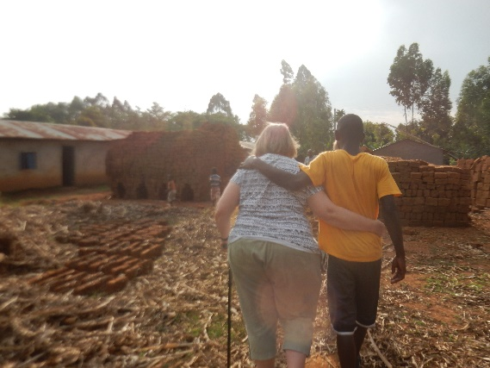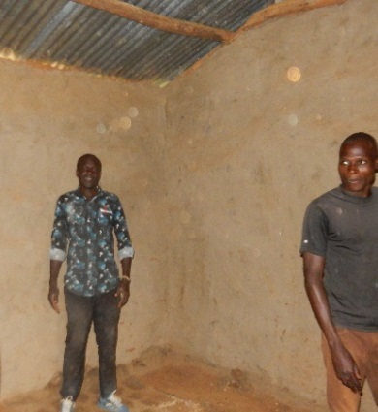

Thanks to everyone who made this dream of a pavilion a reality. It will be used for study, prayer and a gathering place for the students. It will also be used for community events. Maybe even a wedding! Nick and the students and other skilled people of the community did a wonderful job of building it.

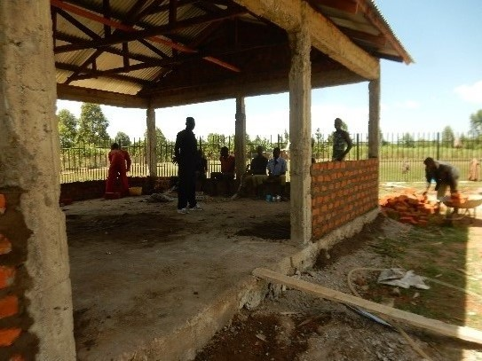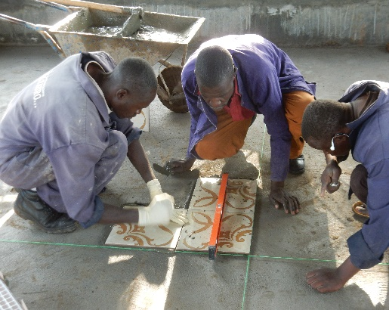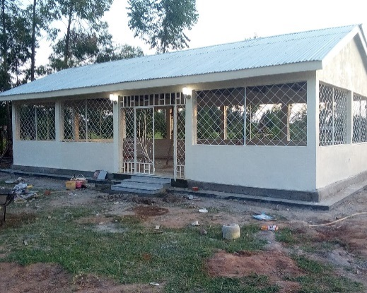

The women of the team were blessed to visit Nurse Catherine’s clinic and meet many of the women she treats and serves. She gives prevention and treatment of mother to child transmission during pregnancy and after birth. For the H I V and Aids mothers and their babies, she offers ant- natal clinic to all pregnant women and guides them with counseling and testing. We enjoyed hearing their stories, singing and praying with the women. Most of all we enjoyed loving on their little ones that Catherine delivered. She also gave us a tour of where the women go to wait until delivery, the delivery room and her consultation room. After the tour she blessed us with a traditional Kenyan meal. If you would like to help Catherine with some support for her ministry she would greatly appreciate it. You can donate to address at end of this newsletter.
At Living Hope High School she gives treatment to students and guides and counsels and offers youth friendly service and to ensure that they enjoy good health and wellbeing while in school and during their end term exam/ final examinations for the form four's.
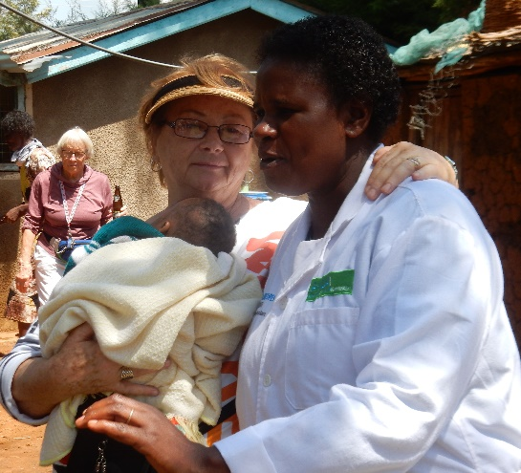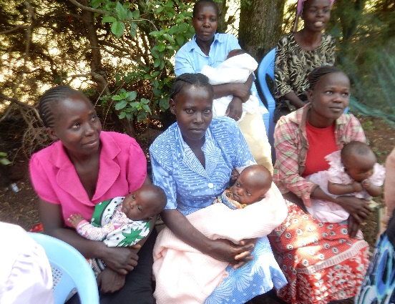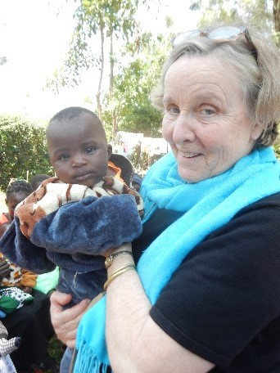

The team visited the Victory Primary School where they had a joyous time, reading stories, playing games and singing songs with the children. Each one of them got a gift of a backpack filled with pencils and other goodies. They were so happy. Thanks to Joanna Lowers and her friends who made them for the children. The team also took a suitcase full of much needed shoes. It was a joyous time of fun, Kenyan music from locals, poems and songs from the children.

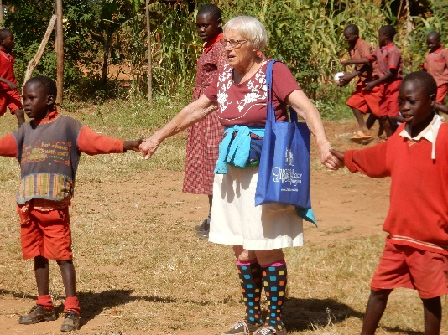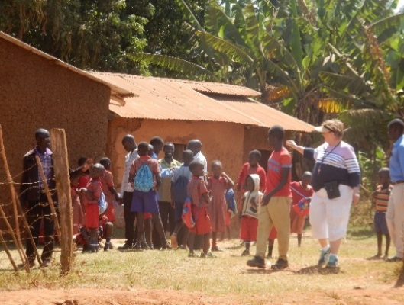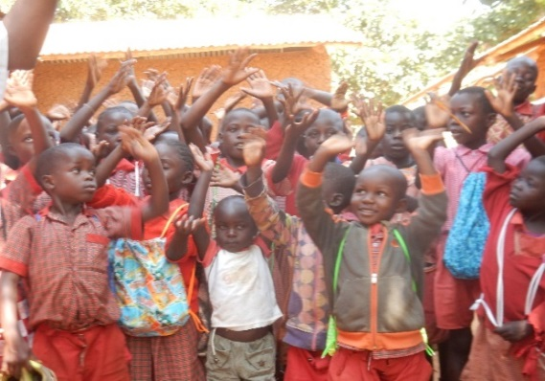

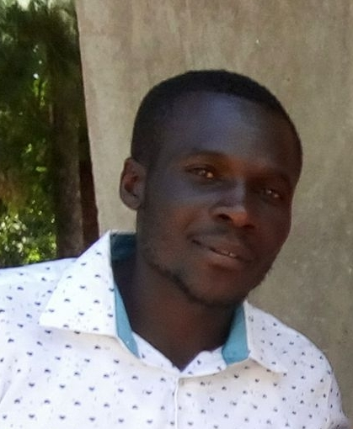
Nic Simiyu His Story-
Living Hope High School Graduate
I was born in a family of poor and illiterate parents. Going to school was a miracle in our family. The best thing one could do is to look after cattle. I decided to be unique among the family members. Life was so hard and tough. Sometimes we would go a day without a meal, it reached a time when I was willing to go to school and get education. Nobody was willing to help me out. This is because no one valued education in our family. One of my neighbors who was a teacher took me to school. She used to love me and support me in all measures. Life was good at schoo,l but at home there was a problem; no food, no light, no soap and my clothes were of poor quality. After reaching grade eight life changed. I was supposed to register for Kenya national primary education. Nobody was there to pay the test fees for me. Madam again chipped in to support me. God was with her!!!!She paid for my exams just to ensure that I could sit for my Kenya national examination of grade. I did my exam in 2009. I managed to pass that exam. Now joining a high school was difficult. I had nothing to do at home. Life was full of stress. I was just admiring those people who were in high school. I prayed so hard for God to open a way. Seeing high school with uniforms was something new to me. I just wished to borrow one from them but things were tough. Some neighbors would laugh at me. I was shedding tears after being rejected. But God is good! The neighboring school was constructed, and I was called there to help them. I would be a helper with hard work and low wages to sustain our family. The guy hired me as a tender (laborer) in Rehema where Living Hope High School started!!!
I was chosen to accompany them to Rehema and they instructed me to lead the helpers. After working there for some weeks, the rumors were all over that there is an American lady coming to start a high school. The American lady was mum Marilyn! I talked to one of the managers of the school about my story and desire to learn. He was good enough to introduce me to mum Marilyn. English was a problem and I needed a translator!! Mum Marilyn accepted me but with many regulations. Life went on and seemed to be smooth and good. My journey was nice and through form four. Praise God for LHHS. I had a wonderful Riverton UMC sponsor.
I did my form four in 2013, God was on my side. I had a dream of being a contractor in my life. I managed to join Coast Institute of Technology. I did building engineering technology at the diploma level. Now I have constructed several structures at Living Hope High School. The structures include the science lab, the healing hut, several dorms and a pavilion. I now have a dream of having my own construction company. I am in prayer about it. I’m done with my college education and would love to have my dream come true to start the construction company. To start the company I would need a transporting truck, a concrete mixer, and generator and cement vibrator. I am now leaving it up to the Lord!
In Christ, Nick Simiyu- Living Hope High School Graduate.
(I have known Nick for many years and he is one of the sweetest and hardworking young men that I know at Living Hope. He has helped Mum Marilyn with building and seeing that it is done well. He also helped with the Bridge which was built last year and the new Pavilion. If anyone would like to help him get his construction company off the ground, please send donations to address at end of newsletter and earmark it Nic Simiyu Construction.) Sandy Binotto
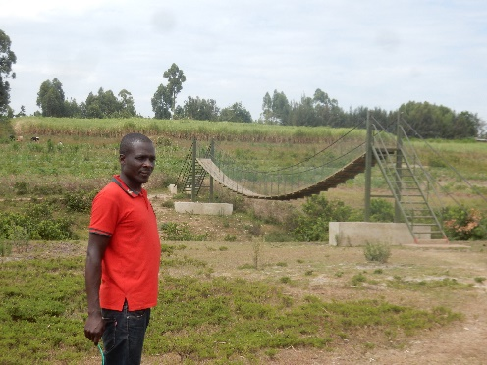

Seat covers for the students to sit on in their wooden classroom
chairs. 106 seat covers were taken by Sarah Fletcher and an upholstery shop
in Bungoma cut the foam and stuffed them with Thanks to Evens, Marilyn’s
assistant.

Another big thanks goes out to St. Paul’s in Oakland, Md. For the artist aprons and hamper bags for the students.

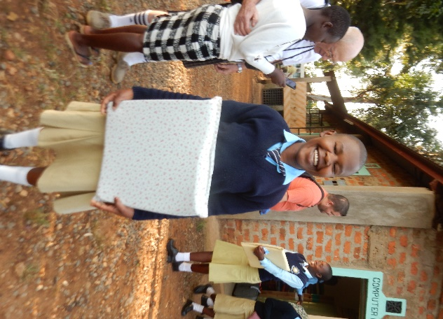
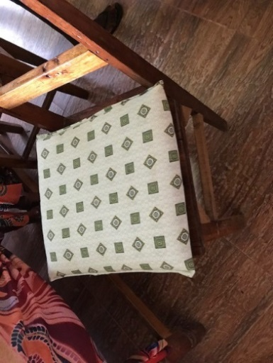
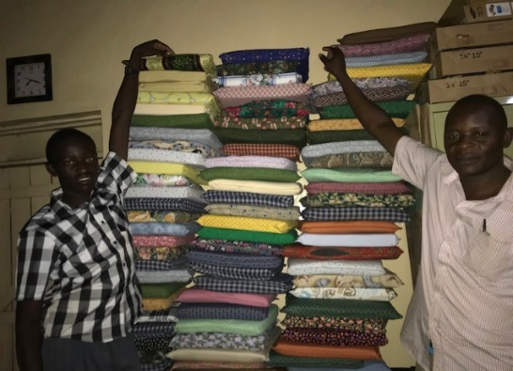
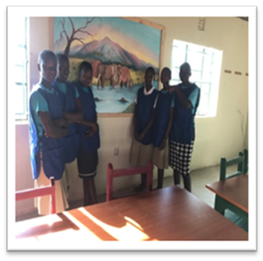

Sponsorship Fee Increase Notice *correction from prior letter sent*

We are announcing that the sponsorship fees from now on starting with the 2019 Form ones will increase to $110/month or $1320/ year. The board met in late November to review our budget. We discussed the expenses we incur and how the costs are increasing. If we are going to be able to continue to run the school and keep the budget balanced, unfortunately, the cost of sponsorship has to increase. This will not quite be enough to meet our needs.
So if you are sponsoring a Form 2-4, and are able, any additional donation on top of your current sponsorship would be greatly appreciated. This will help keep our finances in the black. As you all know our school is funded completely by sponsorships and donations. If you are not able, we completely understand. If you choose to do this as a Form 2, 3, or 4 sponsor, please note in the memo line on your check that you would like to donate extra and the amount. Our Form 2-4’s would need an additional $264 per year to make up the increased cost to have them on campus at Living Hope.
Here are a few of the items that are increasing: employees now have to carry hospitalization insurance, our vehicle insurance has doubled this year and the price of gasoline has gone up 16%, and corn price has gone up 50%. Thanks in advance for your generosity. Once again we ask God’s blessing on this budget and we feel that this increase is in his will.

There are still students who need to be sponsored and you can find them on the website at
http://www.livinghopehighschool.org/

Need a mission speaker? There are team members who would love to share at your church or event
about Living Hope.
You may contact Helen Markwell or Sandy Binotto for more information.

If you would like to donate to Living Hope High School, just send your donation to:
Riverton UMC
P.O. Box 23
Riverton, WV 26814
(If it is going to a specific item please earmark it on your check or send a note)

U.S. coordinator
Helen Markwell –
helenum@spruceknob.net
304-567-2254

West Virginia Mission Team Coordinator
Living Hope High School
Sandy Binotto
yashe4jc@hotmail.com
304-839-1505

