Living Hope High School
P. O. Box 2376
Bungoma,
Kenya-50200
Email: marilynkuhl59@gmail.com
info@livinghopehighschool.org
website: www.livinghopehighschool.org
June/ July Newsletter 2019 U.S. Contact- Helen Markwell-304-567-2254
Team Coordinator/Newsletter, Sandy Binotto-304-839-1505

Marilyn Uhl Arrived Safely to the States from Bungoma Kenya

Marilyn arrived safely to the states to attend the WV Annual Conference. She and her sister Helen are also busy sharing about Living Hope around the Conference.
The Kenyan Breakfast was a great hit, a time to have a reunion with past team members and sponsors and to inform new interested people about Living Hope High School. Many stopped by the Living Hope Display and several signed up to sponsor Form 1 Students.

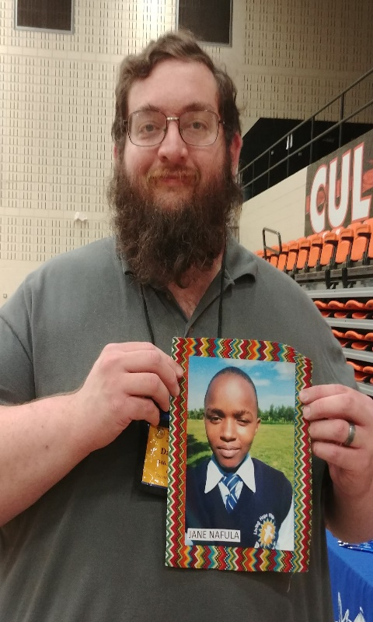
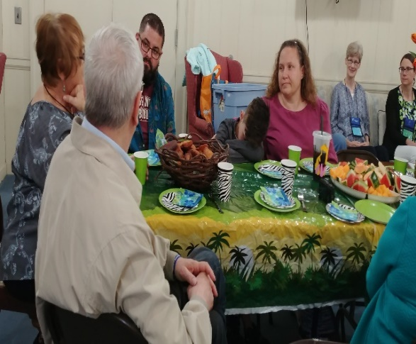
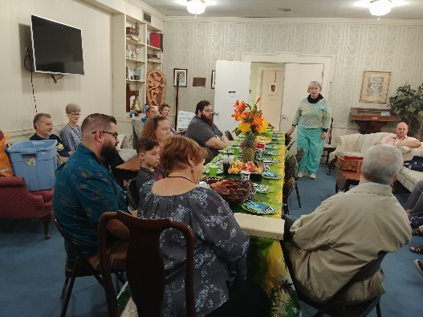
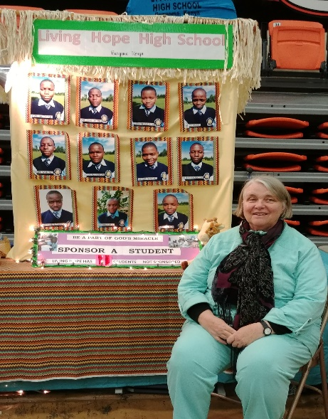
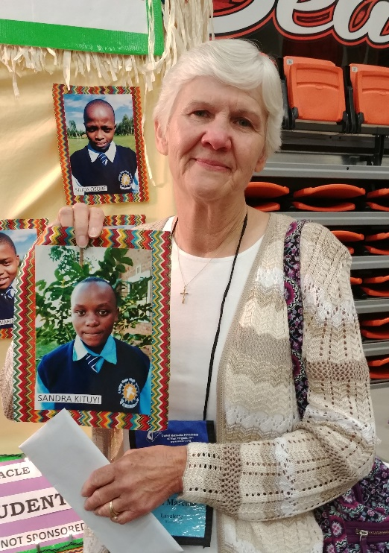
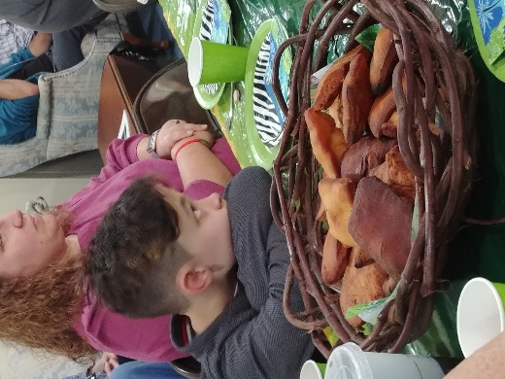

LHHS Students Who Still Need Sponsors
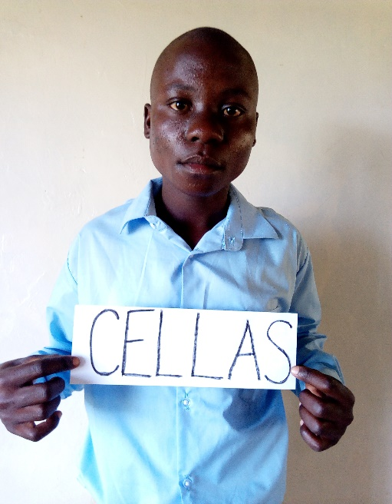
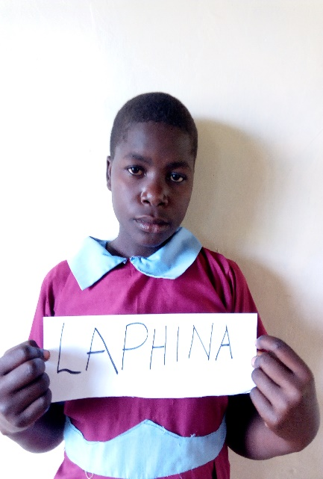
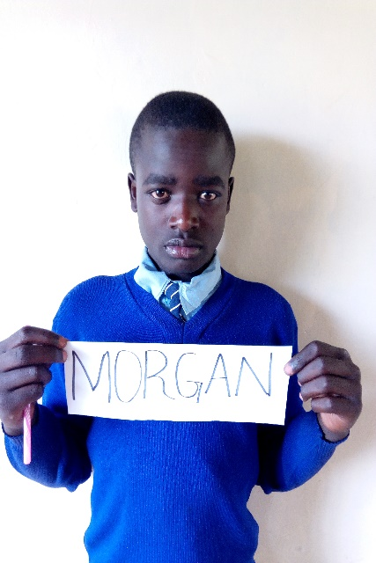
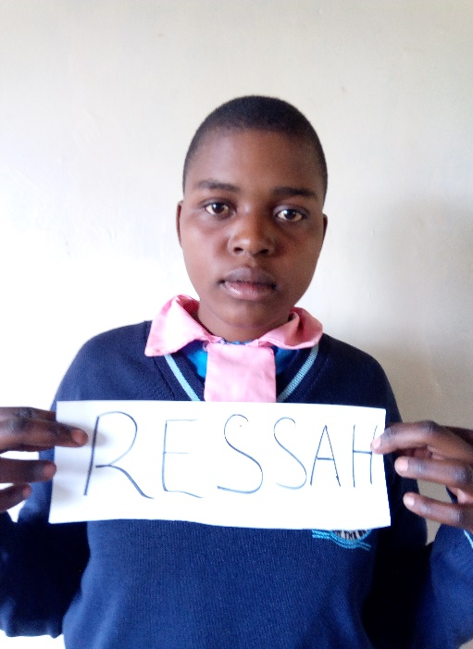
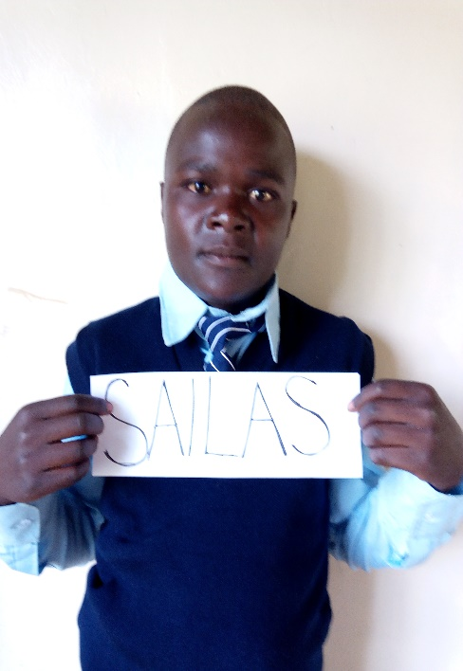

It is crunch time!!! We still have 5 Form One’s that are without sponsors. This is costing the school $500 a month. If you are interested or know of someone who is (maybe a youth group, choir, UMW, or bible study group), please call Helen Markwell (US Coordinator of Living Hope). 304-567-2254
These 5 students (2 girls, 3 boys) are well deserving of your sponsorship. They are bright, they are praying, and part of the best class yet we, Living Hope, have had. Let’s do what Jesus asked us to do in Mathew 25:35-37. “For I was hungry and you gave me food. I was thirsty and you gave me drink. I was a stranger and you welcomed me. I was naked and you clothed me. I was sick and you visited me. I was in prison and you came to me. Verse 40 says, “And the King will answer them. Truly I say to you as you did it to one of the least of these my brethren, you did it to me.”
A New Roof

While Marilyn is in the US. Her small home is getting a new roof. The roof wasn’t leaking, yet, but during the last windstorm it was thought that it might. It was a horrific storm. The roof wasn’t a flapping, it was squeaking. The boys were asked to go up and to hammer down the roof. They found there wasn’t anything to hammer the roof down to. The trusses were all rotted.
So all the supplies were bought that were needed. They ripped the roof off, and went straight to work.
6:00 am- The boys started building the trusses and put them up
12pm- The boys started putting the tin roof on.
3pm –The last nail was being hammered in
3:05pm it started raining.
God obviously was in control here. Thanks to him the sky didn’t open up beforehand.

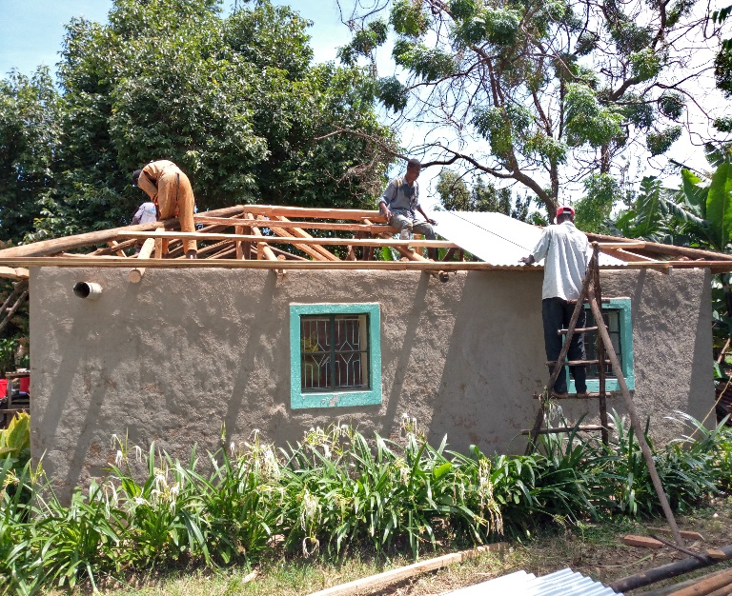
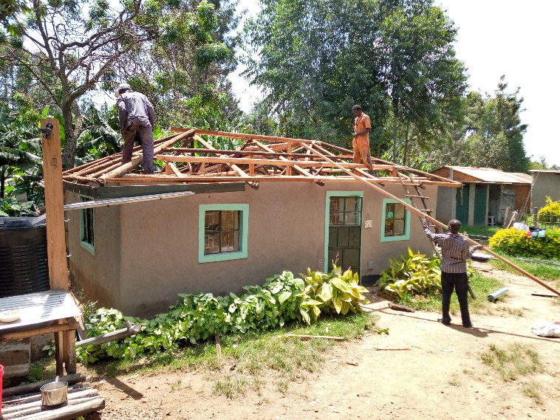
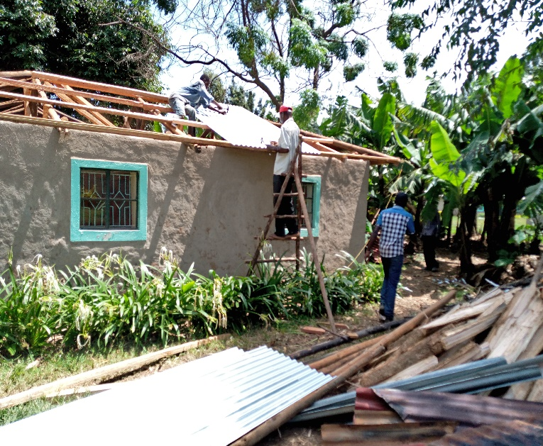
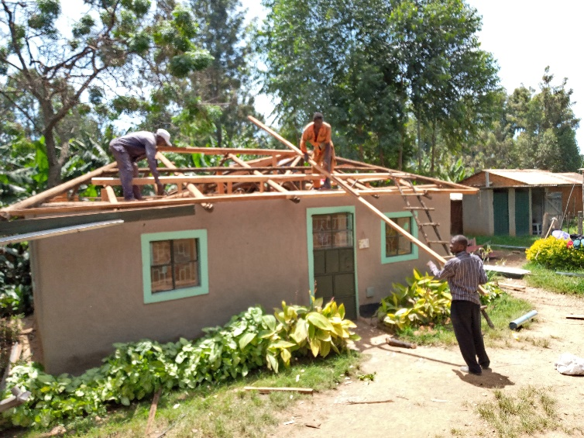
Matthew 5:45 45 that you may be children of your Father in heaven. He causes his sun to rise on the evil and the good, and sends rain on the righteous and the unrighteous.

Please Contact Sandy Binotto if you are interested before deadline! 2 not 3 slots left for team!

Ways You Can Launch a Missions Movement in Your Church
Many churches want to be involved in global outreach and missions, but feel they can’t. Our church is too old, too young, too poor, too new, spread too thin, or just not ready. Are these excuses valid?
One common reason churches are not involved in missions is failing to understand that involvement in missions is a biblical imperative. Scripture mandates local churches and their members to glorify the Lord by sharing His grace, mercy and truth with the lost across the street and around the world.
Acts 1:8 tells us we must share the gospel in our town and around the world. Matthew 28:18-20 commands us to go to all nations and make disciples. Jeremiah 22:3 tells us to show justice to the orphan and the widow. Isaiah 58:10 says we are to feed the hungry. Missions is important for the spiritual growth of Christian disciples and for the expansion of the kingdom.
Once we grasp that we must be involved in missions, the question becomes how. Even with limited resources, your church can foster a missions movement. If your church is not involved in global outreach, here are a few ideas for you and your church leadership to prayerfully consider:
1. Teach
From the pulpit and in all your Sunday school classes begin teaching about what Scripture says about missions and serving the poor. Allow your congregation to be educated on the importance of glorifying the Lord through service. Lesslie Newbigin said, “Mission is an acted out doxology. That is its deepest secret. Its purpose is that God may be glorified.” The church is a place to educate, instruct, and prepare its members to impact the world and share God’s love, mercy, and message. Our purpose in the church is to make disciples for Jesus Christ and teach them to make disciples.
2. Pray
During your weekly services begin to pray for the missionaries you know. Pray as a congregation for several missionaries by name. Include missions ministries in your prayer bulletin and during all prayer times. A.B Simpson said, “Prayer is the mighty engine that is to move the missionary work.” If you don’t know the names of missionaries ask your denomination or neighboring churches.
3. Host
Invite a missionary to come talk about their ministry at your church and host them for a lunch. Allow Sunday school classes to ask questions of the missionary. Invite a missionary to preach on missions. When missionaries come visit your church thank them and honor them in front of the congregation. Cover the cost the missionary incurs visiting you. Plan a mission’s conference and invite several missionaries.
4. Serve
Get out in your community and have your church serve the poor where you live. Organize volunteer efforts for your church at senior centers, food pantries, or women’s shelters. If your church isn’t spreading the gospel to the lost across the street and around the world, your church doesn’t understand the gospel.
5. Support
Begin to financially support missionaries and missions organizations. Provide your congregation with opportunities to sew, collect baby clothes, donate food, or financially support a missionary on their own. John Piper said, “All the money needed to send and support an army of self-sacrificing, joy-spreading ambassadors is already in the church.” Did God make U.S. churches the richest in history so they could buy new cushions for their pews or to spread the gospel around the world?
6. Go
Contact your denomination or a non-denominational Christian mission’s agency and inquire about opportunities to send a short-term mission team next summer. Collect information on how high school and college students can be mission’s interns. Organize several annual missions’ trips and make them regular events at your church.
Mike Pettengill

