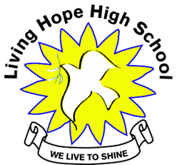

Living Hope High School
P. O. Box 2376
Bungoma,
Kenya-50200
Email: marilynkuhl59@gmail.com
info@livinghopehighschool.org
website: www.livinghopehighschool.org

September 2019-Newsletter
Special Visitors Came to Visit Living Hope

The group led by Nyamah Dunbarved- from the GBGM arrived around 2:00pm. After a late lunch. It started to rain but they got the tour of the School.
The group was very impressed with the campus, buildings and the students that they interviewed. They were also impressed with all Living Hope was doing with getting the word out through communications about the school. They weren’t able to stay long since they were on a tight schedule.
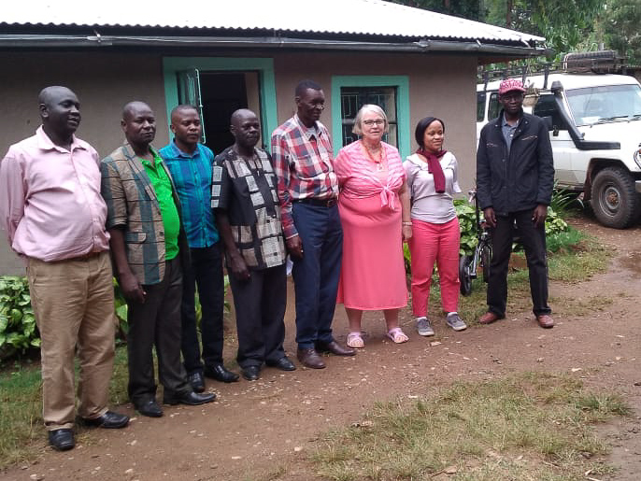
David Barza - UMC Conference treasure
Nyamah Dunbar - General Board of global ministry
Rev Wilton Odongoo - UMC conference secretary
Rev Carol Ososo - Dean of superetendent Kenya - Ethiopia Annual conference
Gad Maiga - conference communicator
Rev Ferdinand Egesa - DS Bungoma district
Marilyn Uhl - LHHS director
Stanley Kutiri - LHHS principal
Murunga Josephtat- LHHS graduate

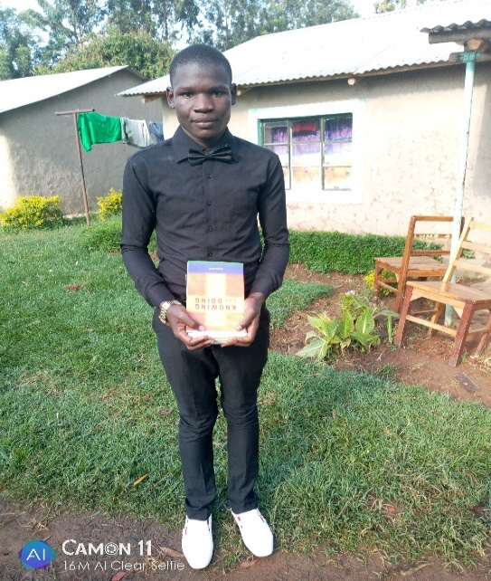
Morphat Wamalwa attends pastor ship program that was held at the Liruta United Methodist Church in Nairobi. He has always wanted to preach but where he goes to college there are non-believers. While at the conference, he learned many things especially about the Bible interpretation, figurative and literally interpretation. He learned how to become a good mentor, and how to overcome the temptations of the world and live like Jesus Christ did. Church leadership was another topic and how to run a church as a pastor and how to run a ministry as a ministry founder. He also learned the importance of prayer and fasting. It should be a lifestyle of every Christian. He also learned how to respect other religions which aren't Christianity. How poor church leadership can lead to the fall of the church. Misinterpretation of the Bible can cause harm to the spiritual life of the church members. He was given good books to use while at home to keep himself updated about Christianity. He learned new ideas which he never knew before and he is now well equipped to counter the abuse of Christianity by the Muslims. He was appreciative of the support that was given to enable him to attend the classes. It was of great importance to us as young Christians who are yearning to serve God in our entire lives.

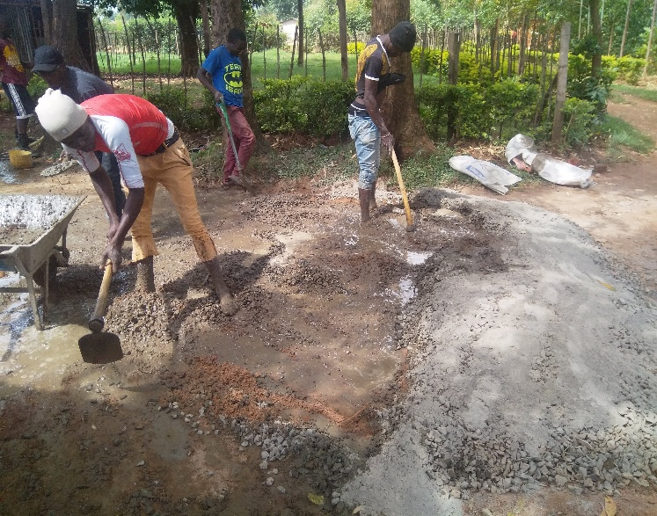
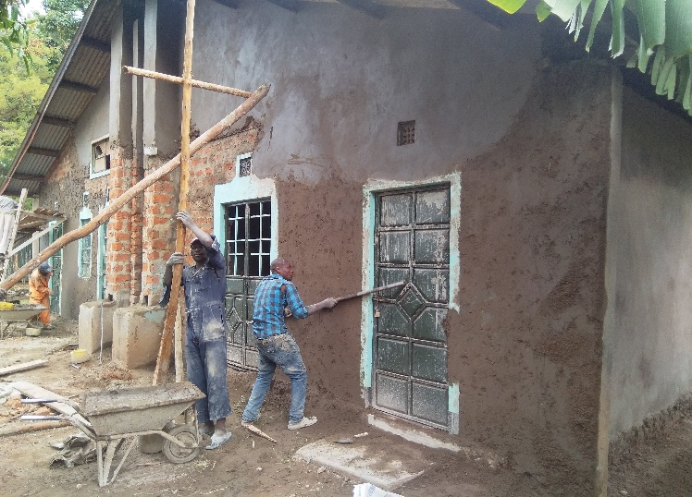
School Improvements
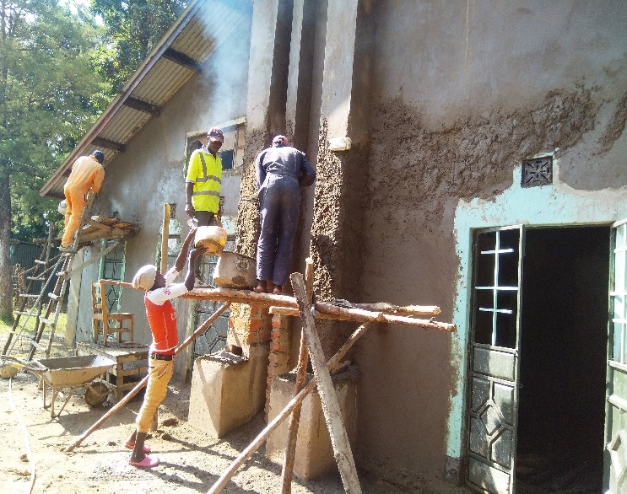
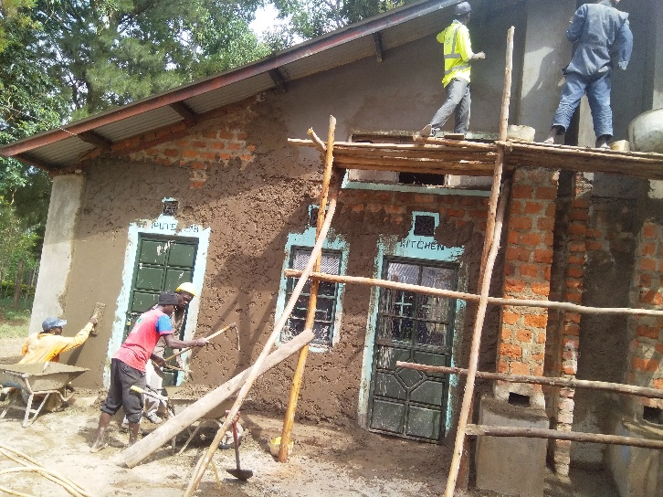

Workers and students are hard at work putting a smooth coat of cement on the walls so the Mission team coming in January can give it a coat of paint!

Living Hope High School Attend Students Christian fellowship Convention
Twenty one persons from Living Hope High School attended the Kenya Christian fellowship. Two adults and 19 students. It was at Chesamis boy’s high school. The students learned so many things including, peer to peer counseling, Christian parenting, chastity, sexual purity. The theme for the week was “Equipped for sacrificial Service.” Everyone had a wonderful time.
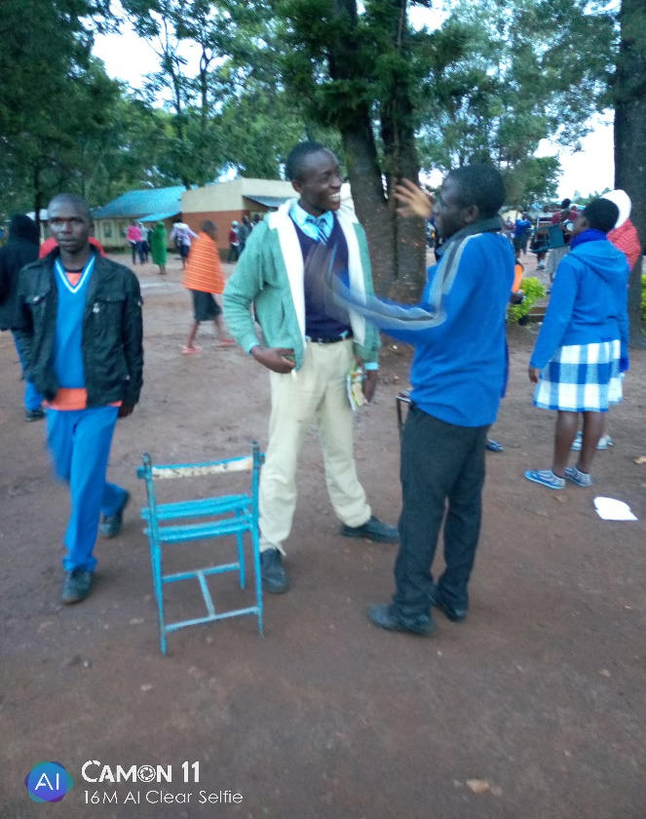
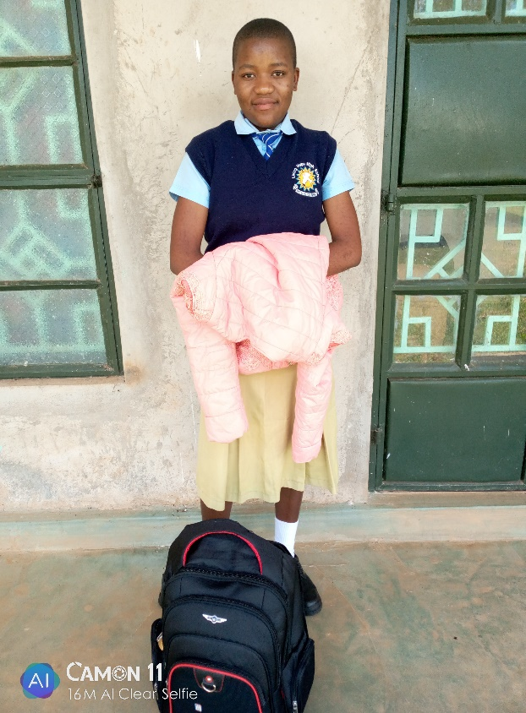

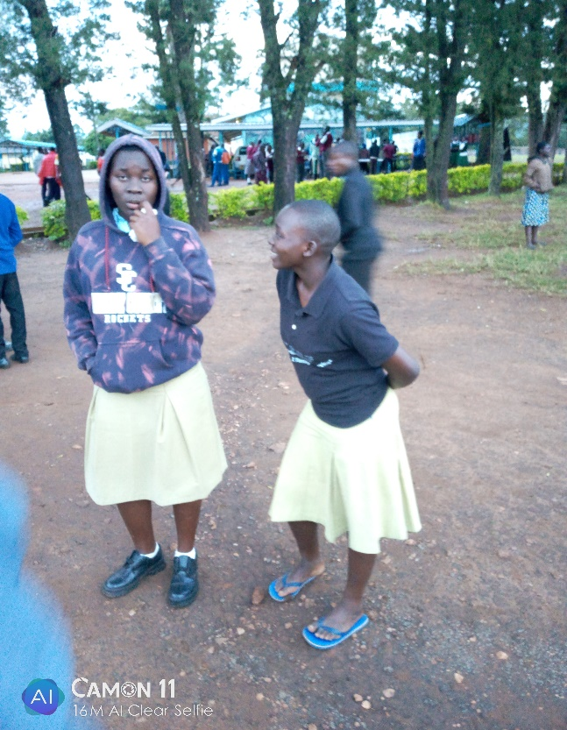
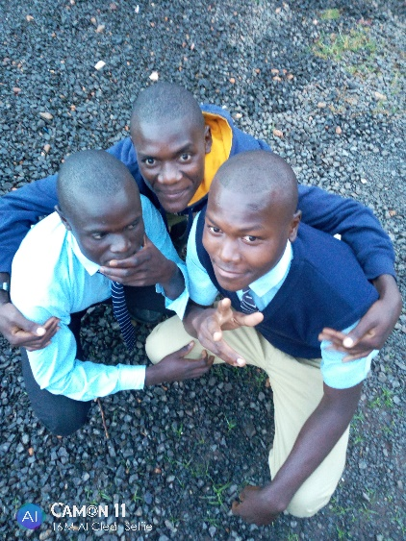

Living Hope High School, Bungoma, Kenya
“Saving Souls and Soles for 2019”
The school is inviting West Virginia United Methodist Women to participate in mission by again collecting slightly used tennis shoes for Africa. All adults sizes 4-12 (both women and men) no children’s this time.
Please send them in a suitcase with your representative to the Fall UMW meeting in Bluefield on Oct 25th. Helen and Marilyn will be there to collect them. Please let me know if you will be bringing a suitcase as I want to plan on the space that is needed to transport.
If you collect them at your church, and it is within my driving distance- please call me and I will pick them up.
Helen Markwell 304 567 2254 - helenum@spruceknob.net

*****We need to have all the shoes collected by Nov 1st. We have a mission team going this year and they will take as many as they can. *********

************************************************************************************

Mission Training

September 28, 2019

8:30 am (REGISTRATION, Lunch & REFRESHMENTS included)

9am - 3:30pm- Class

198 Cape Cod Dr. Augusta, W A
Equipping Team Leaders and team members for Short-Term Mission across the Street and Around the World
Cost $35.00
(Class size 10)
(Lunch and Snacks included in cost)
Who should attend? Pastors, Laity, Youth and those interested in leading or participating on a Mission team- All persons invited, any denomination.

Where in the World is God Calling you to go and Serve?

Class will be taught by Sandy Binotto. A 30+year veteran, Former Volunteer Coordinator with the Methodist Church for two Conferences. She has been on or led Mission teams around the world since 1989, including Disaster Relief. You will learn why we do missions, how to pick a place to serve. Organizing a team, what you need to know before you!
…………………………………………………………………………
Registration Form
Name________________________________Address____________________________________________
Phone_________________________Cell_______________________________
Email____________________________________ Church________________________________________
Registration Deadline-September 16, 2019. Cost for training is $35.00. Make checks payable Sandy Binotto, earmarked Mission Training. Mail payment along with registration form to: Sandy Binotto, P.O. Box 478, Augusta, WV, 26704. For more information contact: Sandy Binotto- yashe4jc@hotmail.com 304-839-1505-C 304-591-7055-H

A Few Needs
Funds for two sets of Bunk Beds. They are $ 100.00 a set. Includes Mattresses.
If you are interested in donating please send your donation to Riverton, UMC P.O. Box 23, Riverton, and WV 26814. Earmark bunk beds on your check.

Need Sponsoring

Two Students need sponsoring. Lavender Simiyu form 3 and Immaculate Wekesa form 2.

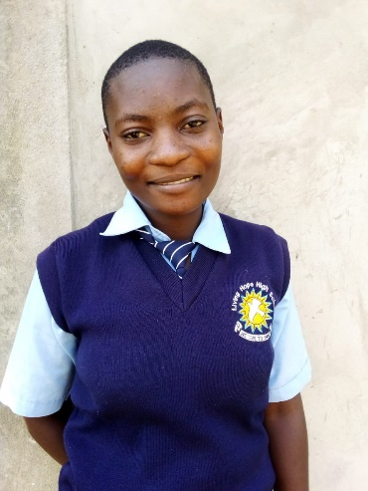
Immaculate Wekesa. I was born on 25th November 2002. I am 15 years old. I went to school the years 2007 in baby class in Kimungui Primary School. I was later transferred to Nzoia Primary School while I was in class three. There I learnt for one term. Then I was transferred back to Kimungui Primary since the fees at Nzoia were too high.
When I was five, my mother was making tea and got burnt very bad. She never really recovered but went mad. She can’t talk and doesn’t know who you are. If I visit her she throws stones at me.
My father took me back to Kimungui. From class three my father started being sick. Sao my education was disturbed by the situation of my dad being sick. In 2012, my father passed on and I went to live with my step-mother. From class four I experienced a hardship, I had to trust God to get me through. In 2017, I sat for my K.C.P.E Examination. I had missed a lot of school so I had to pray God that God would help me. When the scores came back I was the happiest girl in the world. I had scored 362 out of 500 marks. This was good enough to apply to Living Hope High School. I did and I was accepted. I have been here since January and I think it is a good place. The discipline is high and I have made a lot of friends. I here I can concentrate on my studies and not to worry about starving or having someone to love me. Her mom has since passed away and she needs a sponsor. If your heart is moved to sponsor her or your church contact Helen Markwell.
***************************************************************************************

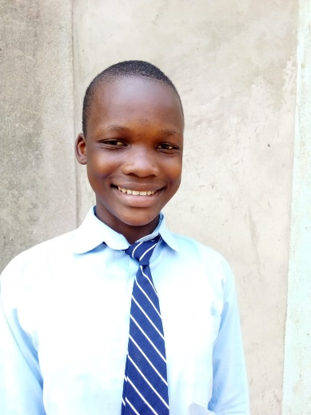
Lavenda Simiyu Form 3
My name is Lavena Simiyu. I was born Jan, 29, 2004, but I have never had a birthday party. I come from Moyokwe Village where I lived with both of my parents and siblings. Some of older sisters got married very young and some of my brother dropped out of school too. It was because the lack of school fees. And caused much stress in our family. Now they are leading a miserable life of poverty.
My father is an alcoholic and provides the family nothing. This forces my mother to do odd jobs for other people in order to provide us with school fees and food. Sometimes there is nothing and we just have to wait on the Lord to provide. When my father would come home drunk he would beat my mother like a drum. One time she knew she would die, so she grabbed the younger children and told us to run very fast and not let father catch us. We all ran to my grandmother’s house. Mother left for whole month while things cooled down. We didn’t know if she would ever return. During that month, nobody studied or went to school. We rarely ate and that forced us to roam around town begging for food. For that whole month we lived a most miserable life.
When my mother came back she went to my principal and begged him to let me sit in class even though there were no school fees. After some time, the head teacher chose the best students in Social Studies to go on a field

trip. I was among them. It was so exciting to see how big the world was. I had never been to town before. We learned so many things and I still enjoy thinking about the trip. It was wonderful.
My strengths were shown during teamwork at school. All of my friends wanted to study with me because I was smart. I could explain to them how to do a problem or explain the plot of the story and they would understand better than when the teacher taught them. By teaching them, all of our grades went up including mine.
My best subject was English although I liked Science and Math too. I loved these subjects because the teacher that taught them was fun and kind and made us want to do our best. I decided to a set goal for my life. I knew that I must finish high school and then go on to a University. I would not drop out like my sisters and brothers. I would be an important person someday so that I could help so many people as possible to have a better life. This is still my goal and I will use my gifts and talents to achieve it.
The next step is to get a sponsors to help support me during high school. I want it to be you! Please help me to be the best I can be. God will smile on you and me. - Lavenda Simiyu

U.S. coordinator
Helen Markwell –
helenum@spruceknob.net
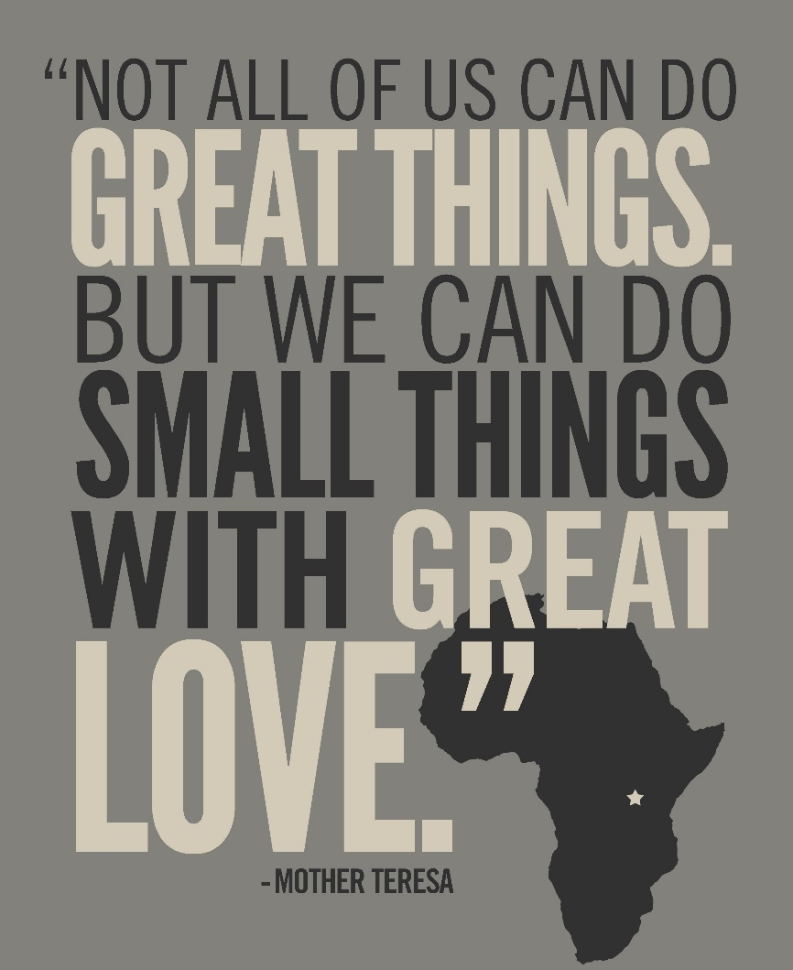
304-567-2254

West Virginia Mission Team Coordinator
Living Hope High School
Sandy Binotto
yashe4jc@hotmail.com
304-839-1505

