**Living Hope High School**

P.O. Box 2376

Bungoma,50200 Kenya

Email: [marilynkuhl59@gmail.com](mailto:marilynkuhl59@gmail.com)

[Info@livinghopehighschool.org](mailto:Info@livinghopehighschool.org)

Website: www.livinghopehighschool.org

Facebook page: Living Hope High School



**December 2017 Newsletter**

**Update on MUM Marilyn**

Four weeks ago John Hopkins stated that her only possible option to improve would be to enroll in some vigorous vestibular therapy. As soon as we got home to Seneca first week of Nov, we started serious research on where she could get this therapy as we had never heard of it.

As only God can, he provided one for us at Elkins Physical Therapy in Elkins. What are the chances of that happening for an old gal in Seneca Rocks? Marilyn is now on her 4th week of PT twice a week in Elkins. She has made miraculous strides.

She’s improved from a person who needed help to walk from the car to the side walk to an independent walker who can walk almost 1 mile by herself with her rolling cart. She is doing all of her own cooking and her own housekeeping. She is climbing stairs well, and is taking the therapy very seriously. She does her exercises diligently 2 times a day.

As Marilyn says, “God is at work!” The therapist says she’ll never be 100% fine, but in another month we will know if her advancement has peaked. The Dr. has released her to return to Africa, January 8,2018. Students will be glad to have her back, she has been greatly missed! Please pray for travel mercies.

**Graduates**

In the absence of Mum Marilyn the school carries on. December 9th 22 students graduated! We are so proud of them. The Lord will now guide and direct them as to where he wants them to go down this journey of life. Some will go to college and some will take up a trade.

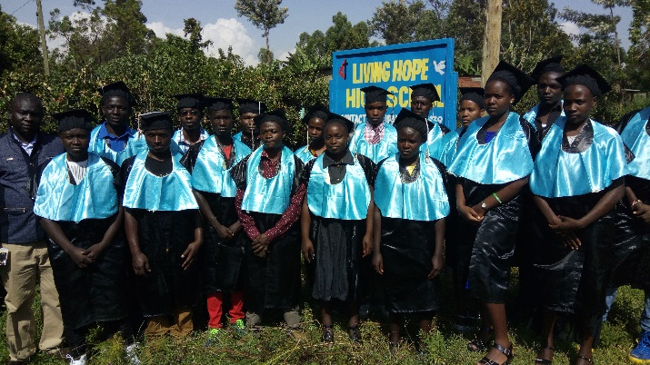

List of 2017 graduates

1. Abeuate Wekesa

2. Amos Wanja

3. Angelah Wanjala

4. Annety Simiyu

5. Brian Masika

6. Elizabeth Wanjala

7. Emmanuel Simiyu

8. Erastus Wafula

9. Gabriel Walela

10. Godfrey Wekesa

11. Habiyongesab Ongayo-1st

12. Hilda Masika

13 Joan Shamala

14. Job Simiyu

15. Lynette Wekesa-4th

16. Kelvin Kiteki-2nd

17 Nehemiah Kalibo

18. Nester Khaemba

19. Nicholas Onyango-3rd

20. Peter Nyongesa

21. Billalah Sakwa-5th

22. Victor Simiyu

The top 5 will receive ¼ of their tuition in a scholarship for college from the government. Please pray and think seriously about helping these students for the next 4 years. There will be three terms per year at about $1600 per term.

**Mission Teams**

**Team One**

December 15, 2017 a team of 9 from the Avery UMC Morgantown and Sandy Binotto will be traveling to Living Hope High School. While there and in the absence of Mum Marilyn the team will be building stage one of a footbridge for the community. Some of the students and fellow Kenyans will be working with the team. The evenings will be filled with making Christmas ornaments, games, bible studies and testimonies. Christmas day will be spent hiking to the Big Rock and having a picnic. One Saturday will be spent witnessing and having prayer at a nearby marketplace. Please keep the team in your prayers as they go to share Christ’s love in Bungoma and to all they meet in Kenya! Thanks to all who contributed to make this trip a reality!

**Team Two**

A former team member Stephanie Arnold and her husband who went to Living Hope High School in 2016/17 came home very excited and will be leading a team back the end of January, first of February. She attends the Winchester Church of God and will be leading a community church group.

They will be doing some construction and medical work.

**Team Three**

First of February two former team members, Pam Francis and Connie Damon will be traveling back to Living Hope to teach first aid classes and vaccinations

Living Hope has been blessed by all the Volunteers who have journeyed there as well as them being touched and moved by being there.

Please keep them in your prayers as they travel and share their gifts and talents at Living Hope High School.

**Harvest Time at Living Hope**

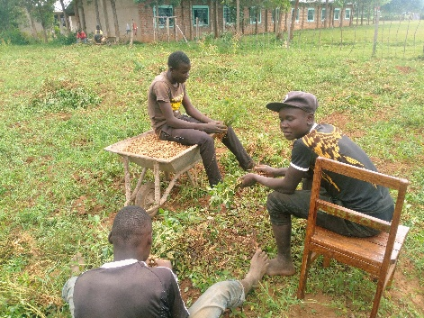

Harvesting Peanuts

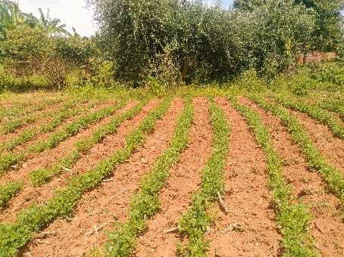

Cow peas doing well

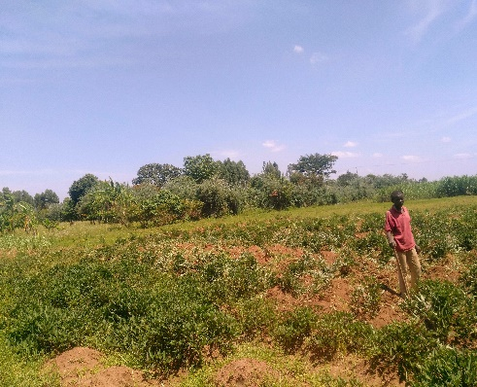

Sweet potatoes

Our other projects

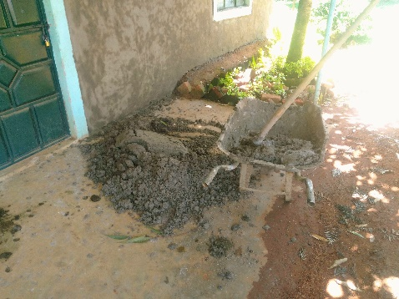

Marsha Cottage smearing

The wonderful hard working women who do the smearing of Marsha Cottage.

Finished Project

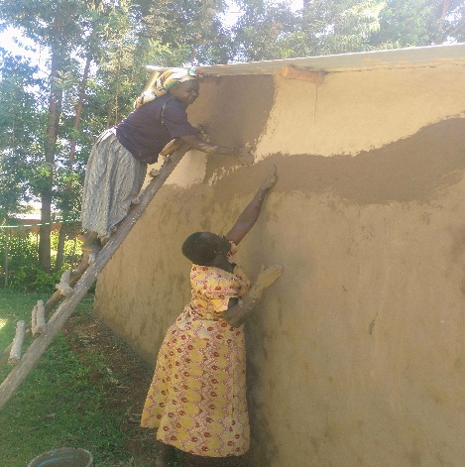

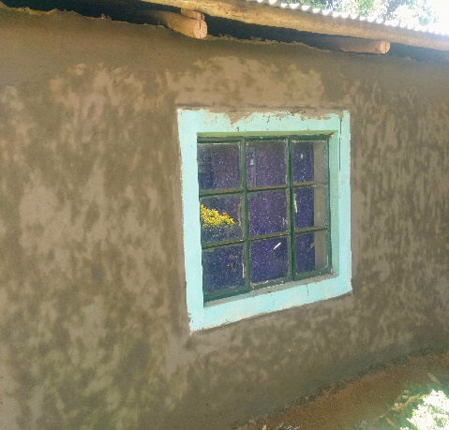

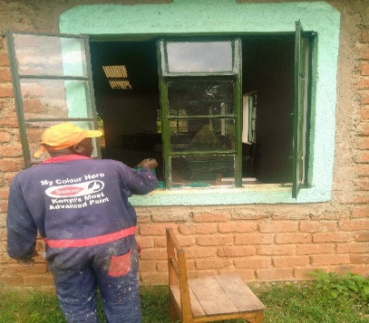

Plenty of painting.

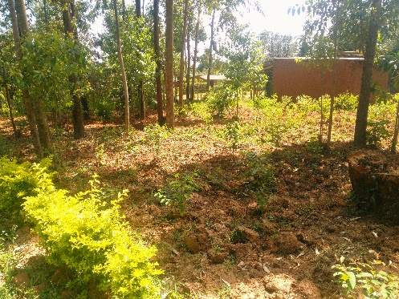

300 Eucalyptus trees being planted for future firewood and building poles.

**Student Story of the Month**

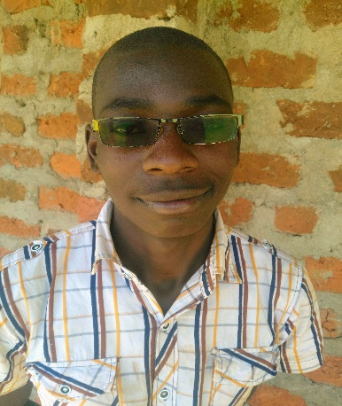

Hello! My name is **Gabriel Walela** and I am here to tell you my story and the wonderful miracles that God has worked in my life. It is a story that could have had such a terrible ending but God was with me from the beginning.

From the beginning, life was tough. I am the second born of five children. That is not unusual in Kenya, but my Father had his hand amputated when I was three. There are not many jobs in Kenya, but VERY few that you can do with one hand. So he would get jobs wherever he could. This meant that there was never enough of anything for the five kids and two adults. My mother would hoe people’s gardens and do their laundry but it was never anything steady. As soon as we were old enough, we would spend every afternoon and weekend hunting a job that might help feed the family for that day. At the beginning of each term, we were in crisis to pay the school fees. A few times the church would help us, but most of the time, we had to pay a dollar at the time and then wait to be sent home for lack of school fees again. At least half of my primary education was spent at home trying to raise the fees or at school trying to learn the new stuff and catching up on what I had missed.

Towards the end of P8, everybody takes the KCPE National Test. It is very important and it decides your future. If you score below 250 you fail Primary but cannot repeat. If you score above 300 you are allowed to go to public high school if you have the money. I had missed so much school that I was worried. Each student has to pay $50 to register for the test. This was more money than I had ever seen at one time, so I started to pray day and night. I prayed while I was at school, and I prayed while I worked, and I prayed in my sleep. Jesus heard my prayer and a well-wisher from our church said that he would pay my registration fees. The day of the test, I was so nervous that I almost threw up. But I figured if God had heard my prayer for the registration fee, then HE would not leave me or forsake me. I took the test and when the scores came back, I was the happiest boy in the whole world! I had scored 362 marks which is VERY GOOD!

The next step was to go to high school. It is very expensive even at the public high schools. School fees, uniforms, books and school materials worried me constantly. It was too much even to pray for, so I just gave up. I thought that I was finished. All the work that I had done was for nothing. Then God answered my prayer even though I hadn’t prayed! Our neighbor was talking to my father and told him about LIVING HOPE HIGH SCHOOL. He said that they were a boarding school that took very smart kids who needed financial help. That was me for sure! My dad and I went to talk with the school the next day. I was accepted and my life changed from that day. At Living Hope High School, I had 3 meals a day, my own bed and blanket. But the best thing was that I got to go to school every day without worrying that I would be sent home for school fees. The school found a faithful sponsor, Jaqueline Hall and Hamlin UMC Church. Praise the Lord!

Two years ago, the principal got a call for me to come home immediately. Our house had caught on fire. Everybody was OK but we had no place to live. Mum Marilyn sent me with the driver to see what the situation was. Half of the house was ok but the back half was a mess. The driver piled all of us students in the car and brought us back to Living Hope while my parents sorted things out. My family stayed at LHHS for over a month. Luckily it was during the break so we had plenty of room. Mum Marilyn sent out a plea to all the sponsors and donors and they bought all four kids a new school uniform, blanket and mattress. At school we had just torn down an old building and the students brought windows and poles to rebuild my house. The Living Hope students proved to be my family’s “Living Hope”. The cooks came and made everybody a good lunch. Everybody worked until we could hardly stand but we got the walls up and the roof on. What a happy day. I was so proud of my friends and fellow students. I love them so much.

I wanted to appreciate God for the wonderful blessing that he had given me, so I started to really study the Bible. I had read it occasionally but I had never gone deep. God was talking to me directly through his word and helping me to understand how to live and what to do. I was saved and accepted Jesus as my Savior. This was the start of something BIG. I started to preach and help with the Student Christian Union. The more I did, the more I loved the Lord.

Now I am almost finished with my high school education. I will graduate on Dec 9, 2017. I would like to study journalism and theology and write Christian books for children. I am going to apply to several colleges for a scholarship. I know that God will be there when I need him. I give my life for Him to use.

Yours in Christ,

Gabriel Walela

