

**Living Hope High School**

P.O. Box 2376

Bungoma,50200 Kenya

Email: [marilynkuhl59@gmail.com](mailto:marilynkuhl59@gmail.com)

[Info@livinghopehighschool.org](mailto:Info@livinghopehighschool.org)

Website: www.livinghopehighschool.org

Facebook page: Living Hope High School

October/ November 2017 Newsletter

**Mum Marilyn**

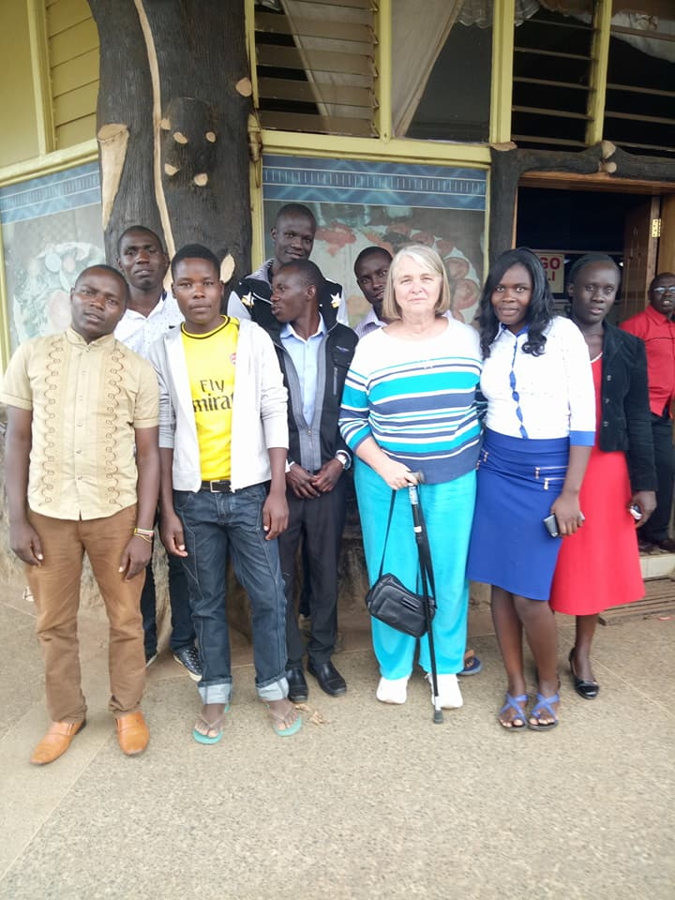 Marilyn has now arrived in the US as of this writing and stepped from the airport directly to John’s Hopkins for testing. She has been battling dizziness for some time. After many tests, they have found she has severe vertigo and there was no surgery for this type of problem. Special Vestibular Physical Therapy was the only hope man on earth could give her. God provided this special therapist in Elkins, WV. She is getting therapy twice a week, and we are praying it helps!

The picture is her send off by the Students who love her dearly. She will be surely missed while gone. She is at her sister’s house in Seneca Rocks.

**Where in The World is Bungoma Kenya?**

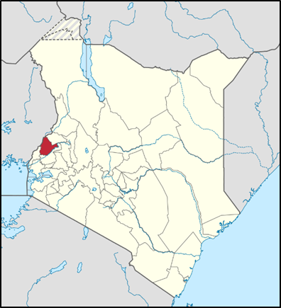

**Map of Kenya- red spot is Bungoma**

Bungoma Kenya is the County in Kenya where the Living Hope High School is located.

Bungoma, was named from engoma — the [Bukusu](https://en.wikipedia.org/wiki/Bukusu_language) word for drums. The town was originally a meeting place for [Bukusu](https://en.wikipedia.org/wiki/Bukusu_tribe_(Luhya)) elders. The sound of drums would emanate from the area as the meeting venue, leading to its eventual naming as Bungoma.

Farming is the main economic activity in the county. Bungoma County is sugar country. It has one of the country's largest sugar factories, as well as numerous small-holder sugar mills. [Maize](https://en.wikipedia.org/wiki/Maize) (corn) is also grown for subsistence, alongside [pearl millet](https://en.wikipedia.org/wiki/Pearl_millet) and [sorghum](https://en.wikipedia.org/wiki/Sorghum). [Dairy farming](https://en.wikipedia.org/wiki/Dairy_farming) is widely practiced, as well as the raising of [poultry](https://en.wikipedia.org/wiki/Poultry_farming).

If you would like to read some more history

of Bungoma you can find it at this link:

<https://www.cs.indiana.edu/~port/kenyafriends/bung.hist.html>

**Exciting New Happenings!**

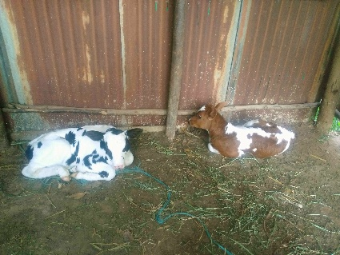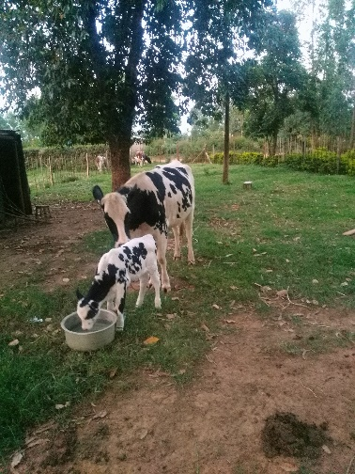 While at Living Hope last year on a VIM trip, I was able to witness the insemination of one of their cows Shirley, the brown cow. I am happy to say that two births have taken place since the last newsletter. Haley one of the younger cows gave birth to a little male calf and Shirley gave birth to a little girl calf. It was an exciting week for the birth of the little ones! Naptha, a LH graduate, was so happy to be there for the births.

The new babies need names so there will be a contest to name them. Please send your suggestions to [marilynkuhl59@gmail.com](mailto:marilynkuhl59@gmail.com)

Haley is the black and white calf’s mom and Shirley is the brown and white calf’s mom. Please have your names in by Thanksgiving Day and the winner will be announced in the next newsletter.

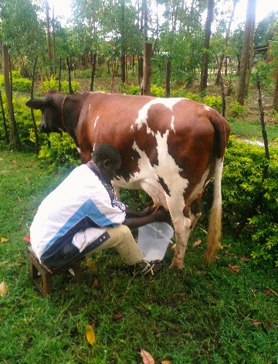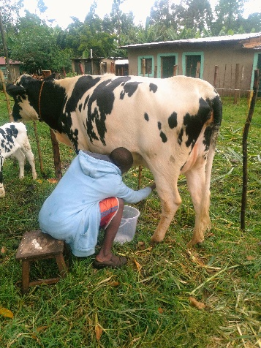

**Baby Chicks**

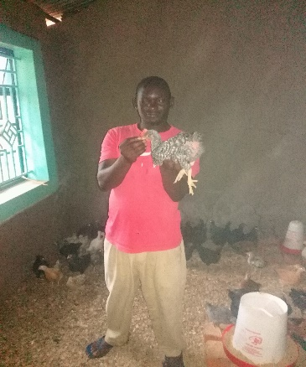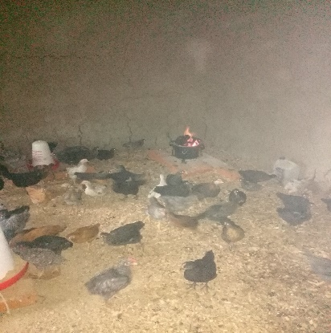The chicken house is all done and now the home to quite a few little baby chicks! They will be well taken care of by the students and staff! Growing fast! Cook Lamick is holding a growing chick.

**Other Improvements**

The kitchen has had a new coat of paint!

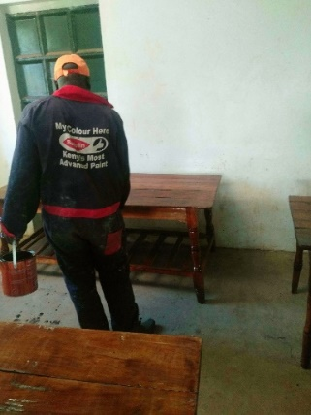

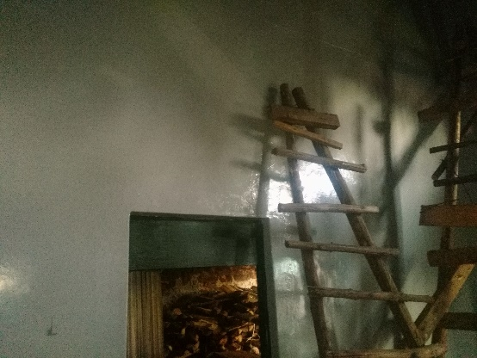Tables and chairs getting a facelift. The remaining grads are cleaning, sanding and varnishing the tables, chairs, and desks in the classrooms and the Dining Hall. They are getting ready for the KCSE Exams inspections, the mission teams, and Graduation. Plus the start of the new school year.

**The Miracle of Birth**

You just never know what a day will bring when you are in Africa. Ezekiel Alumasa is a graduate student of LHHS. Last year he was the Asst. cook for our team and did a great job. He was on his way from college back to LHHS. It is a long journey of about 16 hours and not too many stops along the way. I am sure the bus he took was quite full. He was prepared with a few items that he may need along the way. Ezekiel’s backpack was packed with such items: a roll of toilet paper, a first aid kit (with some pain killers), and rubber gloves which he used when cooking, a bottle of water and a Maasai blanket. Little did he know that he would use them ALL that day! In the back of the bus there was a pregnant woman and she went into labor! Ezekiel and another lady to the rescue. All the items became very important to him that day! The Maasai blanket was used to wrap the baby in, toilet paper to clean up delivery mess, rubber gloves for delivery, other items used accordingly. A baby boy was delivered with no problems. When her stop came, the new mother got off the bus with baby and told them thank-you and off they went. What a story! Wish we had more pictures, but his phone wasn’t working that day. We thank God he was there and able to help bring another new little life into the world. This picture is of him and his new Maasai blanket that Mum Marilyn had gotten him.

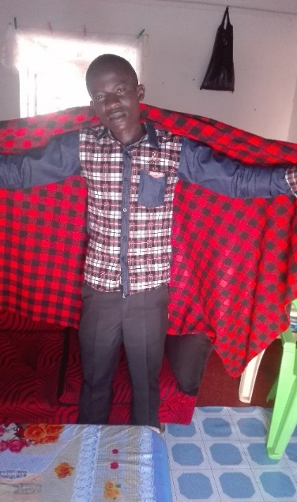

**Student Story of the Month**

**Sammy in 2014 Sammy and Peter**

**SAMUEL WAKOLI.**

**Those of us who have been on past VIM trips remember Sammy very fondly. We met him in 2014. He is one of the most kind and hardworking students. Sammy would always see if you needed anything and always had a smile. It is so wonderful to see how he has grown in Christ and doing so well in school. Here is His Story!**

Samuel Wakoli (known as Sammy) was born in 2002. He is the second born in his family. His parents are laborers. They cultivate people’s fields and gardens to make ends meet.

Samuel started his early education at Chekulo Primary School where he was enrolled in Nursery School. He went to Chekulo up to class five then he transferred to Sunset academy. He is currently going to Nzoia Industrial Primary School.

He hopes to join Living Hope this next year when he graduates from primary school. He lives in the neighborhood, but stays at Living Hope often. He helps Living Hope students whenever there is work like baking bricks when he is at home on break. Samuel is a hardworking, honest, and obedient boy.

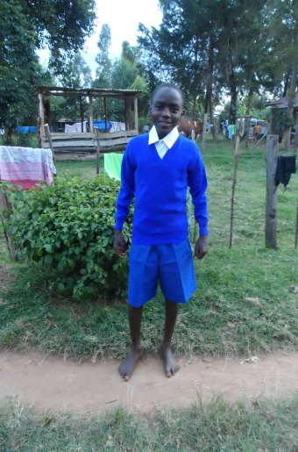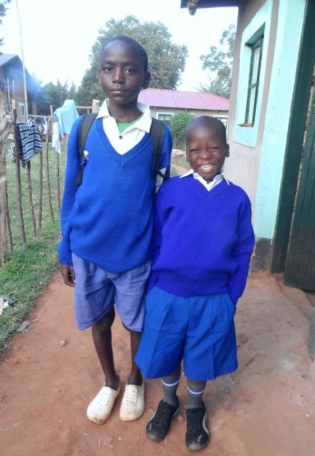Samuel Wakoli acknowledges Living Hope High School as a source of his success. He remembers when he joined as hopeless boy. He now has hope in life. Living Hope High School has enabled him to get a good quality education. He can get quality food there, and he has friends that can advise him whenever he has a problem. Living Hope High School is like a home. He looks forward to joining Living Hope after Primary Education. He also thanks his sponsor; Pastor Larry Anderson, for his support in Samuel’s primary education. May the Almighty God bless him abundantly.

Samuel Wakoli has had tremendous achievements in his primary Education. He is third in his class out of 250 pupils in eighth grade. Samuel was elected the school president. And is now head of almost 700 pupils. Moreover he won a mathematics contest and was awarded a trip to Nairobi Museum. He is the best student in mathematics in the whole school.

Samuel would like to be a forester when he grows up. He likes planting trees. He always plants at least five trees a week when he is at Living Hope. He now has a small forest of eucalyptus trees at Living Hope High School.

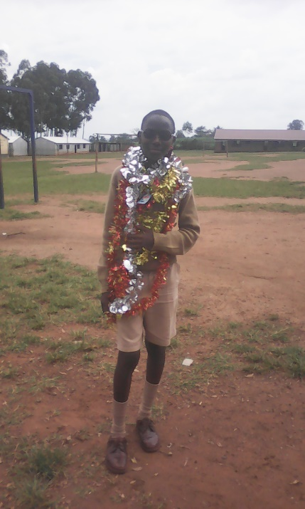

**Sammy today, grown into a fine young man!**

**Christmas in Kenya**

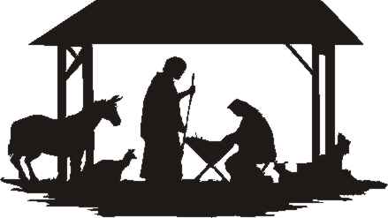

This year a UMVIM team from our WV Conference will be spending Christmas in Bungoma, Kenya at Living Hope High School December 15-January 3, 2018. A team of 10 will be traveling there to build a footbridge. The bridge will cross a body of water that no longer has a way to get over it. The new Bridge will allow people of the community to have a shorter distance to walk to collect water. They will also be able to visit family and attend to their small plots of fields where they grow the much needed vegetables to feed their families.

The bridge will be built in 3 stages. The team will do the first stage with local Kenyan laborers and LHHS students. Another group:

**Bridging the Gap Africa** <http://www.bridgingthegapafrica.org/> will help with the next two stages.

On Christmas day the team will hike to the Big Rock with a Picnic lunch and visit a prayer cave. It will be a very different Christmas, but one I am sure the team will never forget. We ask for your prayers and if anyone would like to donate to the project you can. Just make your donation to the **Avery UMC, 1152 Cheat Lake Rd. Morgantown, WV 26508. Earmarked Kenya Bridge Team.** Deadline to have donations in is December 4th. Donations will be used where ever they are needed the most.

**Donations** are still needed for several students:

Rogers Wabwile- College Student at Africa

University- for his non-scholarship expenses, food, travel, etc.

6-7 others can still use help to go into the College Scholarship fund. The total cost is $1,500 per trimester.

If you feel led to help any of the students you can send donations to Riverton UMC, P.O. Box 23, Riverton, WV. 26814 **Earmark** College Fund, **Checks payable** **to**: Riverton UMC.

Alternative Christmas giving!

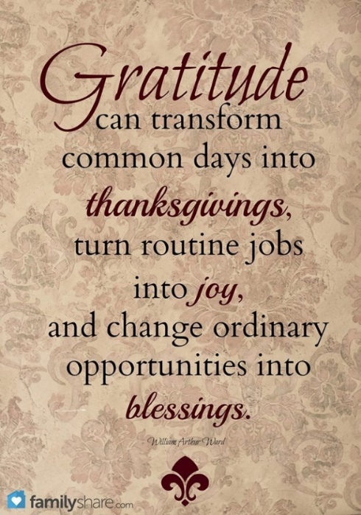

Living Hope High School is one of our

West Virginia Conference Advance Specials and Mission Project that we support.