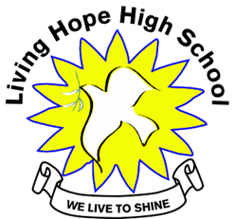

Living Hope High School
P. O. Box 2376
Bungoma,
Kenya-50200
Email: marilynkuhl59@gmail.com
info@livinghopehighschool.org
website: www.livinghopehighschool.org

August Newsletter 2018

Back Home at Living Hope!
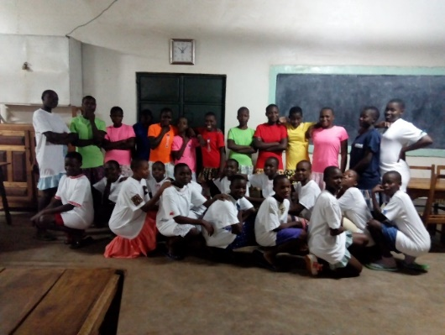
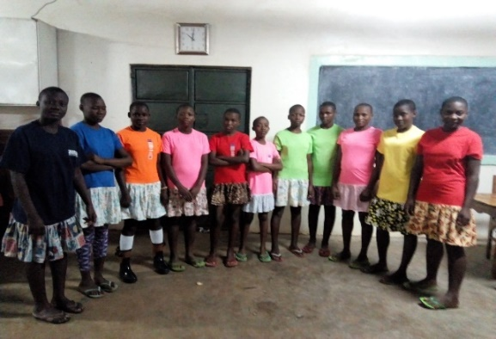
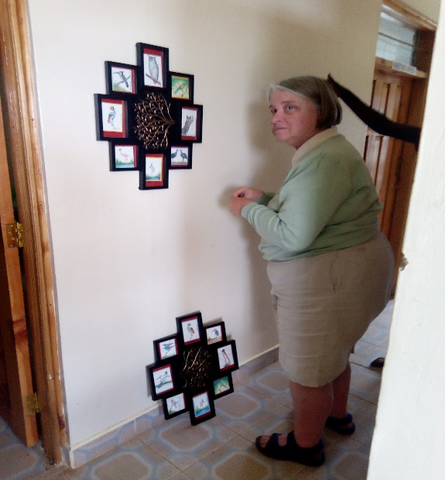
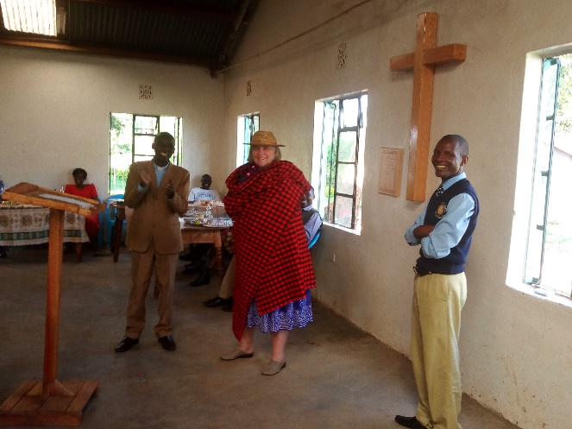
Marilyn is back to her beloved Living Hope High School and doing well. She is working with the students to make sure the school is running smoothly and working with incoming teams to visit and work at the school. She is wrapped in a Maasai blanket with one of her students and Pastor Gabriel. Items she brought back from the states to decorate the Healing Hut!
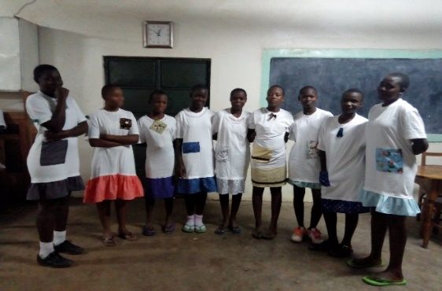

Big Thank-You
A Big thank you goes out to the UMW who made the night dresses for the girl students. They loved them. Many of the students come with nothing or hardly anything except the clothes on their backs. They are given uniforms and many have nothing to sleep in at night. For several years UMW have been making t-shirt dresses which they wear to bed. The new students and former students were so excited to receive them and send their thanks!

Eye Clinic Blessing

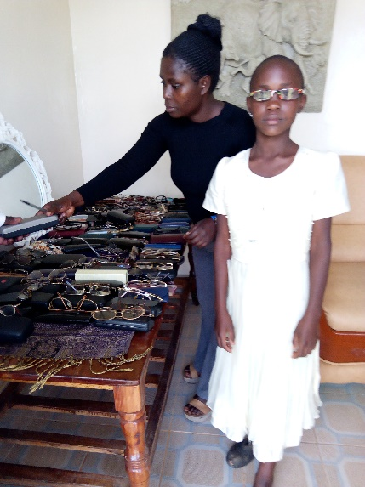
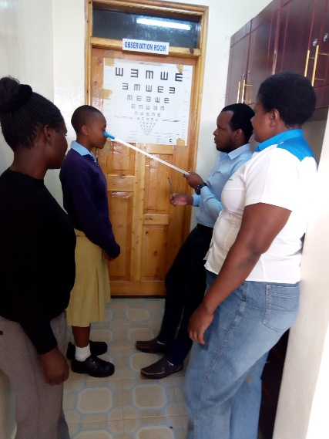
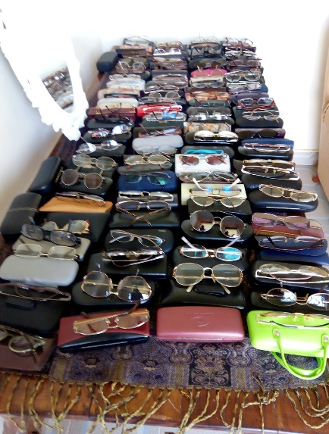
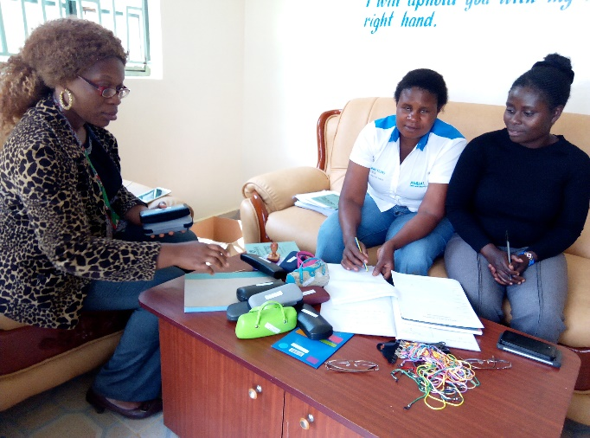
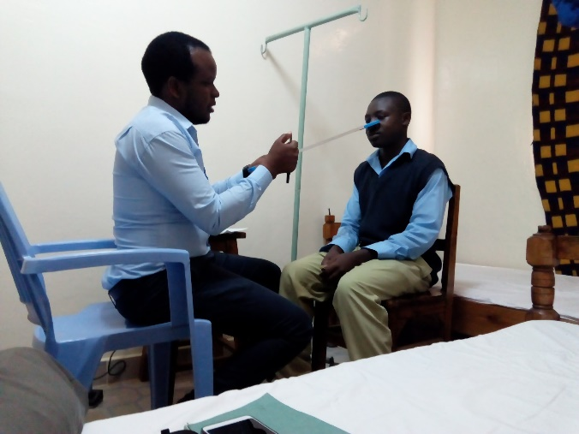
Living Hope was blessed with an eye clinic coming to the school. They managed to examine the eyes of all students, teachers, workers, graduates and some villagers. The patients who had eye problems were given medicines and spectacles. Remember to save your old glasses and donate them to those who need them, the Lions Club or Missionaries teams going out to serve in the world! You might want to do an eye glass drive at your church!

Construction

I can’t imagine Living Hope without a building project says Marilyn.
The school received a wonderful donation that was truly a blessing. The floors of the school were collapsing, due to water flowing under the floor during the rainy season. There were 8 inch holes in the floor that were 6 inches deep! You had to watch your step. The desks had to be placed carefully to miss them. So we decided to replace all the cement floors, plaster the one room that had never been plastered so that we can use it as a classroom and the art room in Jan. We built a cement berm around the foundation off the building on the outside. The kids are on break until Aug 26, and Nick said that we could get it done by then. As of tomorrow, all of the floors have been poured and now we are painting. I feel sure we will make it. What a mess! But God is good and HE has provided the materials and manpower to get the job done. The rooms will be beautiful, clean, and will help the kids to do well. Praise the Lord!
A special thank you to the grads who gave up their break at college to help get this project done. God bless them!

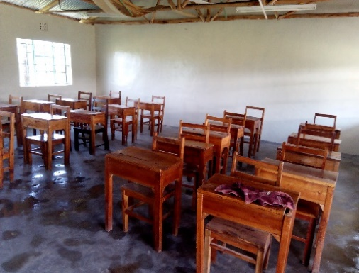
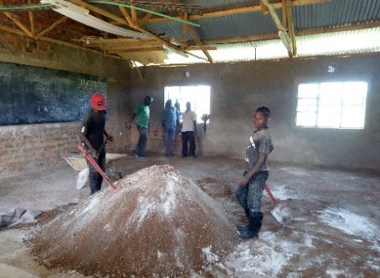
Nick Simiyu, Andrew Wakaro, Josephat Muruga, Andrew Nyongesa, Collins Wasike, Duncan Wanjala, Godfrey Wekesa, Kelvin Kiteki, David Pepela, Gabriel Walela, Abeaute Wekesa, Dynitias Wanjala, Amos Nalimaye,
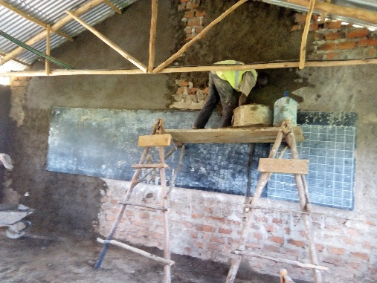
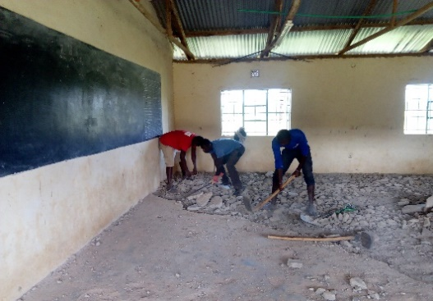
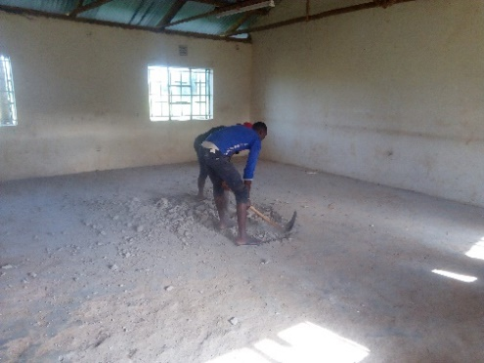
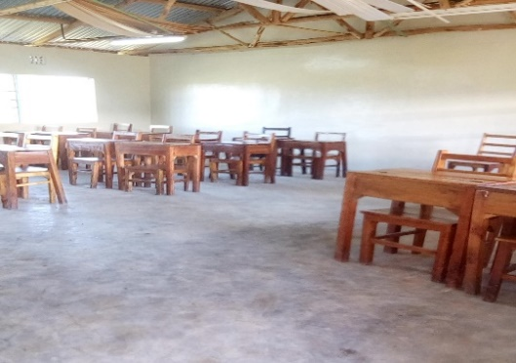
UMC Visit- By Marilyn

On Aug 12th the students of Living hope High School visited the only United Methodist Church in our area. We were thrilled to find Makhuma United Methodist Church and worship with them. God had it planned because the area superintendent Rev Ferninard was there too. His area covers all of Kenya. He told us that our annual conference covers seven countries! The Bungoma District Secretary, Rev. Abiud Ambunya was also there.

Four of our students sang several original songs with David Pepela accompanying them on the guitar.The ladies of the church fixed us a wonderful lunch and a good time was had by all.
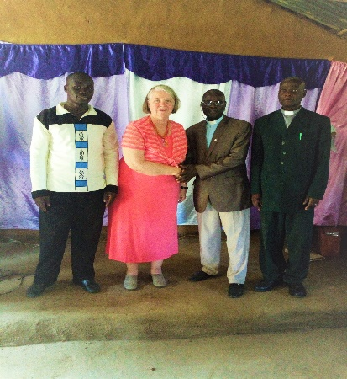
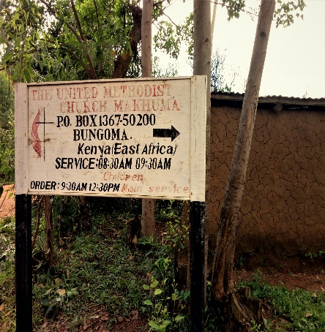
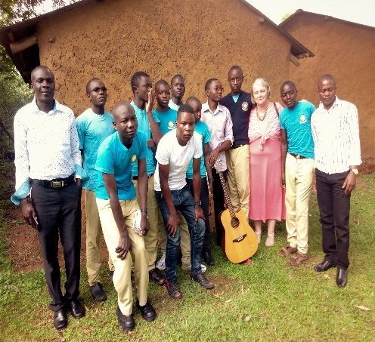
We invited the local pastor Saul Wekesa to come to our school and preach in September.

19-Students attend a CHRISTIAN UNION CONVENTION IT WAS A WOW!
MAIN THEME: CONSIDER YOUR WAYS (Haggai 1:7)

Venue: Maliki Boys
This is the most fantastic ceremony I have been there. We left Living Hope High School on Sunday 5th August 13, 2018. We were 19 I number when we left the school. In total there were almost 72 schools that were invited to the convention producing almost 750 students.
Some of the things that we learned while we were there include:
-Integrity
-Sexuality
-Academic excellence
-Occult
-Music
-Talents
-Betting and gambling
The main speakers in the ceremony were: Bishop Kaitano and Bishop Moses.

-Praising and worshiping God
-Presentations
-Creation of the theme songs
-Peer to peer counselling
-Preaching
-Bible study
-Interactions with other school
-Talent show
-Video show

The most interesting part in the convention was the praise and worship. In the praise and worship people were actively singing and dancing to the Lord. Many people gave their lives to Christ and most were delivered. It was powerful and life changing. What I learned from that session is that there is power in praise and worship. It is one of our weapons against spiritual warfare.
In total, about half of the whole population got saved or rededicated their lives to Christ. It made us hungry to evangelize for Christ.
I have been blessed,
Dynitias Wanjala, Head boy Living Hope High School
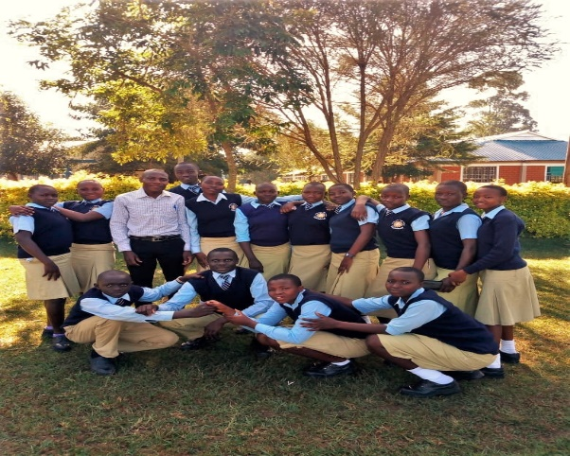
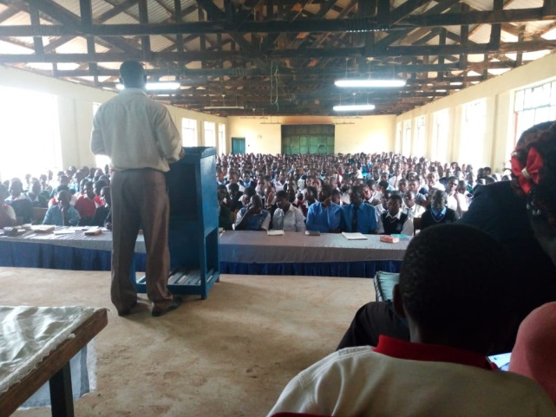

Christian Union Convention LHHS Students Who Attended

I met Nicholas a few years ago, such a nice young man- On my last trip to Living Hope I was able to sit and talk too many of the students and hear their stories one on one! Nicholas was one of youth who shared with me his life’s story. I sat intently listening with tears running down my face as he shared. This is part of his story, he left some things out but if you have it in your heart as an individual or as a church group, to help him with his request please contact Helen Markwell. He is kind, very helpful, and smart and knows who has kept him on life’s path holding his hand all the way Jesus! - Sandy Binotto

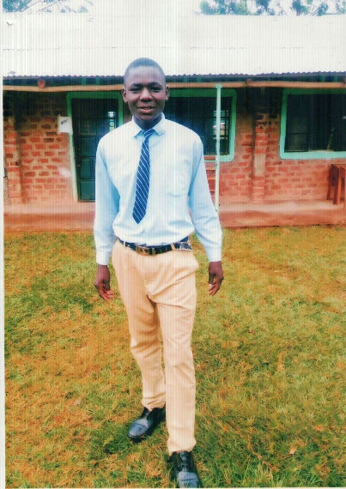
My name is Nicholas Onyango. I am a 2017 graduate of Living Hope High School. I graduated 2nd in my class of 22. On my National tests I scored a B- which is extremely high. I qualified for a 1/4 scholarship to university.
My background is dotted with family financial crises. But sometimes I just try to sit down and meditate on all my blessings from God. When I was a baby I died and had to be resuscitated. I was very sick and no one could touch me as my skin was falling off my body. But my mother nursed me back to health. She is one blessing. My primary education was full of doubt as I wanted to go to High School and University. I knew I could do it, but we had no money for school. In P4 God sent me a sponsor who promised to support me through University. He was a blessing. Unfortunately, he was killed in an auto accident before I could enter High School. I stayed at home for a year, working on other people's farms to help support my family. I tried to save for High School but there was never enough money. Then God worked a miracle and I was accepted to Living Hope High School. That was a blessing and I received a sponsor, another blessing!
My dream has always been to be in the medical field and use my talents to help others as Jesus taught us. I applied myself in school and earned good grades. Upon graduation, I was accepted into University. I received donations for my first semester as my sponsor could not support the cost. I now want to return but I have no funding. I am asking for your support, any amount will help, but the three month term will cost $1500.
Thank you for your consideration. God bless you all.

Another Brave Student Who Needs Some Help

IMMACULATE WEKESA
FORM ONE
I am Immaculate Wekesa. I was born on 25th November 2002. I am 15 years old. I went to school the years 2007 in baby class in Kimungui Primary School. I was later transferred to Nzoia Primary School while I was in class three. There I learnt for one term. Then I was transferred back to Kimungui Primary since the fees at Nzoia were too high.
When I was five, my mother was making tea and got burnt very bad. She never really recovered but went mad. She can’t talk and doesn’t know who you are. If I visit her she throws stones at me.
My father took me back to Kimungui. From class three my father started being sick. Sao my education was disturbed by the situation of my dad being sick. In 2012, my father passed on and I went to live with my step-mother. From class four I experienced a hardship, I had to trust God to get me through. In 2017, I sat for my K.C.P.E Examination. I had missed a lot of school so I had to pray God that God would help me. When the scores came back I was the happiest girl in the world. I had scored 362 out of 500 marks. This was good enough to apply to Living Hope High School. I did and I was accepted. I have been here since January and I think it is a good place. The discipline is high and I have made a lot of friends. I here I can concentrate on my studies and not to worry about starving or having someone to love me.
Immaculate didn’t want to go home for the break. I asked her why and she started to cry. She said at home things are very bad. Her mother has epilepsy and fell in the fire and was burned very badly. Since then she is handicapped, physically and mentally and cannot work. Immaculate has a little brother who is 8 years old who is trying to hold things together. He collects sticks for firewood, carries water and cooks breakfast (if there is any food) before he goes to school. We sent Enos Nyongesa to check things out. He told us that they are sleeping on the mud floor on some seed sacks, no mattress. There is no food and they have to beg food from the neighbors. They have a garden space but no seeds.
LHHS sprang into action! We gathered our extra seeds and seedling, took our tools and Carol, my cook, took lunch and firewood. The 15 LHHS students had the garden turned over, cultivated and the garden planted by lunch. The land is swampy so no water needed.

When Immaculate comes back to school and her brother goes back to primary school, the mom will be there by herself. Without a husband or man the garden will be in danger. We need to hire a man to help work the garden. It will cost $2 a week until they harvest in late December. Also the little brother needs a backpack and school supplies, $40. Please consider helping this family! You may send your donation to Riverton UMC, P.O. Box 23, Riverton, WV 26814

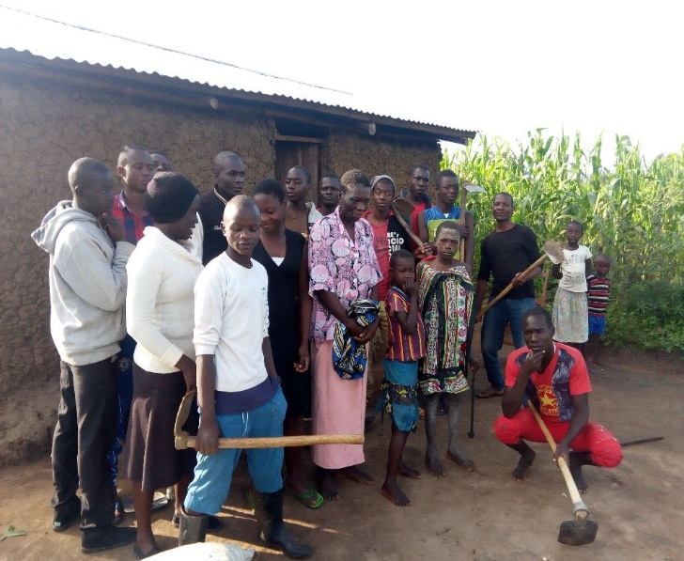
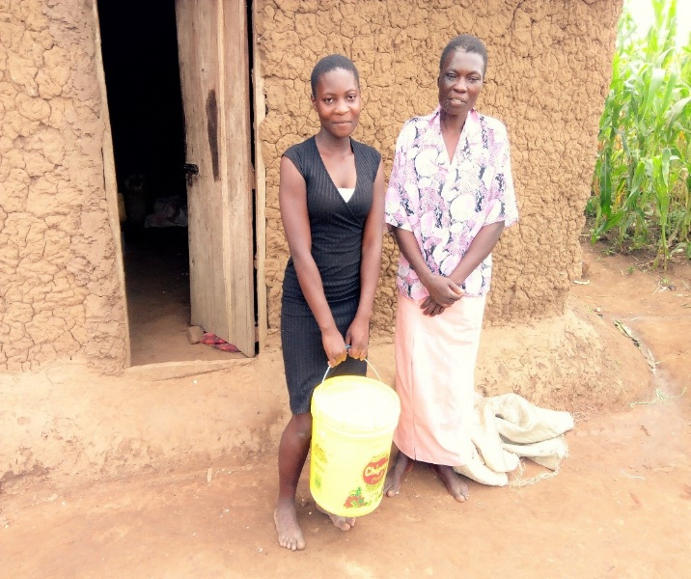
Update: Immacuate’s mother passed after being hospitalized. We are not sure what will happen with the land and her little brother. She is blessed to be at Living Hope for that is where she can stay until she graduates. She will need some extra funding. Praying her little brother can find a good home and can continue to go to school. Very sad!
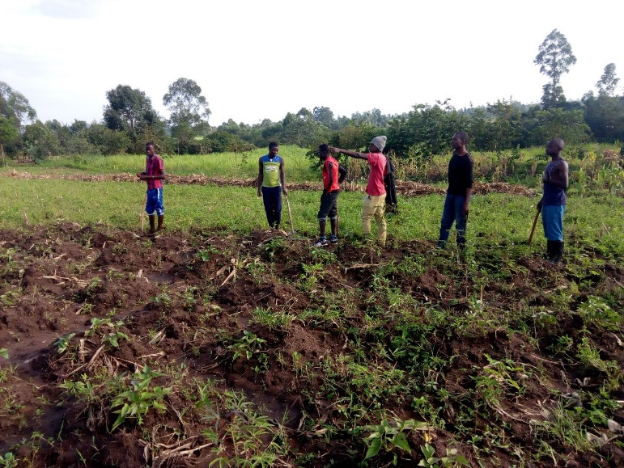

Jesus Calls us to help the least of these!
Several deserving students need some assistance to continue their education. If you, your church or any group would like to help them please contact Helen Markwell-304-567-2254 or helenum@spruceknob.net

Upcoming Announcements!

Mission Team traveling to Living Hope January, 8-24, 2019 Prayers for team, trip and if anyone would like to donate to project materials please send them to Riverton UMC P.O. Box 23, Riverton, WV26814 Memo line- Project Materials- January VIM Team. Good Christmas Gift!

Mission Team Training: September 29, 2018-8:30-3:30pm Augusta, WV. For registration form contact Sandy Binotto yashe4jc@hotmail.com Class size 12- There will be another Class on October 27, 2018 anyone leading a trip needs to have training from their Conference VIM Coordinator or others who have lead teams and have experience in this field. If you would like to lead a team to Living Hope You may Contact Sandy for help and information.

Helen Markwell –
US coordinator
helenum@spruceknob.net
1-304-567-2254

West Virginia Mission Team Coordinator
Sandy Binotto
yashe4jc@hotmail.com
304-839-1505

