Living Hope High School
P. O. Box 2376
Bungoma,
50200 Kenya
Email: marilynkuhl59@gmail.com
info@livinghopehighschool.org
website: www.livinghopehighschool.org

Newsletter- January/February - 2018

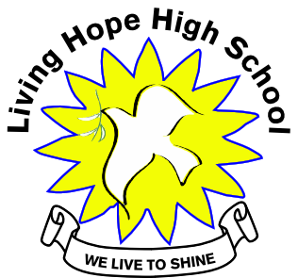
Update on Mum Marilyn
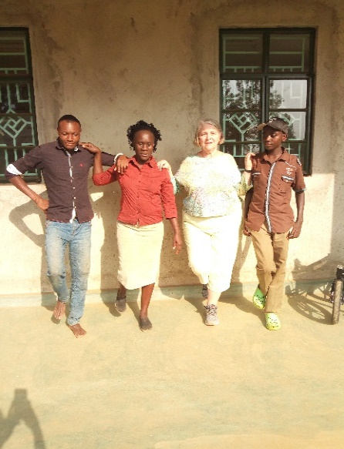
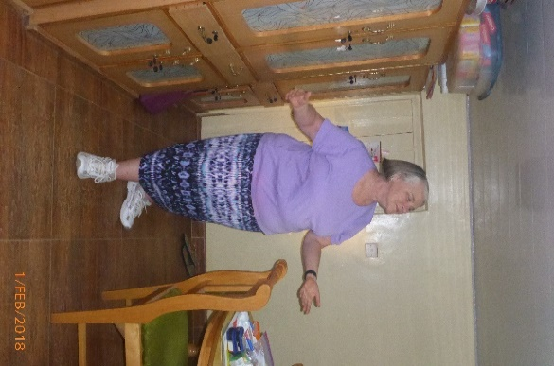
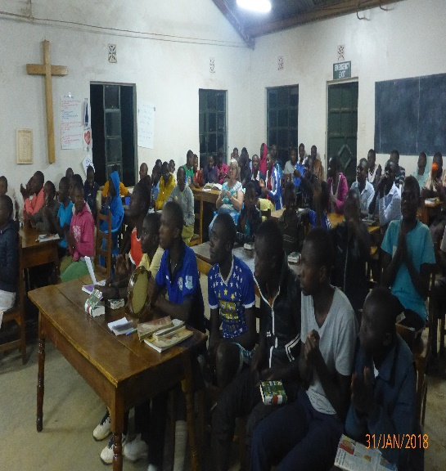
Marilyn finally made her way back to Living Hope High School after being in the states since October. After many tests and therapy the Dr. released her to return to her beloved school and students. Although she still gets dizzy at times she preservers and trudges on with the students by her side. Marilyn planted her feet back in Kenya on January 9th at the school and was present on January 14th when the twenty one new Form 1 students arrived. She was so happy to be back home!
Praise and Worship time with the students.
Marilyn doing her exercises with several students and cook.
Marilyn Praising God for her new skirt and the VIM team!

New Form One Students Arrived

Twenty one new Form One students arrived to their new home at Living Hope after leaving their villages and families behind. I am sure many of them came with the first day school jitters. The twenty one were picked from 200 applicants. I was told some left in tears when they found out they weren’t picked. Surely many of them will return next year to try again. After getting settled into the cottages, they found a bed with new sheets, pillow and a blanket along with other items such as toiletries. This would be the first time some of them have ever had a bed to sleep or get three meals a day. They would be welcomed with open arms by the Form2, 3, and 4 students already there. Living Hope High School is a family and all take care of each other.

Many of the Form one students do not have sponsors. If your heart is moved to take one of these wonderful and beautiful students, I assure you, you won’t regret it. If interested in sponsoring a student you can contact Helen Markwell at @ 304 567-2254 for more information on how to sponsor these needy young boys and girls. Living Hope takes the brightest and the poorest in the area. The cost is $88.00 a month. Church groups are encouraged to make it a joint venture. You can sponsor as an individual, youth group, Sunday School Group or whole church. I suggest you pray about it! As of March 15, you can read their biographies and view their pictures on our WebSite livinghopehighschool.org. This might give you a better idea.

The New Form One Students Here are two new Form 4 students.
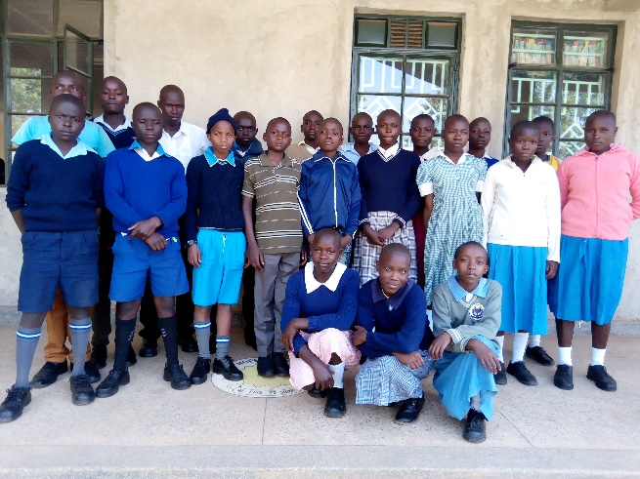
(Highlighted are sponsored already)
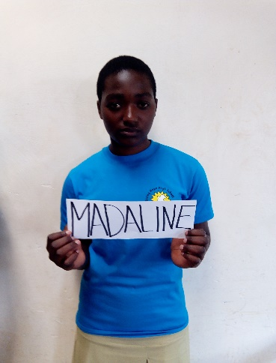
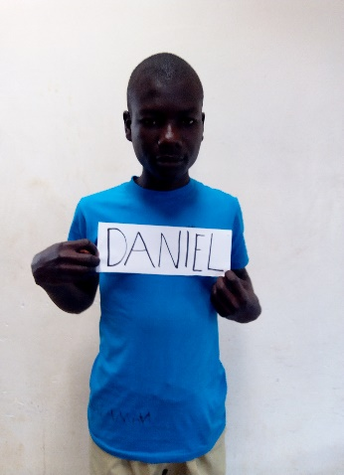

Daniel is a humble boy good at praying and dancing. He doesn't talk much, but he is used to smiling most of the time. They are grateful for their welcome at Living Hope.

Girls
Madaline is a young Christian
Girl. She has a good voice to
sing and praise God.
She was the CU chairlady
at her former school.

Boys
1.Samwel Wakoli
2.Johny Kwate
3.James Rabilo
4.Isaiah Wanyama
5.Farith Tiema
6.Evans Simiyu
7.Evans Wasike
8.Eugine Wiraka
9.Brian Wafula
10.Bhailey Migiro
11.Amos Kundu

1.Yvette Barasa
2.Phanice Barasa
3.Joy Nyongesa
4.Jamillah Wekesa
5.Joan Simiyu
6.Immaculate Wekesa
7.Elcah Wanami
8.Dasha Muchwenge
9.Brenda Simiyu
10.Betty Masika

FORM FOUR
Girl-Madaline Nafula Simiyu- she is just a one year sponsorship
Boy-Daniel Namasaka Barasa-he is just a one year sponsorship

The Bridge
Sometimes the Lord gives us a dream and vision. We can say “oh gosh that will never happen.” And then sometimes we say “With Christ all things are possible.” That is exactly what happened with team member Karl Barth who went on the January 2017 team. He was an Engineer Professor at West Virginia University. While in Kenya and at the Living Hope High School, he got the God idea of building a walking bridge for the community near the LHHS. It would help those who had to walk so far to fetch water and tend their crops in little plots. He met with other Kenyan bridge builders and the local owners of the land where it would be built. The land owner would not agree after the meeting, so the site was moved a little further down the river. After meeting with another land owner, the chief, and the LHHS asst. director the plan was put in place. It wasn’t without its challenges, but as we all learned, the Lord was in control. Karl presented his plan to his church (Avery UMC, Morgantown) and by Marilyn Uhl and Sandy Binotto. Soon a team was put together and plans on the other side were made. On December 16, 2017 a team from Avery UMC and several others and one of his students embarked on the adventure. Many helped make this dream a reality. Donations came from all over the WV Conference and the WV Foundation. A Carnival fundraiser and individual donations poured in. God certainly had his stamp on the whole process. Many of the Living Hope graduates and students who didn’t go home for the Christmas Holiday stayed to help with the digging. Local villagers were hired to help, the whole project blessed so many people. The work was hard and physical as the temperature reached over one hundred degrees in the afternoon. Almost all of the work was done manually. The project was blessed to have a cement mixer but the concrete had to be passed in a conga line into a deep hole filled with rebar to make it sturdy. Phase one was completed just before the team prepared to leave. Stage two will be finished by March by “Bridging the Gap in Africa” and locals. This is a dream come true for so many. Villagers came to see what the Mzungu (white people) where doing. After finding out they gave us a smile, a thank-you, and handshake which made the trip really worthwhile.

Hard Manual Labor
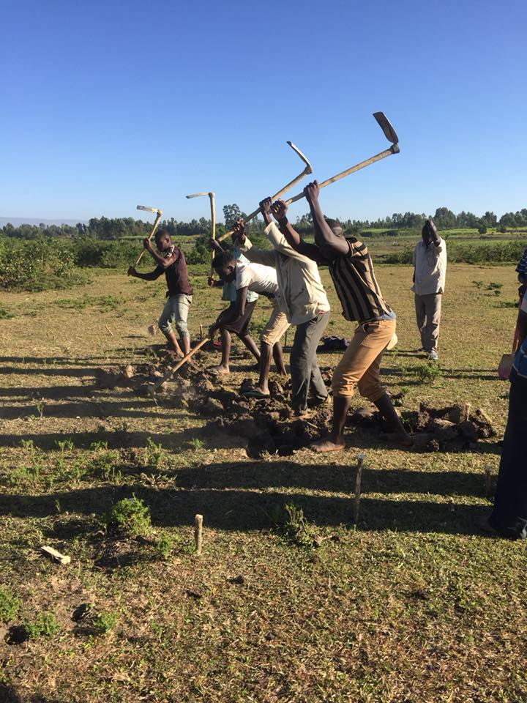

Bridge Team: Left to Right Bottom Row
Thomas Williams, Robbie Tennant, Karl Barth,
Katherine Barth, Claire Garner. Back Row, Ward Ries,
Emma Williams, Ben Moorehead, Fellow Worker and
Rev.Jenny Williams sitting on ledge.
(Sandy Binotto took Picture)

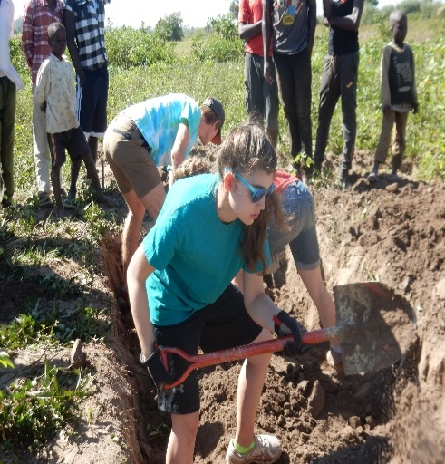
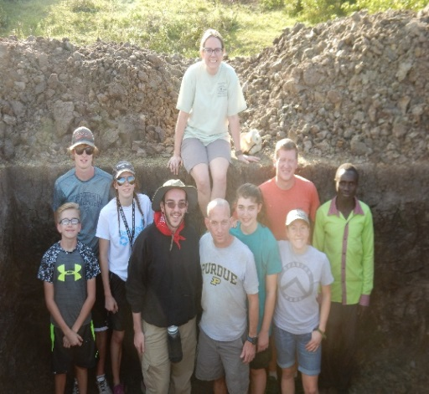

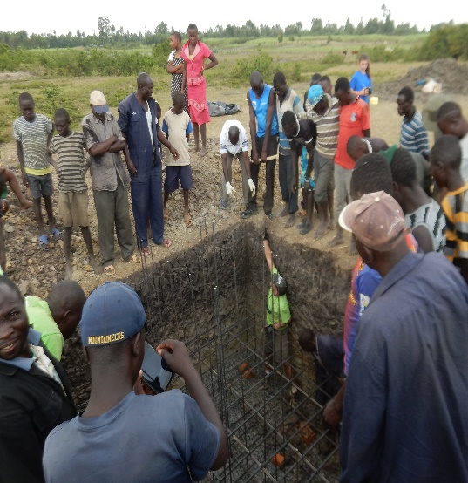

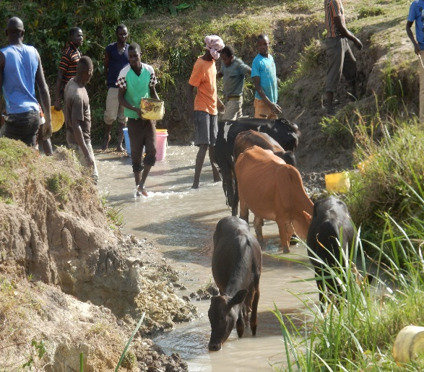

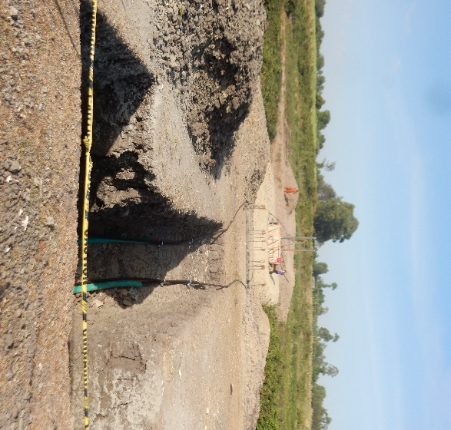
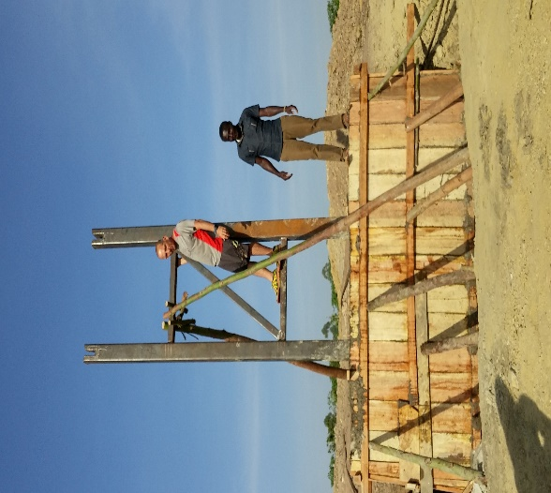
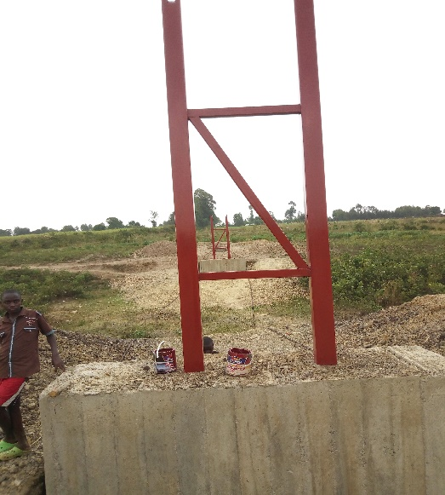

This New Bridge will now help solve so many problems, flooding, easy access to crops and safe passage from one side to the other.

Team Two
One team heads back to the states and another one prepares to arrive. Two other former
team members returned with two other couples. They were a Community Bible study group from
Winchester Va.
Dave & Roseann Rhinehart (spouses)
Bruce Goad & Gail Cox (spouses w/ different last names)
Steph and Steve Arnold (former VIM team members)
The project was to refurbish the kitchen and bring medical supplies and clothing to the school and community. Mission accomplished!
They also went into Bukembe to pray for anyone in need and meet the local people. It was a huge success.
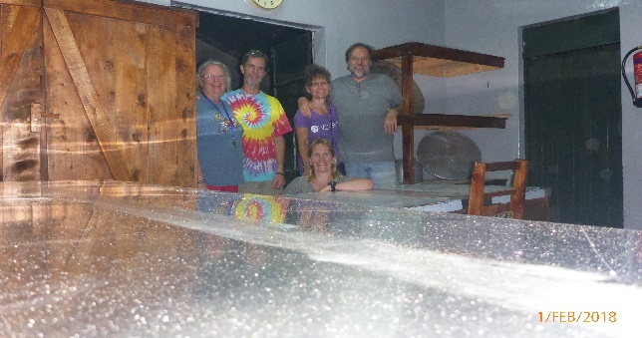
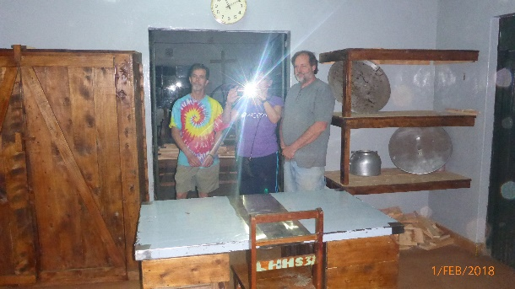
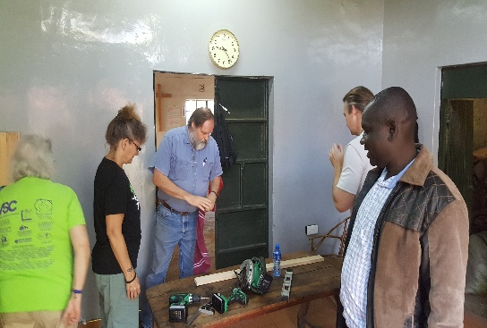
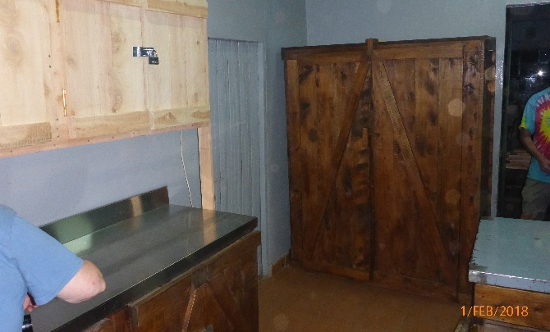
They then took a day and went to meet with John Kariuki and his team, meeting AIDS affected children and adults, learning about the ICARE program and the Nucleus Children's Trust program, delivering medical supplies, and meeting with the clinic and hospital staff.
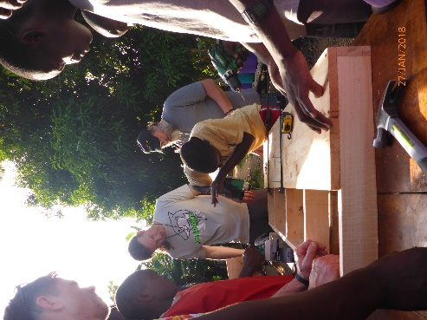
Lastly, a beautiful updated kitchen with stainless steel tables and plenty of storage!
Living Hope High School has been so blessed to have wonderful and skilled Volunteers who come to share their gifts and talents with the students at the school. They get so excited when they hear teams are coming. Students, the community, and many others get to make new friends, learn new skills and most of all feel loved! This school was a dream and vision of a woman (Marilyn Uhl) who listened to God’s calling and obeyed.
Let us all do the same. When we hear the still small voice of God, may we step out in faith and reach out to those who He calls us to help and love. So many people have helped to make this school a reality and we thank so many for their prayers, donations and love!
March’s newsletter will have Team Three’s story at Living Hope and some wonderful stories of Hope, Endurance and Love. Stay Tuned!
If you are interested in forming a team to Living Hope High School please contact:
Sandy Binotto at yashe4jc@hotmail.com- 304-839-1505. Or if you would want a speaker one can be supplied for you!

The length and breadth of our influence upon others depends upon the depth of our concern for others. Anonymous

In Christ-Helen Asante- Sandy Binotto

