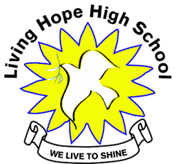
Living Hope High School
P. O. Box 2376
Bungoma
50200 Kenya
Email: marilynkuhl59@gmail.com
info@livinghopehighschool.org
website: www.livinghopehighschool.org

June/July Newsletter 2018
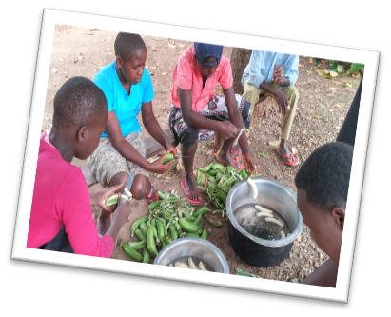
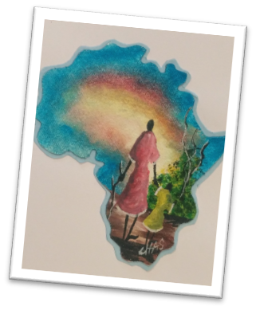
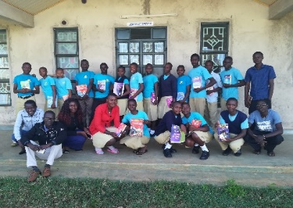
Mission to Bungoma, Kenya
Living Hope High School
Dates of Trip
January 8-24, 2019 returning home the 25
Projects:
Building a Pavilion to be used as an outside Learning Center
Updating a Classroom
Teaching Art/ Music and other Workshops
Bible Study in evenings
Approximate Cost: $2,500-$2,700
(Includes Safari)
For team application/questions, please contact
Sandy Binotto: yashe4jc@hotmail.com
304-839-1505
Deadline for application is July 20, 2018
4 spaces left

What does it mean to be in Missions?

Why do we do missions? Because God calls us to. God is a Missional God and he created Missions. Once we have a relationship with His son Jesus Christ we see things through different eyes. His passion for people becomes our passion too. We see the pain that others are suffering and we want to help. It could be just being a listener, hearing the need and finding a way to meet it. It could be using your talents and skills to help build, teach, or make someone well using your medical skills. What do you have to offer? There are many mission opportunities out there.
Going on a short term or long term mission will totally change your life and how you see things, and others. “Mission people were a different breed of people” I was once told. What is your church doing in missions? What are you doing in your neighborhood, your community, state or around the world? You don’t have to go to help. Prayers, funding and items are needed. School bags, pencils, medical supplies. Maybe you can’t go but you could be help for someone else who can go! I encourage you to consider doing something if you aren’t. If you would like to help Living Hope High School please make contact with Helen Markwell- 304-567-2254, helenum@spruceknob.net or Sandy Binotto- 304-839-1505- yashe4jc@hotmail.com.

Mum Marilyn Arrived Back to States

Marilyn arrived back to the states safely and one of the students Naphtal Sikuku accompanied her. Naphtal a former Living Hope High School graduate, was to visit the states with some past mission team members and was also given an opportunity to work at a Camp. God was at work for the first camp didn’t work out, but he was then given a job at a UMC Camp in Ohio. He is much happier and can praise the Lord, play his guitar and get paid more than the first camp. God is so good and it was a great learning experience for all of us who were in prayer as to how the Lord works. It is a dream come true for Naphtal to come to America and we thank the Lord for his sponsors, hosts and friends who made it possible.
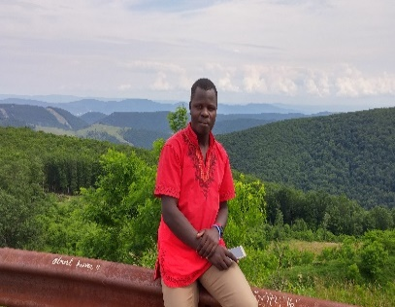
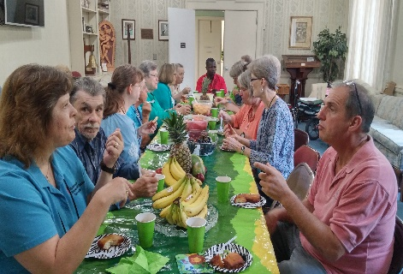
Marilyn is getting some good old R&R for being a director and running a school in Kenya can be a big challenge. She got a good medical checkup. Spoke at a few churches and attended the WV Annual Conference. The Kenyan breakfast was a great reunion for many of us who have traveled to Kenya and to the School. She also met with team leaders who are planning more trips for 2019. She’s now back in Kenya and the school will be hosting an eye clinic July 13th.
Please be

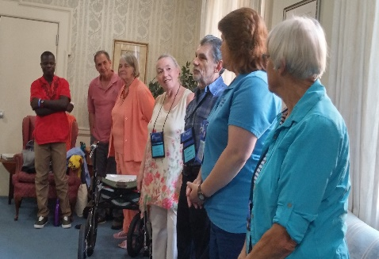

Donations Needed for Living Hope
Funds are needed for:
- Typhoid Vaccines for all 86 students to be given in January 2019
- Medication funding is needed to treat ill students when they are sick
- For the New Bible Center Pavilion
- Art Supplies for Art Classes
- For 10 students who have gone onto college without complete funding
If you would like to donate to any of these needs just mail the donation to Riverton UMC, P.O. 23 Riverton, WV 26814 and note in the memo line what it is for.

Latest Happenings at Living Hope High School

Living Hope Mentor-ship program

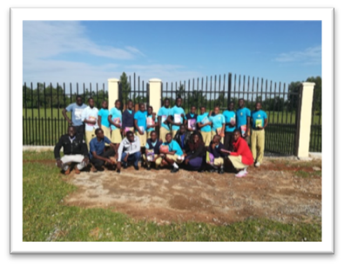

Ezekiel Alumasa, Purity, Andrew Nyongesa and Philip- Mentor Leaders
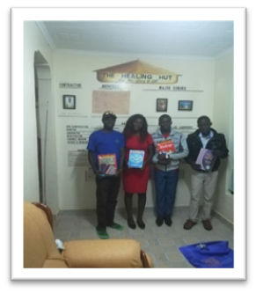

Ezekiel Alumasa graduate of LHHS. Chef in training. He cooks for VIM teams!

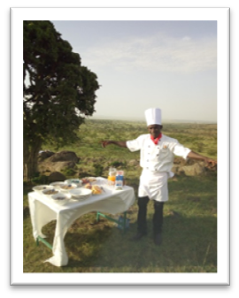

Backpacks wanted!

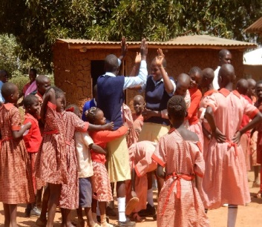
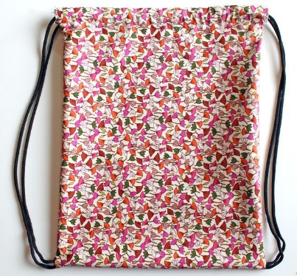

Looking for sewers who could make drawstring backpacks. Each year when our team returns to Living Hope we visit the Victory primary school down the road from the school. There are about 125 children who go there at a given day. The teams along with the Living Hope girls visit one or two days to play games, sing songs and just have fun with them. They are so in need of a back pack of some kind for their school books. I would love to take at least 125 of them when we return in January. If your sewing group, UMW would like to make some, please let Sandy Binotto know. We will also purchase some school items in Bungoma to put in the backpacks. You can find patterns on Pinterest or just Google Kids backpacks.
We also need some sewing volunteers for 90 seat cushions. Call Sarah Fletcher at 304-642-4061.

Leonard Wakhungu- Living Hope Graduate

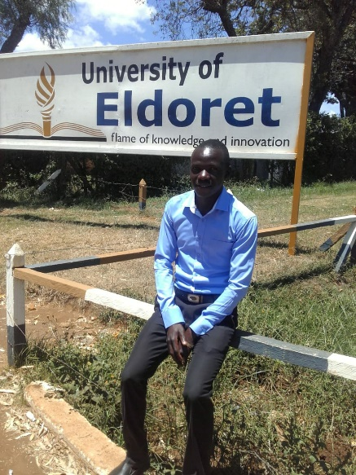
Here is my story;

I am Leonard K.Wakhungu, 2014 Living Hope graduate. I attained a average grade of B-(minus) and I was lucky to be sponsored for my tertiary Education by my beloved sponsor Pastor Robert Baer. I was among the a few blessed LHHS graduates for the first time to be able to join a University. I am the only child in our whole family (extended) to join a university. It was the greatest miracle in my life and to my family! I was so happy, not just because I had joined the university, but because I saw my dream to become a 'change agent' to my community was coming true.
My mum struggled with poor Agricultural facilities and techniques to grow maize and sugarcane on a 3/4 acre piece of land after my dad passed away to feed us and pay for our education. It was a very hard life for six of us at home to survive.

During my primary Education, I was disturbed because of the life we were living depending only on a poor agricultural production. I developed interest in finding a solution to poor agricultural practices so that I can help not just my mum but the community and my country. This led me to the course I am taking now at University of Eldoret; one of the best agricultural universities in Kenya. I am taking Agricultural Extension and Education. Currently I only have two more remaining semesters (one semester at school and one semester in the field attachment), and then I’ll be finished with my degree.

However, it is quite unfortunate for me because I am supposed to be attending lectures for my last semester but I haven’t reported back yet because of financial crisis. My sponsor Pastor Baer developed a health problem which forced him to reallocate his finances. So he is only able to sponsor me partially now. This money has been of great help to me because it has kept my dream valid despite it being not enough. I thank God for getting me this far. I really appreciate Pastor Baer for his faithfulness. He has always kept his promise. He has also been a great pillar in my spiritual life because whenever he has emailed me he always has a spiritual word for me.
I’m so grateful for Pastor Baer to be in my life, I really thank God for this great gift in my life.

It is with a humble heart that I am sharing with you my story, requesting for your help and contribution so that I can join my classmates and finish up my remaining semesters. I am hopeful that our heavenly Father is soon opening doors for me.
Thank you so much for having time to read my story and even praying with me at this moment.
Amen! Leonard

Living Hope High School is an Advance Special of the United Methodist Church and a supported ministry of the West Virginia Conference.

Your donations and support are greatly appreciated by the school and students.
They never thought their dreams would come true, but with your prayers and support these wonderful young adults are changing our world.

“I shall pass through this world but once. Any good thing, therefore, that I can do or kindness that I can show to any human being, let me do it now. Let me not defer it or neglect it, for I shall not pass this way again.” Stephen Grelet
Helen Markwell –
US coordinator
helenum@spruceknob.net
1-304-567-2254

West Virginia Mission Team Coordinator
Sandy Binotto
yashe4jc@hotmail.com
304-839-1505

