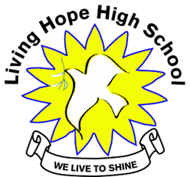
Living Hope High School
P. O. Box 2376
Bungoma,
Kenya-50200
Email: marilynkuhl59@gmail.com
info@livinghopehighschool.org
website: www.livinghopehighschool.org
Newsletter December 2019-January 2020

Praise God from whom all blessings flow!
Living Hope Graduates – By Marilyn

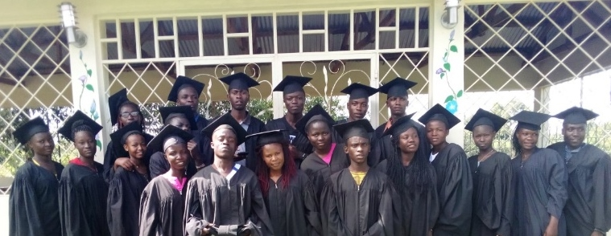

First let us say Thank you so much for giving us a wonderful day to remember our time at Living Hope High School. We know that without Living Hope we would not be prepared for life.
Now we are ready! We got the grades back from our KCSE test and we were number 3 in the county, out of 341 schools. We had 17 students scored a C+ or better, with 4 scoring a B+ as our high mark. You must score at least a C+ to be considered for university or to get the direct entry tuition scholarship from the government. We are so proud of our fellow students, teachers and administration. The hard work was worth it!
The graduation went smoothly and all of the grads were present. Although four were late and did not get a cap and gown picture. We had two wonderful guest speakers. One was a lawyer who came from nearby. A local boy who overcame poverty to be a lawyer with three offices. He spoke about the “power of choice”. He also talked about the challenges of being a Christian, honest lawyer. The second speaker is a lecturer at a university and does career counseling. He gave us many hints to choose a program that we are interested in and that is marketable when we are done.
Then the grads took the parents and guests on a tour of the campus while the older grads set up the tables for a delicious 😋 meal. They cleaned the pots and nothing was left. Just right. We had a beautiful, decorated cake. We ended with a prayer for the graduates for their protection and future.
Thanks to a special donor who sent us $500. We spent $435. Most of the expense was the 18 chickens! The rest we will use for the Parents Day on Jan 11. It will be the first time for the new Form 1 parents to be part of us. We will have soda and a pack of cookies for each one. A good time for all!
May God bless you abundantly!
Living Hope High School Graduates 2019
Abraham Barasa, Annah Busolo, Benjamin Wafula, Centrellah Wabwile, Diana Barasa, Diana Wanyonyi, Edmond Manyasi, Elizabeth Pepella, Elizabeth Wanyonyi, Emmanuel Wakhima, Ephraim Wafula, Ester Mukhwana, Fednard Wamakacha, Fred Wanjala, Joan Marani, Jones Wanyonyi, Joshua Nyongesa, Lavendah Wasilwa, Lucy Wanjala, Malkiel Nyalita, Martin Omenda, Mercy Injeti, Meshack Nyongesa, Naomi Wafula, Stellah Simiyu

The Coins
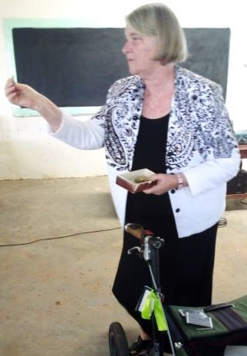
30 years ago, Lavonne, our volunteer accountant in America, received her birthday gift from her father. It was $30 silver dollars in this box. Then she put it in the back of her drawer. Several years ago, she decided to give one silver to each graduate. The tradition is that, the graduate gives their first born the silver dollar when their sons or daughters graduate from high school.

Top Students
Benjamin Wafula and Naomi Wafula top students 2019.
Benjamin Wafula wants to go to law school.
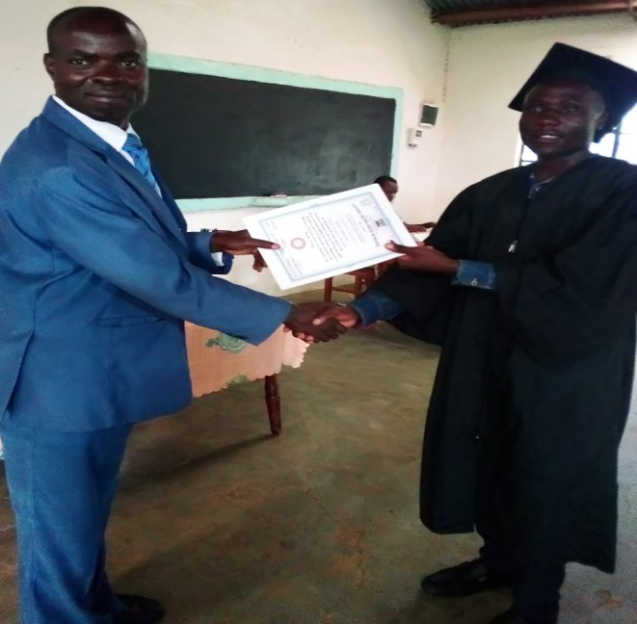
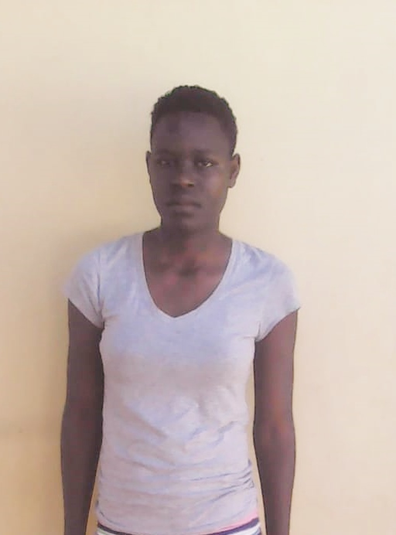

Praise Him all creatures here below!

Mission Team arrived at Living Hope

December 30, 2019 an eight member team left for Living Hope High School. They will stay at the school for 12 days and leave for a journey to do a short Safari and then onto Nairobi for some sightseeing. While at Living Hope, they did a 3 day VBS for the community’s 65 elementary students. This was concluded with a student presentation for parent’s day. Then the following week they will be doing some construction, painting and doing workshops in the afternoon that the students will attend. During the evenings, everyone participates in Bible study and worship, and other fun activities.

Please keep Karl Barth in your prayers as he was a team member, but had to drop out last minute because of a medical issue where the doctors wouldn’t let him travel. We are very saddened by this, but know he is in God’s hands.

We will hear more about the mission trip when they arrive back to the states in a couple weeks. We are sure God has been blessing them with many wonderful memories and hearts full of worship.

Praise Him above ye heavenly hosts!
Grad Dorm
Living Hope has been so blessed to have graduates to return while the mission team is here. This year the graduates and mission team are painting the large dining hall (main building). They are making the homemade bricks and building a graduate dorm. When this is completed they will have a place to stay when they come back to campus. This will allow for a much more comfortable accommodation for the graduates and current form 1 -4s.
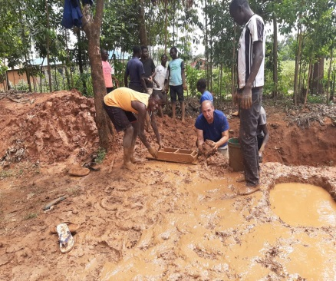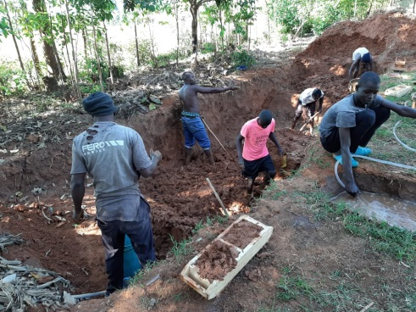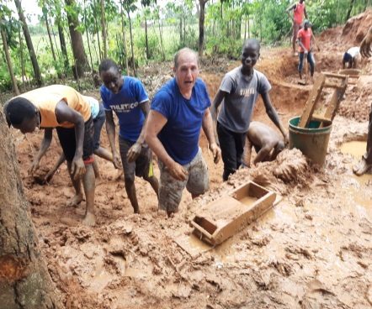

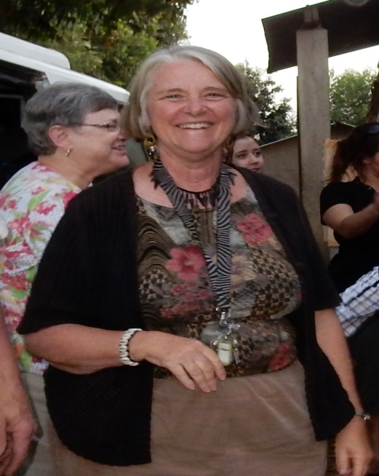
Praise Father, Son, and Holy Ghost!
Looking for Replacements
By: Helen Markwell

Marilyn received the vision to start LHHS in 2009. We’ve spent the last 10 years of our lives, totally devoted, to growing the school and setting the standards. We have invented ways to make Living Hope High school an outstanding and a coveted place in the community of Bungoma to attend high school. LHHS has graduated more than 150 students, giving each an excellent Christian high school education.

Next year Marilyn will be 69 and I will be 73. Our best years as educators are behind us, as are our best years of health and vitality. It is time for us to start thinking about passing the torches. We are looking for both someone to replace Marilyn’s position, and my position here in the U.S. Marilyn wants to stay in Kenya to continue to see her vision flourish and help with the transfer of leadership.
We are both very willing to mentor and guide our replacements for a year or so. Below you can read about both of our job descriptions.
Marilyn’s job description:
At school:
-Supervise all support staff (one accountant, two wood choppers, three cooks, one personal cook, a matron and boarding master, three watchmen, one driver and one school nurse) and make schedules & pay them weekly
-Control daily petty cash payouts, writing checks, and tracking daily expenditures
-Responsible for all maintenance (major and minor repairs and building projects) Most of the major repairs happen during breaks while the students are home. Dec-Jan, April, August
-Responsible for textbook repairs and ordering new ones, getting donations for replacements.

-Conduct interviews and select new form one with the school administration every December
-Compiling their stories and having them posted on our web site to help get sponsors for each student for four years.
-Responsible for organizing the graduation, graduation dinner and guest speaker, and the Christian Union appreciation dinner.
-Obtain, sort, and store and distribute supplies from America on as needed basis ( to include pens, pencils, backpacks, warm hats, sandals, shoes, socks, handkerchiefs, Jackets, sweatshirts, etc)
-Help organize mission teams and all aspects of their on-site projects
-Teach the clubs in the afternoon, assist with fieldtrips, and participate in home visits
- Write thank you notes to all donors who have helped us to make Living Hope successful and a reality

In the U.S.(two times per year):
-Acquire donations to supply the new form ones coming in Jan (welcome kits, school t-Shirts, Gym shoes, donations for vaccinations and the first aid class for form 2)
-Responsible to be sure needed supplies (student Bibles, mattresses, blankets, sheets, pillows and mosquito nets) are donated by our church donors.
-Visit churches and organizations to introduce people to Living Hope and how they can become a sponsor or donor
My sister, Helen Markwell, and I attend the UMC Annual Conference in June and run our booth for 4 days. We talk to everyone about becoming a donor or a sponsor and sometimes we have things from Kenya for sale. We also attend the WVUMW (West Virginia United Methodist Women) conference in October. We usually give a short update on Living Hope.
Many times I am called upon for individual and group counseling. I am also involved in discipline. Occasionally I am called on to preach or teach.
These jobs keep me busy full time, year around. But the nice part of my job is that I can take a day off or come to America for a month and everything will be covered by the principal and my staff.
This job has been the toughest, but the most rewarding and joy filled. I know that I and Living Hope have made a difference.

My job description:
United States Coordinator for Living Hope High School (LHHS) in Bungoma, Kenya
The U. S. coordinator for Living Hope has a broad spectrum of duties. This is made a little more complicated because all of the U.S. help is volunteer based. The duties usually entail at a minimum 10-15 hours per week. This includes secretarial work regarding student accounts, creating newsletters, and other general correspondence. Living Hope High School pays for all secretarial supplies and postage. Below is a list of the majority of other things the coordinator does:
- On average 2 speaking engagements per month regarding fundraising for school and sponsorships for students. This usually takes 6 hrs. per speaking engagement ( includes, travel time and presentation)
- Attend official meetings of the annual West Virginia United Methodist Conference for 4 days in June in which LHHS pays for costs
- Organize and run information booth at WV United Methodist Conference for 4 days in June
- Attend and present at WV United Methodist meetings ( both district and state level) approximate 4 days per year which LHHS pays for travel and lodging costs
- Work directly with Living Hope HS director (when stateside) to collect, process, and package for shipping donated items for LHHS to be taken with mission teams as free baggage (examples : shoes, hats, welcome kits, baby clothes, medical supplies)
- Coordinate all donated supplies for LHHS
- Monitor & Update information for LHHS’s website
- Communicate with Website manager these updates as needed
- Attend Mission Team meetings (at least 2 per year in Romney, WV)
- Correspond with donors either in writing, via email, and telephone almost daily
- Sort, package and send to sponsors the monthly student letters
- Assist with Thank you notes to donors
- Other short term obligations and duties may arise and need your attention

These descriptions may seem overwhelming, but I can guarantee that neither Marilyn nor I have had a more rewarding job, ever. Living Hope High School continues to ever praise God the Father, God the Son, and God the Holy Spirit for all things.

If you are interested or know someone who is, please have them contact me, Helen Markwell. 304-567-2254

We are thanking God for all his blessings and keeping Jesus first!!!!!!!!

