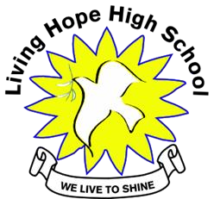
L
IVING
H
OPE
H
IGH
S
CHOOL

P. O. Box 2376

Bungoma,

Kenya
-
50200

Email: marilynkuhl59@gmail.com

info@livinghopehighschool.org

website:
www.livinghopehighschool.or
g

February 2020

Thank-You, Thank-You, Thank-You

Living Hope High School and the community would like to truly thank everyone who donated items to LHHS. Mum Marilyn Uhl packs up items and takes many of them with her on her journey back to LHHS in November. The other items like the shoes were taken with the January 2020 mission team.
Thank you’ s go out to the Pregnancy Center for the baby clothes, Welcome Kits from Donna Coblentz and family, Uniforms from the Pendleton County High School and the many shoes from the United Methodist Women and so many others.
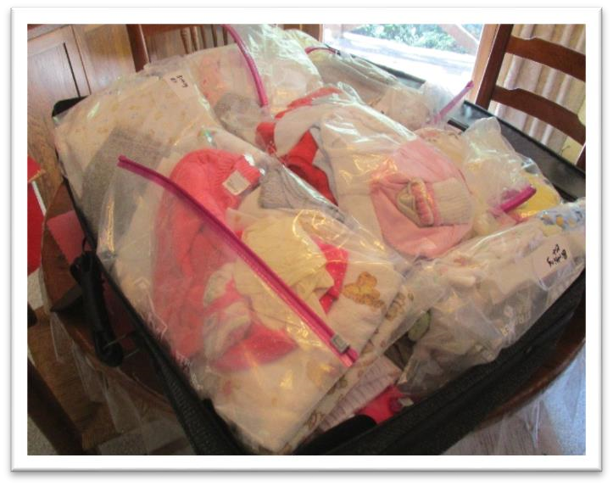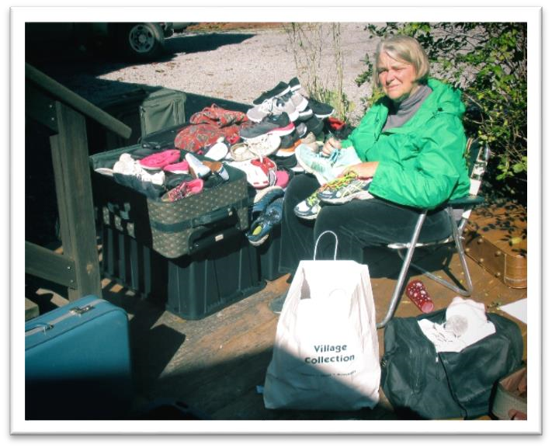

Marilyn packing shoes. Baby Clothes

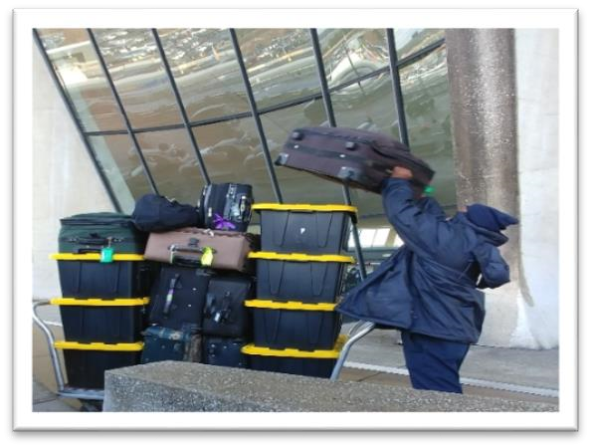
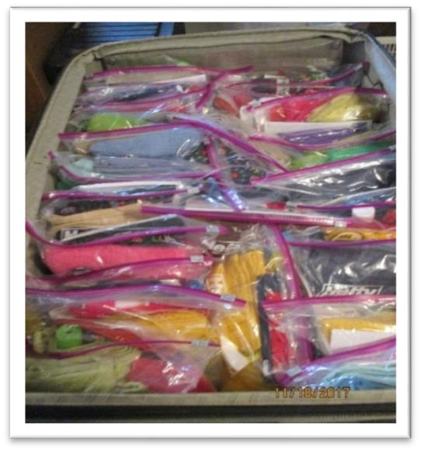
The containers of the shoes made their journey to Kenya without incident. We were very happy they made it. Just a little conversation at customs in Kenya to ask if they were new or not. If new we would have had to pay a duty on them but after some exchanged kind words we got them through. Thank You Jesus!

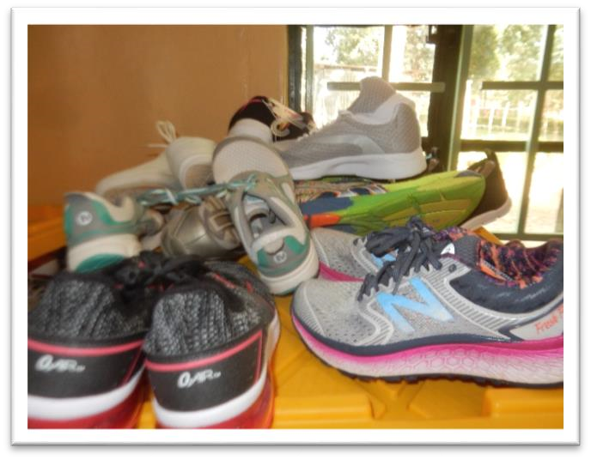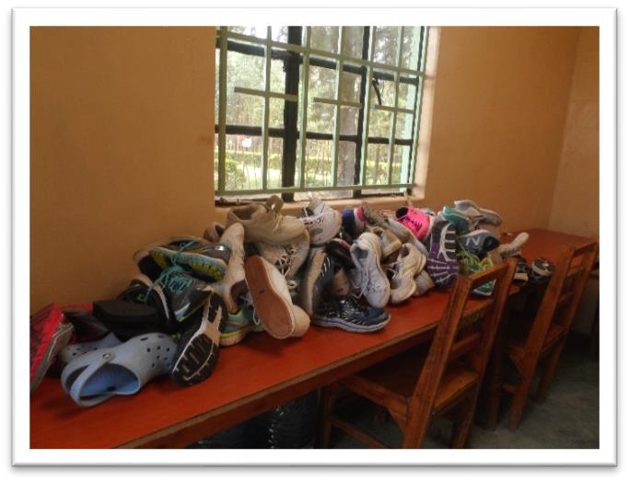

The shoes were unpacked, lined up and sized as the students waited outside for their turn to pick the shoes they wanted. Then to see if they would fit!
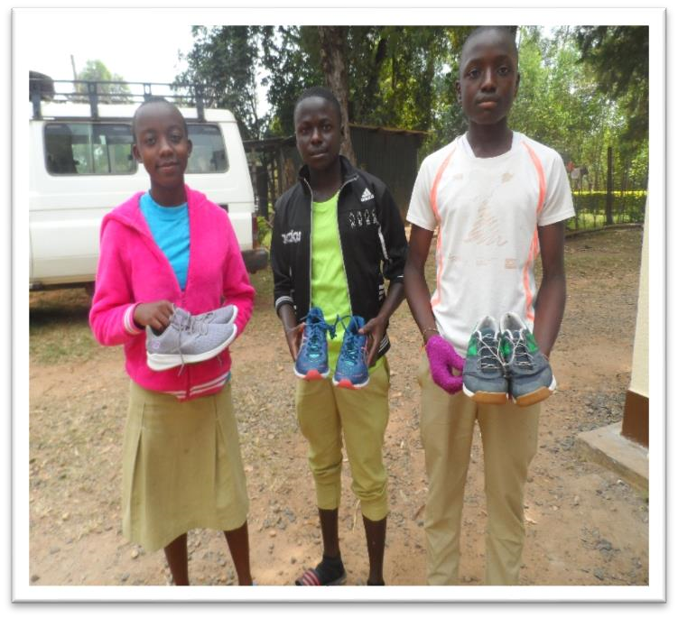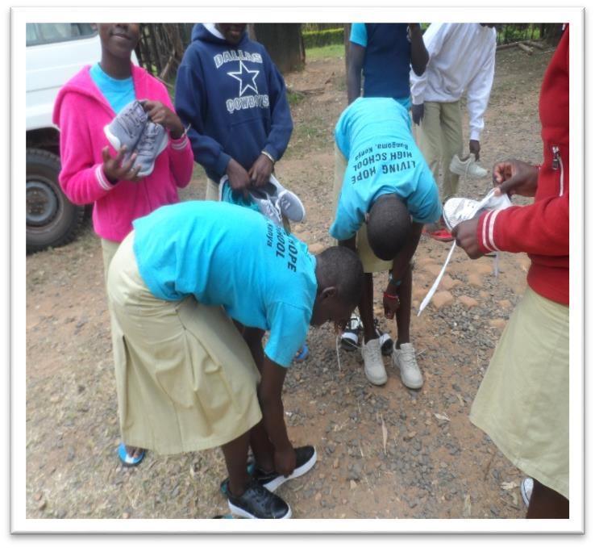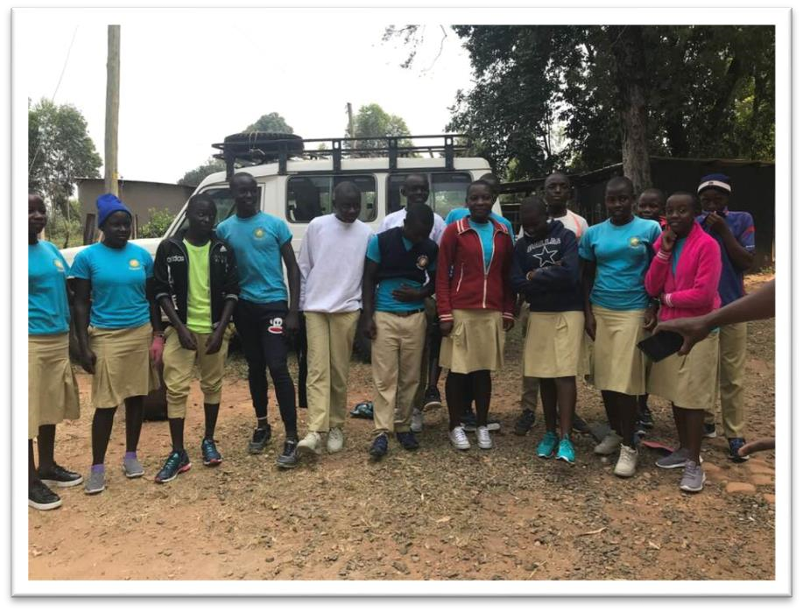

Afterwards there were smiles and modeling of their new shoes and they were so happy!

2020 Mission team to Living Hope High School- Their thoughts on the journey!

Sandy Binotto-This was my ninth trip to Living Hope High School and being the team leader for them all. Each team is different and unique. Living Hope is a place where students get HOPE. Many of them leave their homes and situations that are sad and challenging. Once you step foot on its grounds you feel Christ love, joy and perseverance. The students are grounded in education, working hard and their smiles prove it when you see them at work, singing and laughing. I have never heard a complaint while there. The atmosphere is grounded in the Love of Christ. Their love surrounds us, the team and our joy and love for them surrounds them. This year I taught 4 classes, one on Sponsorship, After Living Hope What? Journaling and Grief. When classes weren’t in session we did jobs around the school and did some home visits. My husband and I visited our son we sponsor, Grivin who is now in college and doing well. It is always a joy to visit his family and catch up. I also had a chance to visit a lady who had lost her husband and was grieving. I give her some hope, comfort and prayer. We also got to dance, shell peanuts, and teach VBS. Before our team left the students fasted one day for us and prayed and sang to us, our hearts were moved. We went on a great Safari! I finally got to see an elephant! This school holds my heart and they are my family. Thanks to a great team who brought joy, hope and laughter to many and seeds of HOPE! I also thank those on the other side who take such good care of us. The drivers, school staff, students and Mum Marilyn. Also for those at home who prayed for us and donated towards the projects.
Nancy Anderson-The January 2020 trip was my first mission trip and first trip to Africa. I was standing with a Kenyan driver at Nairobi Airport waiting for the team, all strangers, as the new decade arrived. I felt a connection to these people; we were a team on a mission. Somehow I felt at home and not afraid. Living Hope High School is aptly named. The day starts with the head boy singing a call to prayer which can be heard across the campus. Soon others join in, a joyous way to begin the day before the sun rises. The students were delightful and welcoming. I taught two craft classes, did sanding in preparation for the painting and pulled weeds around Marilyn’s cottage. I came to work and learn. The painting got done. The food was better than I have at home since I don’t have a cook. I did just fine without
a flushing toilet. The poverty is heartbreaking, but the sponsored students at LHHS have a home atmosphere at the school and regular meals. I know that the money I spent to sponsor Joan went for her care and education and not for the overhead for a charity. I spent some money on the trip which included my food, a safari, tours, two home visits, souvenirs, and airfare. I spent all the money I had with me, not that much. I arrived back at my home with five dollars in my purse, but forever richer and blessed than I was before I went to visit Living Hope High School outside Bungoma, Kenya.
Gordon Howard-I am excited to be asked to write a paragraph about my recent trip to Kenya and Living Hope High School with the VIM team. The LHHS kids were awesome. They are Christ centered, devoted to success, hardworking, and a joy to be around. I came home ready to sponsor a new form 1 student. The VIM team members were talented, caring and fun. Our leader was well organized and prepared us well for the trip. We laughed a lot, worked hard, and prayed together regularly. What an exciting way to make new friends! Sightseeing in Kenya was an enjoyable adventure. It was a thrill to see lions, giraffes, water buffalo and all the rest in the wild and digest the extraordinary beauty of Kenya. The staff at LHHS is made up of the most
dedicated people I have ever met and deserve our support. Please pray for them regularly. Moreover, it was a great bonus for me, as an active Rotarian, to have lunch with members of Bungoma Rotary club. There is a chance our two Rotary clubs can work together for the good of Kenya. In summary, it was an awesome, rewarding and worthwhile trip. I would recommend a trip like this to anyone.

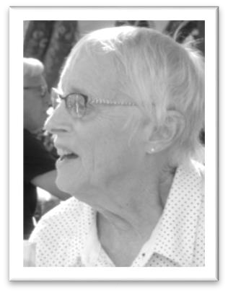
Sarah Fletcher-Gordon did a good job summing what our mission trip is about. As soon as they are able, there will be an appeal for sponsors for the Form 1 Students. Many of these students live under the most trying of living conditions and we here in America should have no real complaints about our students and their living conditions. The Living Hope Form 1 students are really looking forward to their education years. For some of the students, this is their first real living experience with three meals a day and a safe place to sleep and keep their books and school clothes safe. I urge anyone who hears about the sponsorship program to consider a serious commitment to sponsor a student at Living Hope and make that commitment for the 4 years of high school.
From Sarah Fletcher, member of the January 2020 mission team.

Paul Binotto-What can I say after my 8th trip to Living Hope? It is exciting each and every year I go! I have learned to have an attachment for the students there, because of their relationship with Christ! The school has grown now, buildings added, utilities becoming better from people at home contributing by sponsorship. Some others make a donation because of their heart or the leading of Christ. The mission teams going there have contributed greatly, but I must tell you this.... When I first went there, there was no running water and no electricity. The children were getting water from a hand dug well with a pale and a rope. We were there, that year, helping to build classrooms and wiring them for electric. The students had been studying by kerosene lanterns. We put up fluorescents and bought a generator! I watched as the whole school, students not led by adults, gathered together thanked
God for their fortune and sang praise songs to him. I got up 5am that year and
gathered with the students as they prayed out loud to God in their prayer room. With no adults leading them, I could feel the presence of God in that room! That morning as I was taking my solar shower (camping shower), I realized that I was impressed and taken by the way they loved God. Though, they themselves had no personal possessions to any extent, the students truly worshipped and loved God. At that moment I realized that I wanted to be part of what was going on there! Over the years I have watched as the school has progressed. It now has permanent electricity. It has a drilled well with hand washing stations throughout the school and a shower! New buildings have gone up, which are of course also better for mission teams now going there. But... most of all the students still praise God! Marilyn Uhl has done an outstanding job as the director of the school. That school now is one of the most highly ranked schools in the area by the Kenyan government. Which means that the kids attending there have a better chance to possibly attend university and support their families. None of this would have been possible without a leading from God! Remember this school started from nothing and brought real hope to very poor people. That is why I go back and I am quite happy to be involved with an organization that helps others. This school is well managed and does so with an outstretched arm from Jesus Christ himself. May this school be blessed and may all those who sponsor a child be blessed for their act of kindness and caring. If you join in, with helping this school, you will not be disappointed!

Rev. Larry Anderson-Jambo! This what is my fourth trip to living Hope high school! It’s always an honor to go to Kenya and meet the students and staff. Each trip is different but full of blessings. This trip was the first time that I got to help make bricks. It was a lot of fun getting in the mud and stomping and carrying the bricks. The New students arrived and attended one of our classes, and 16 of the children accepted Jesus as their Lord and Savior! Glory to God! Like all mission trips, we always get to meet new people and have new relationships! We had a lot of fun, a lot of laughter and great memories. Looking forward to the next trip and many blessings to Paul and
Sandy for leading the teams! Many blessings to Marylyn and Helen and the
rest of the volunteers! Please continue to pray for living Hope high school and all the students and staff!

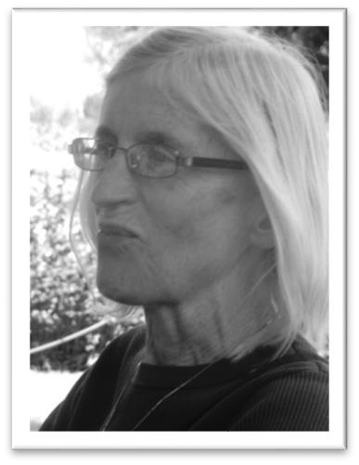
Ann Warner-For four years, as a sponsor of a Living Hope High School student, I received delightful, heartfelt letters from my “African daughter,” now a recent graduate. We were both pleased to finally be able to meet in person during my two-week stay at the school, part of a slightly longer stay in the beautiful country of Kenya. “My girl,” as I have come to think of her, though quite reserved, is like so many of the students: diligent, respectful, and reverent in faith. No wonder so many people continue the sponsorship of their LHHS students during college! These students have struggled with poverty, challenging high school curricula in a second language, and the ups and down of living in close quarters with so many other people. Yet, they treated us so deferentially. I came to realize that were are like angels to them – because God is working through us to better their lives. We are merely willing vehicles of God’s love. Love was clearly evident during our trip: in the wide eyes of the VBS children who looked up to the head boy as he instructed them in singing and dancing, in the expressions of concern around Marilyn’s kitchen table for various current and former students and staff, in the developing relationships between students and their sponsors, and in the new friendships formed among team members. Yes,
Living Hope High School lives up to its name. As was often said during among our team members, “it’s a God thing.”

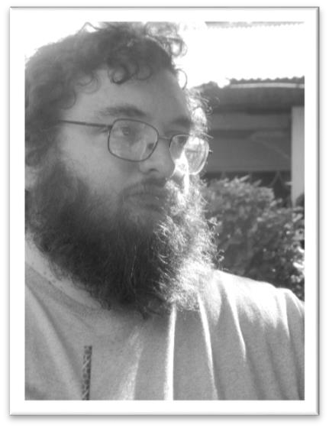
Rev. Daniel Fulton-I don’t really know where to begin with talking about
Living Hope. What an incredible trip! During the week that we held our “clubs” I got to spend some extended time with about a dozen of the Living Hope students, as Pastor Larry and I shared with them about evangelism and spiritual formation. I was really impressed with the heart for evangelism that the students demonstrated, as well as a deep knowledge and understanding for the scriptures. It was clear to me that the students had a strong faith in Christ that shaped their lives. I love that Living Hope High School is instilling such strong values and Biblical knowledge in their students. I came to really get to know and love several of those students, and through our prayers and letters will continue to encourage one another, I’m sure. It sounds cliché’, but I really do feel like the students were at least a much of a blessing to me as I could have been to them, and perhaps more so. I hope someday the door is open again for me to return to them.
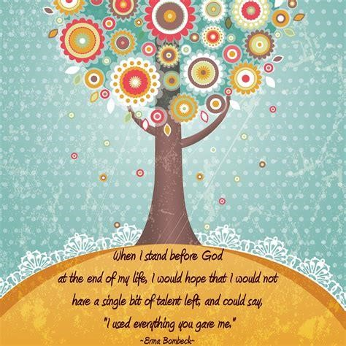

Around The School
A Few Pictures of a day at the School. Painted buildings, washing clothes, making bricks and eating lunch, Ugali and Kale. The students are always busy and working hard. They love teams coming and visitors!
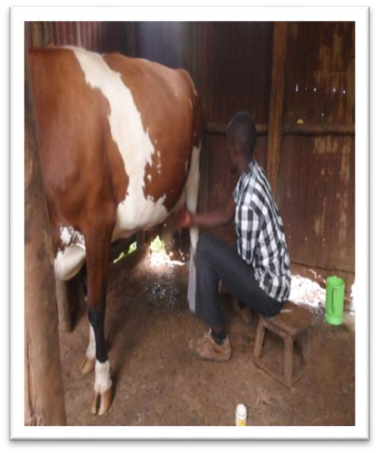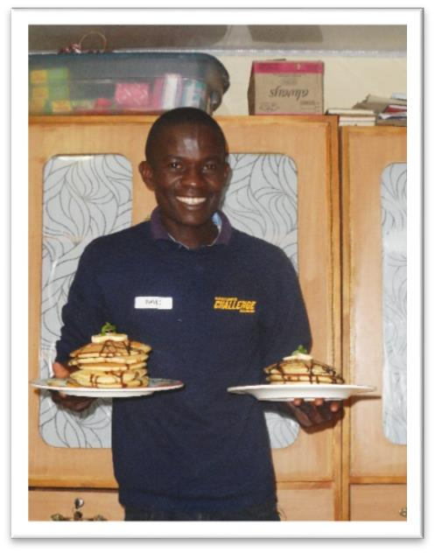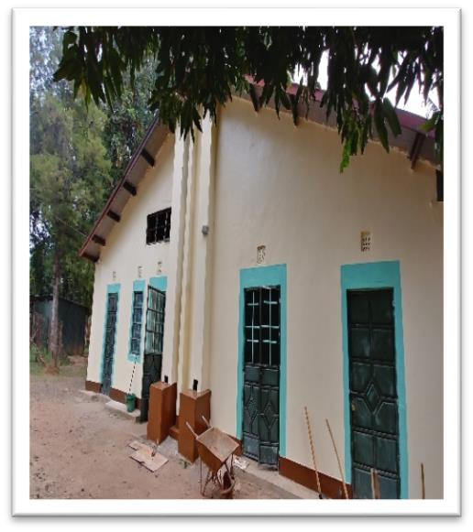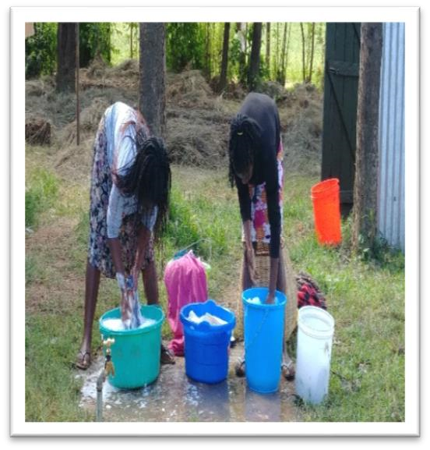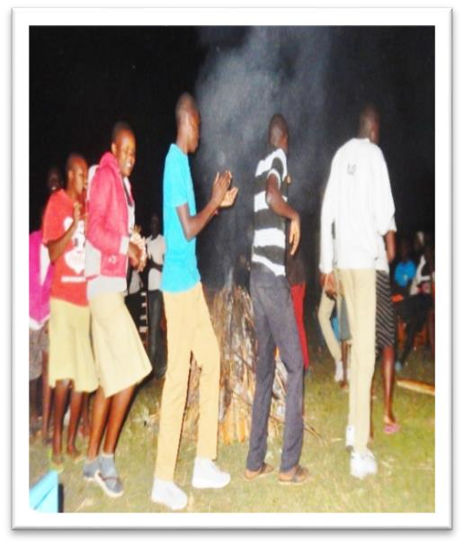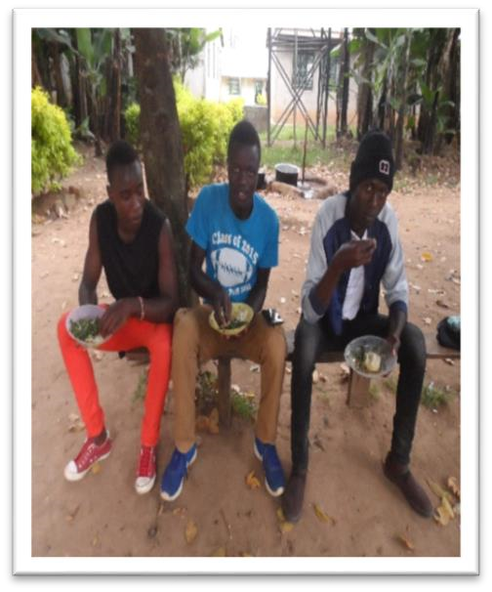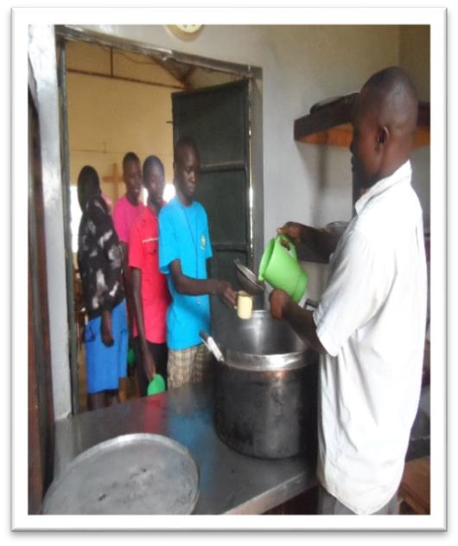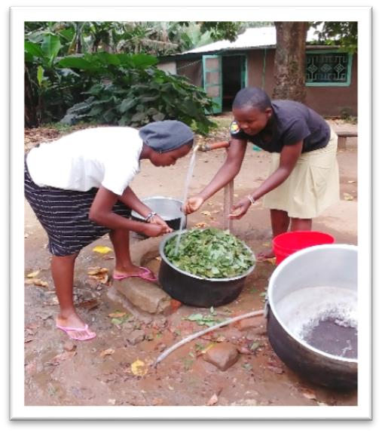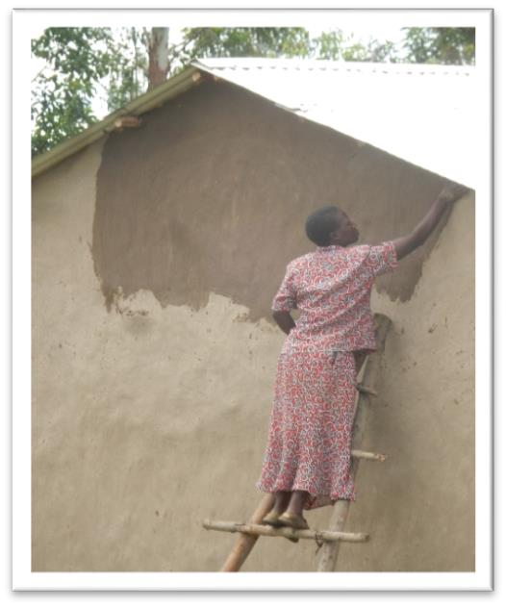

A Living Hope Reunion is being planned for summer for sponsors and past VIM Mission team members and guests! More information will be forth coming!

Form 1’s
There are 25 New Form one students that need sponsors. We are praying that they will be sponsored soon. The mission team was blessed to meet them and help several of them go shopping for items they needed for their time at Living Hope. Many had not ever been to the town of Bungoma, gone shopping or experienced buying new things. They got socks, backpacks, books, pens and other needed items. I think several of them were overjoyed at getting a soda and ice-cream donated by the team members. One girl stuck her ice-cream in her pocket and we had to tell her to eat it since it would melt if she didn’t. It was a fun afternoon being with them.
So if your heart is moved to sponsor one of the students you can find them and their bio on the Living Hope Website- http://www.livinghopehighschool.org/Sponsor.html Cost for sponsoring is $110 a month and that covers their stay at Living Hope, meals, books, medical care but most of all they get love and hope.
If you can’t do it as an Individual you can join together with a group of people or your church. It is a rewarding experience. For more information for sponsoring contact Helen Markwell at helenum@spruceknob.net or 304-567-2254

Sponsors
Dear Sponsors,
A school year is beginning. Students are returning excited and full of anticipation for a wonderful and successful new year. Please send them a letter every now and then. This shows them you truly care. They will greatly appreciate it and treasure your correspondence. Sometimes they put them on their beds and the students always include you in their prayers. Please include any photos of yourself, children, pets, etc. Mail them to:
Living Hope High School c/o YOUR STUDENT’S NAME PO BOX 2376
Bungoma 50200 Kenya
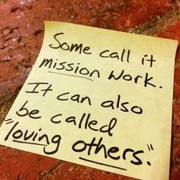
Thank you for your faithful sponsorship. Coupons to follow. In Christ,
Helen

Our God is a Missionary God

The Bible is a missionary document; the agent of God’s mission is the Holy Spirit; the partner with this Spirit is the called –out-community, the Church of Jesus Christ; and the work of this community of Christ-followers is to facilitate the coming of the kingdom of God in ways consistent with who Jesus is and what Jesus did.
-Jeremy Basset

Volunteer/Volunteers Needed
Living Hope High School will be going through a transformation in the next year. We are looking for someone to work with Marilyn Uhl to eventually learn the ropes and to run the school. She will continue to live there. The school is also looking for short term teams and individuals who would volunteer 2 weeks to 3 to 6 months. That person or a couple would help with teaching, daily tasks at the school, organizing and helping with counseling the students. The school is also looking for a pastor who might want to come for a time (to be worked out) with Marilyn who can teach bible and be a guiding light for the students. If you are interested in becoming a long term volunteer or joining next year’s team/ or going as a pastor contact Sandy Binotto for information/application. Yashe4jc@hotmail.com/304-839-1505
Helen Markwell is also looking for someone who will eventually take over her job as U.S. Coordinator if interested please contact her.

U.S. coordinator West Virginia Mission Team Coordinator
Helen Markwell – Living Hope High School /Newsletter
Sandy Binotto
helenum@spruceknob.net yashe4jc@hotmail.com
304-567-2254 304-839-1505

