March 2020 Newsletter
P. O. Box 2376

Coronavirus in Kenya
Dear Sponsors and Friends,
An update at Living Hope. Like all of us here in the U.S, things are up in the air, so far Kenya has a few cases of COVID-19, one of which is in Bungoma. It is a student from Italy whom has traveled there. He was taken to Nairobi Hospital to be quarantined.
All students in Kenya have been sent home. All schools are closed. We are uncertain as for how long, same as here in the US. Several students have already returned to Living Hope because there isn’t any food at their homes. Marilyn has sent them back home with some food from the schools supplies. Thank goodness she had the foresight a month and a half ago to start stocking up on the basics.

Catherine, the school nurse, is staying at Living Hope. She has stocked up on all medical supplies and is ready to treat all emergencies. We may need to put our healing hut into full operation with our 4 isolation rooms.

Only one person is allowed to go to town for mail and other supplies. They are taking all precautions they can.
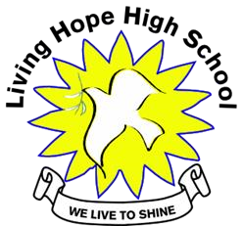

Bungoma,

Kenya
-
50200

Email:
marilynkuhl59@gmail.com

info@livinghopehighschool.org

Website
:
www.livinghopehighschool.org

Marilyn remains healthy and is confident the Lord will see Living Hope through this. I should be getting letters soon. I will quarantine the letters and spray with Lysol and then mail them out to you. Please keep Living Hope and the students in your prayers, as they are keeping us in their prayers.

Life Goes On
Life does go on while in the midst of our world’s pandemic both here in the states and in Kenya. The students work daily doing what needs to be done at LHHS. Bricks are stacked then baked and ready for the next building project.
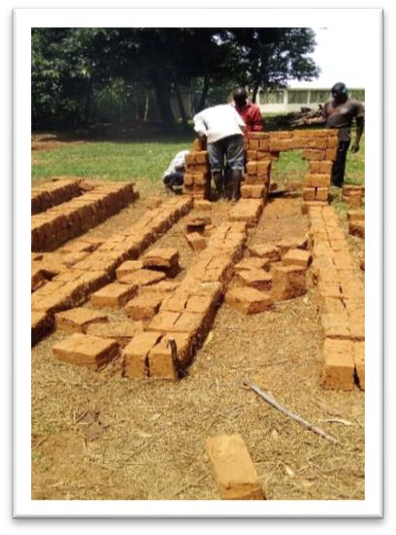
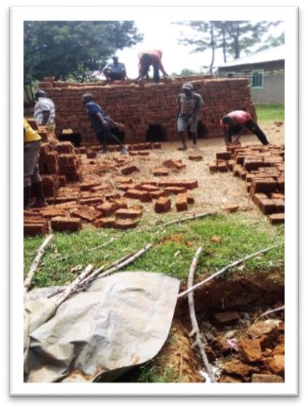
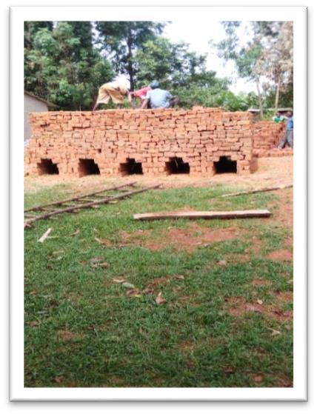
They are stacked and put in a pyramid form where a fire is then lit underneath them to burn and back. It is a process. For now they are being put aside and stacked to use at a later date.

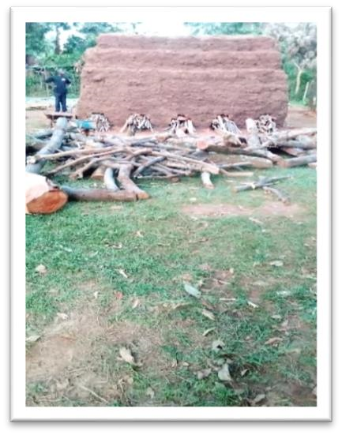
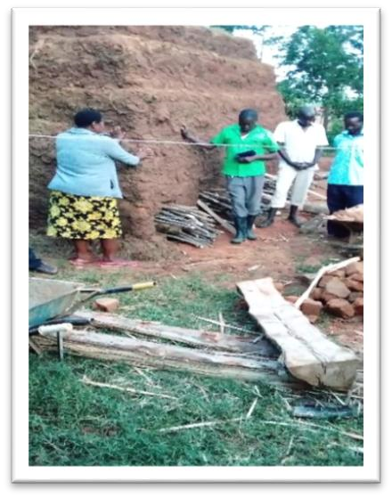
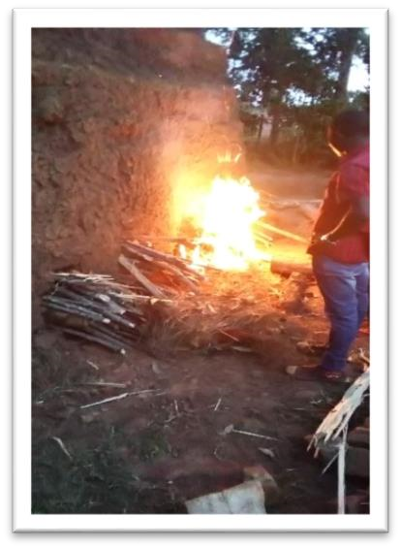
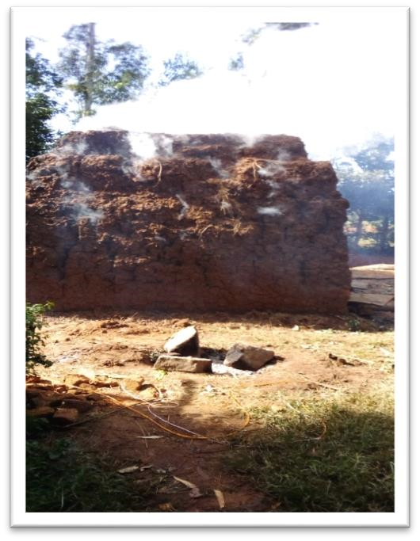
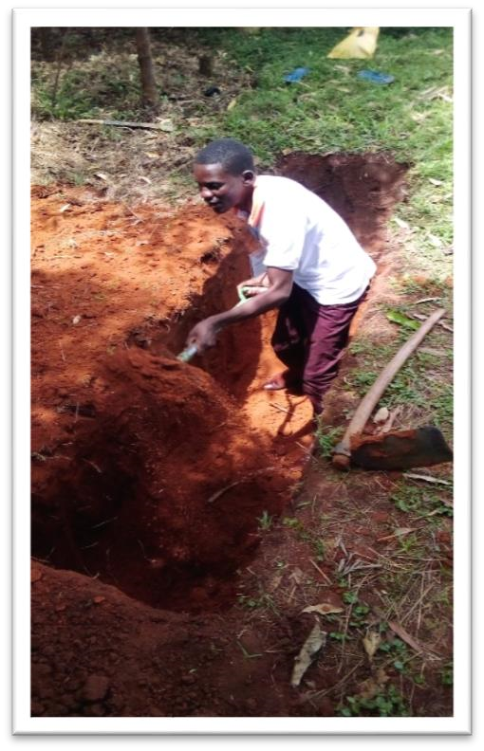
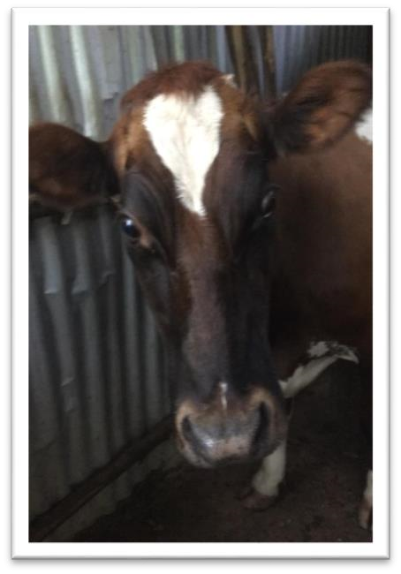
Getting a building ready for its construction takes lots of hard work
for those who live in Kenya and other parts of Africa. It is a
traditional process of building.

•

Mud has to be dug and made pliable to be put in a brick frame.

•

Then the
bricks are turned every day until they are dry.

•

After

they are dried they are then piled high in pyramid style.

•

The
y are then are covered with mud after piled high.

•

A fire is then made in the bottom where it burns for hours/days

•

The bricks then bake from t
he heat and then cooled.

•

After that they will be ready for constructing a building.

•

After

used for building they are covered with several mixture
s

of different materials. Concrete mixture and cow manure
mixture. It is
smeared on the walls by hand
. It is a
long
process.

A new girl’s latrine is being dug. It
goes pretty deep a
nd takes hard work
to get it deep enough
. A small fence
was put around it. Even with the fence
Butterscotch the school cow d
id not
heed the warning. She fel
l into the
hole and could not get out. A local
with a tractor came and the vet was
called. After a long fight she was
brought out of the hole. The struggle
to get out was just
too

much for her.
She took her last breath and died.
Everyone was devastated and

sad.
But Butterscotch lived on in the
stomachs of some hungry community
people. After hearing this a donation
came in to purchase another cow. In
life things happen, we just have to
make the best of it and go on.

February Team of Two

The second small team of two, Pam Francis and Connie Damon arrived in Kenya ready to return to Living Hope to help with the First Aid Class and Vaccinations.
Their talents they shared are so vital to the school and community as the students learn first aid and get checked for several diseases. While there they helped do things around the school, visited friends and attended Nick a former student and college graduate’s wedding.
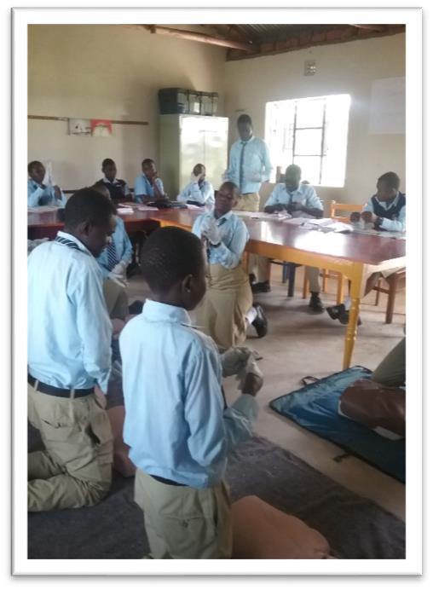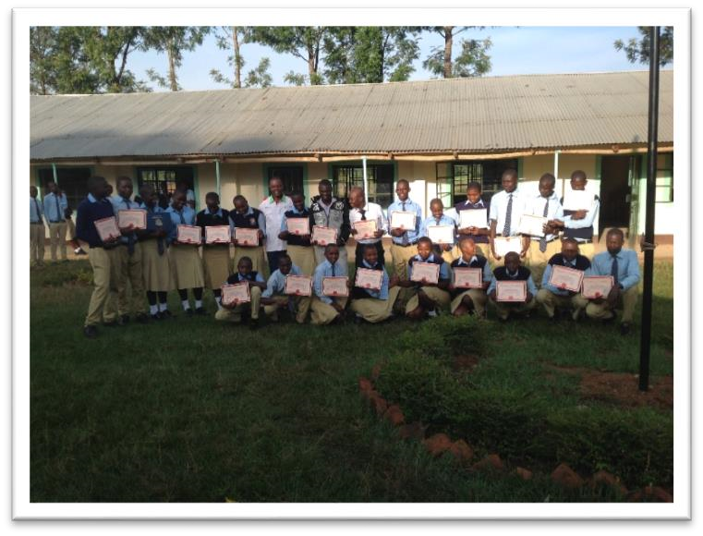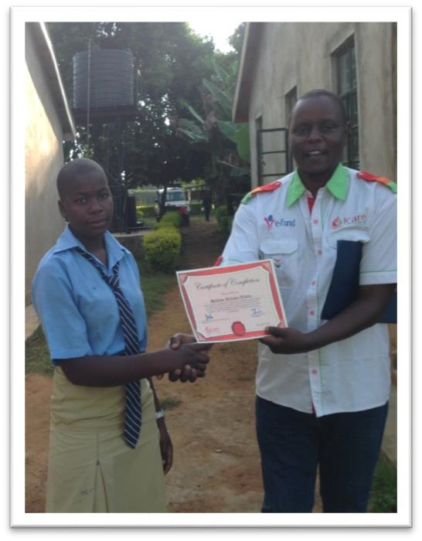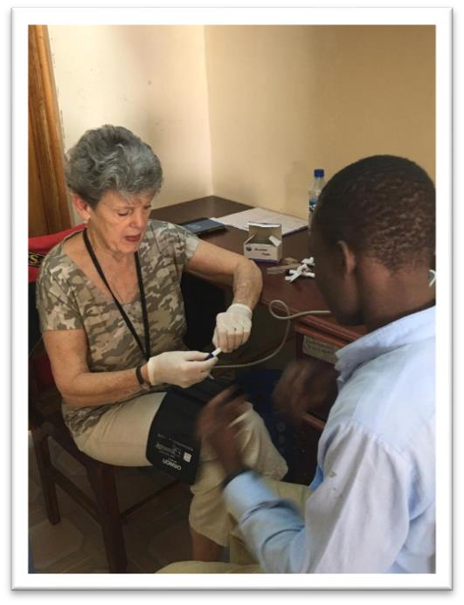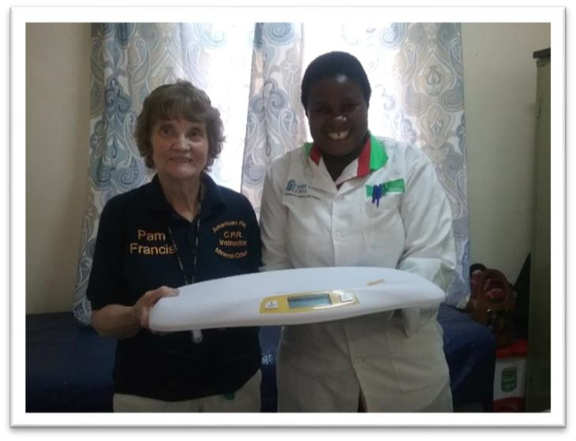

Connie

Students who completed the First Aid
Training

Gift of baby scales to
Nurse
Catherine from Pam

Our trip to Living Hope High School was -as usual a busy one. We immediately began CPR and First Aid training led by John Kariuki of I Care Associates. Form 2 students and 3 teachers all learned to be prepared for emergencies. Living Hope is one of the few High schools in Kenya who offers this course.

We attended a wedding of a graduate and met with former students who are studying all over Kenya. Living Hope is changing Africa! - Pam Francis

I am sitting on the plane (on my way home) after a 2-hour van ride, then a small plane ride to Nairobi and now a plane to Amsterdam. My goal is to share with you about my visit with the children at Living Hope High
School, but how can I? I’m tired beyond words. My mind is awhirl with memories. My heart is overflowing with love for the children and adults I left behind there. Tears flow as I thank God for the blessing of being His hands and your ambassadors there in Kenya. What a joy it was to be welcomed by all 88 students, lining the entrance to the school, clapping and singing as my co-worker and I arrived at the school for the 7th time. The Boy Scout Drill Team performed an impressive routine and escorted us onto the campus. Work began the following morning at 8 am as we began doing the medical testing of all students and administering needed meds. We assisted the Kenyan Red Cross in teaching a class in CPR and First Aid during an 8-hour class. I taught an English Class and answered the students’ questions about America (one boy asked me if I know former President Obama.) One of the highlights of our stay was attending the Kenyan wedding of one of our graduate students. One thing I did NOT do was to accept the invitation to get down in the clay pit and stomp clay to aid the students in brick-making. That’s a story in itself! Home visits, attending a local church on Sunday, praying and teaching as we interacted with those outside the school gave us the opportunity to share the love of Christ. Once back in Nairobi we invited all of the graduate students going to college there to join us for breakfast at the guest house for missionaries where we stay. What fine young people they have come to be… confident adults, grateful for the chance to get out of poverty through their having had the opportunity to be at Living Hope…having high goals of helping their fellow Kenyans when they have finished their education.
I am reminded of the words in James 2: 14-17: “What good is it, my brothers, if someone says he has faith but does not have works? If a brother or sister is poorly clothed and lacking in daily food, and one of you says to them, “Go in peace, be warmed and filled,” without giving them the things needed for the body, what good is that? So also faith by itself, if it does not have works, is dead.”
I felt God’s blessings on my efforts every step of the way. Now I continue on my 56- hour journey home, filled with memories to last a lifetime (and anxious for a hot shower!) - Connie Damon

Form 1 Students still need Sponsoring
Running a school in Kenya sometimes has it challenges and problems. With the Coronavirus it is more challenging. Most of the students have returned home but some along with graduates are staying there. I know many are struggling but if your heart is moved by the Holy Spirit to sponsor a student they would really appreciate it. You can view the students who need sponsoring on the Living Hope website: http://www.livinghopehighschool.org/ on the sponsorship page. There you will find a picture and story of the students. You then can contact Helen Markwell U.S. coordinator helenum@spruceknob.net 304-567-2254 to sponsor a youth.

“Be merciful to me, O God, be merciful to me! For my soul trusts in You; and in the shadow of Your wings I will make my refuge, until these calamities have passed by.” (Psalm 57:1)

LHHS is so thankful for those who continue to bless them with sponsorship of students/college graduates and donations which keep the school running. Without you there wouldn’t be a Living Hope. God Bless All of you!

The Wedding
It is with great joy that the school announces that Nick Simiyu a Living Hope High School Graduate and College
Graduate got married to a beautiful bride named Merci on February 9. Two of the February team members Connie and Pam were there to attend along with Mum Marilyn. They said it was a beautiful wedding. Nick has been very instrumental for LHHS. His construction skills have been such a blessing to Living Hope as he has been in charge of the build of the Science Lab, Healing Hut, Community Bridge and the Pavilion. Nick recently bought a hardware store and is doing well. We wish him and his lovely new bride all the best and God’s Blessings. Nick is loved by many and now we have Merci to love along with him!
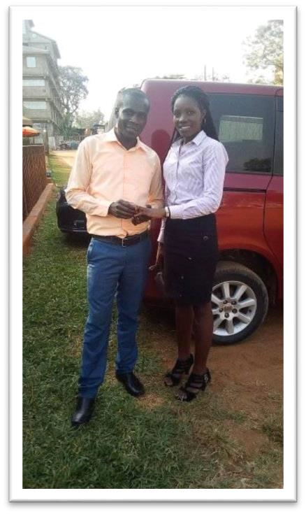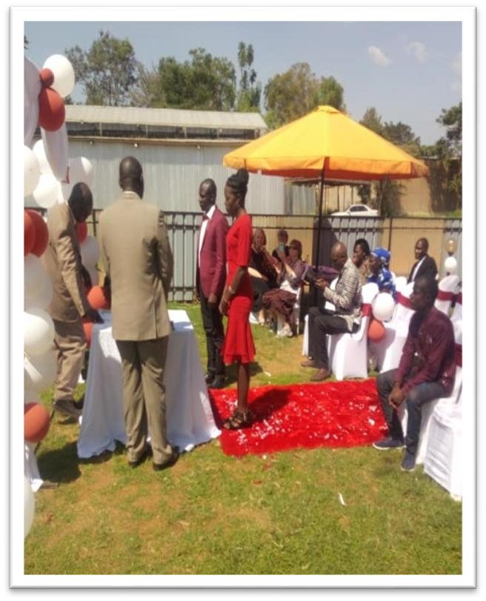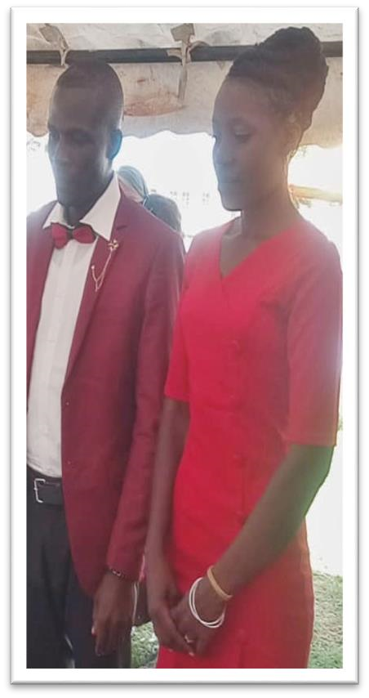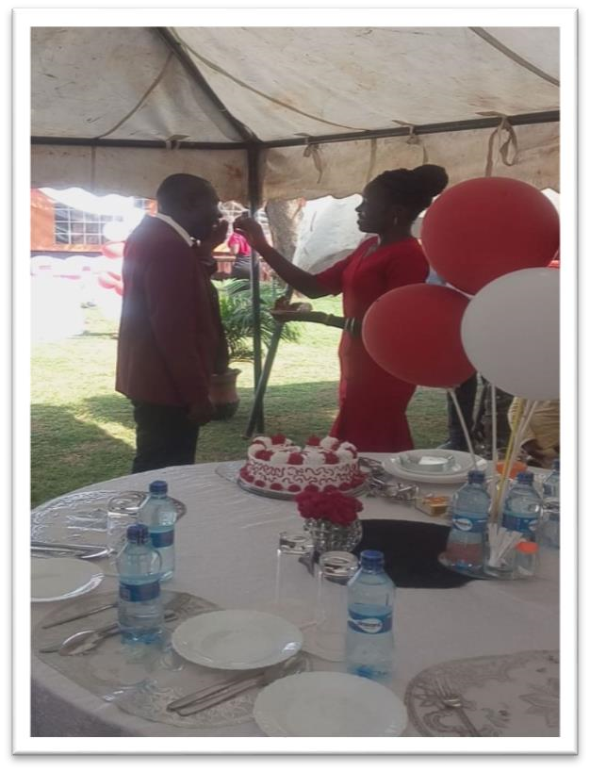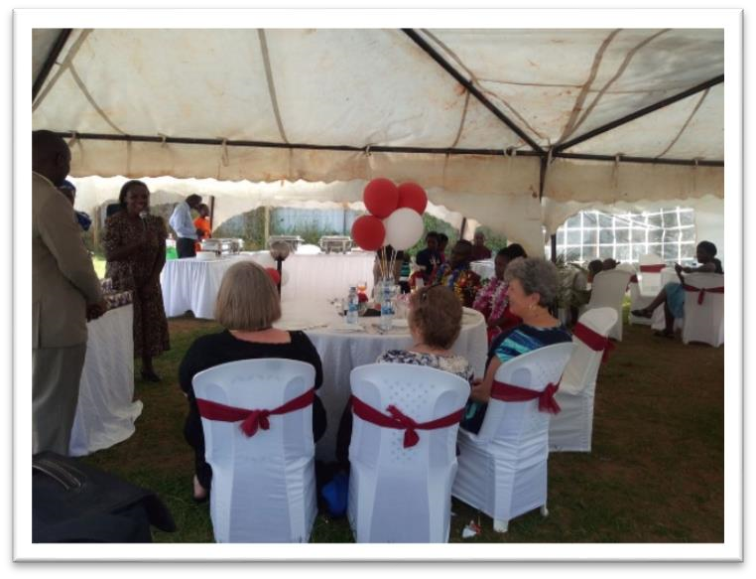

Marriage is a Gift from God to us, the quality of
our marriage is our Gift to Him……..

Blank Note Cards for Sale

Notecards from Bungoma. Chaz the art teacher at LHHS has made beautiful notecards which are for sale.
All proceeds will go to Living Hope. Each packet holds 10 cards with envelopes. They are $20.00 a pack.
If you would like some to sell some or purchase some please contact Sandy Binotto- yashe4jc@hotmail.com. If you live near Romney I would be glad to deliver them to you or meet your somewhere. If not I would be glad to mail them to you. I have some packs of Easter ones as well. Let us bring back note writing.

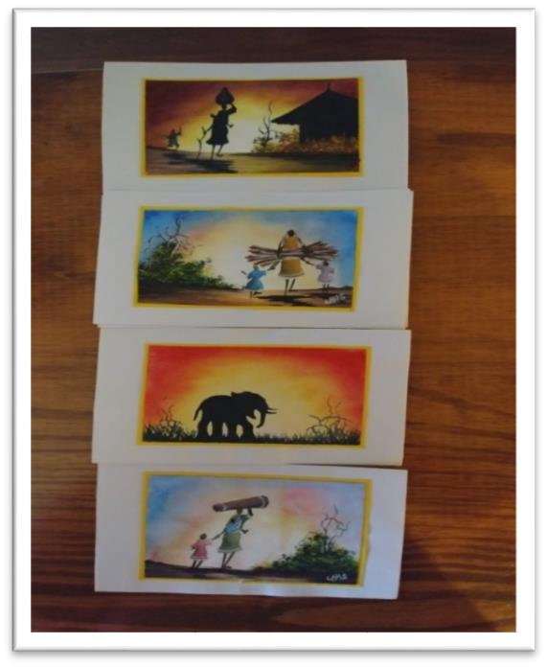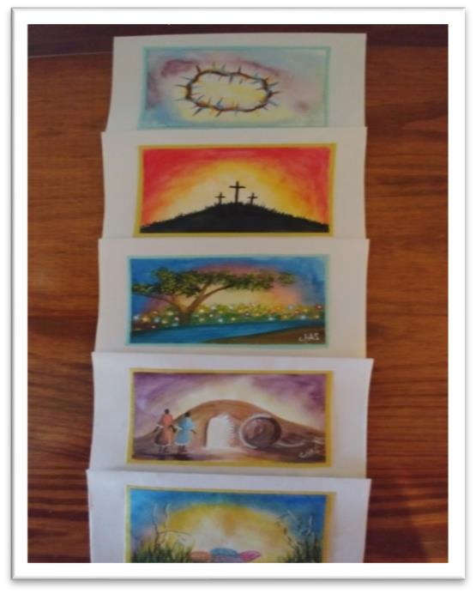
Future?

Right now everything is in question. We don’t know what the future holds, but we know who holds the future. Everyone’s life is in uncertainty. Mission, we are not just to be in mission when things are great but to be there when they are not so good and rotten. Right now they are a little rotten. Travel is halted, churches closed, people in great need. Let us at this time Pray like we have never before, call out to our Lord to hear our prayers. We can pray for Mum Marilyn and our brother and sisters at Living Hope and those around the world. Pray for those who have lost loved ones and who are grieving and need comfort. Help clothe and feed the needy, do whatever we can where we are. Pray for those who are working tirelessly in hospitals, clinics, those who are keeping our countries safe around the world, truck drivers, and so many others. We need to help and go where ever Jesus is and He is everywhere!

U.S. coordinator
Helen Markwell – helenum@spruceknob.net
304-567-2254

West Virginia Mission
Team Coordinator
Living Hope High School
Sandy Binotto yashe4jc@hotmail.com
304-839-1505

