P. O. Box 2376
Bungoma,
Kenya-50200
Email: marilynkuhl59@gmail.com
info@livinghopehighschool.org
website: www.livinghopehighschool.org

March 2021 Newsletter

And So the Exams Begin
The exciting news is that form 4s starts their exams March 26. The students and the teachers have worked very hard to catch up 10 months of lockdown. The students and teachers all feel that they are well prepared and are excited to get started. The test will last until April 19th with two or 3 exams a day. I am praying that they don’t get worn out. Stanley has to wake up at 4 o’clock to pick up the tests in Chwele which is an hour away. The police escort him and to and from to make sure that there is no cheating. The Government people giving the test are always impressed with our campus and with the good behavior of our students. Many years ago the students started the tradition of serious prayer after the test is over. At the other schools, the students tear their books, burn their uniforms and are very destructive. Thank God we are here at Living Hope where students have some sense. God bless us all. Special thanks to all of the thousands of people that have helped us throughout the years. Keep praying for us. We love you all, thank you. Mum Marilyn
Living Hope High School Students, past and present.
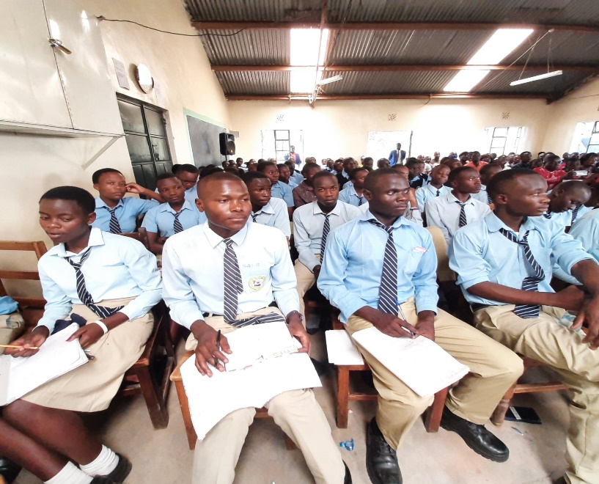

Please keep the students in your prayers and the college students as well. These are very stressful times for the students as they take everything they studied for and learned and put it on paper. May the Lord surround them with wisdom, clear minds and keep them well and safe.

New Schedule for Living Hope High School

The Kenya Government has changed the Semester Term dates for 2021. As follows:

Period Event
March 26-April 19 K.C.S.E. Exams
April 24 Graduation for Form 4’s
April 25 Form 2’s return
April 26-29 First Aid Form 2
May 2 F1, F2, F3 Return
May 3 School Starts for Third Term
June 8-11 Short Break
July 16 Closing Schools for F1, F2, F3
July 17-25 Holiday
July 26 Opening New Academic Year (all students move up one class)
July 27 Admission of New Form Ones
August 26-29 Short Break
October 1 Closing for 1st Term
October 2-9 Holiday
October 11 Opening of Term II
NO SHORT BREAK
December 23 Closing of Term II
January 3-2022 Opening Third Term
NO SHORT BREAK
March 4 Closing Third Term
March 11-April 1 K.C.S.E. Exams for Current Form 3’s
December 2022 K.C.S.E. Exams For Current F2

House Blessing celebration- Marilyn Uhl
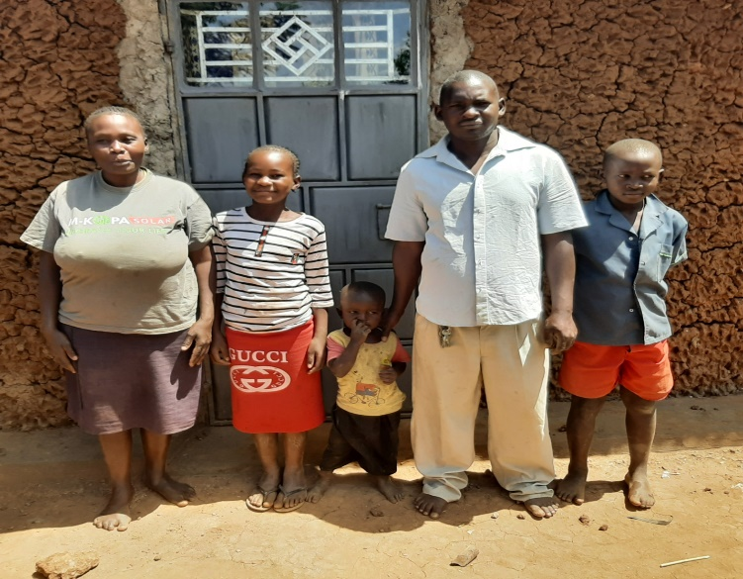
Lameck Juma, and his family finely moved into their house and they were so happy. Lameck was so proud and Pauline was beaming with happiness. Well, we went down to their house, Carol baked the banana cake, Living Hope donated the sodas and Pastor Gabriel prayed and preached for the house and for the family. It was very nice and we are all proud of Lameck for working so hard for such long and never giving up. God truly has blessed his family. A lot of the progress on his house was due to donations and well-wishers here and in the US. Lameck has been a faithful employee, a good man, a good father and a good husband. He is always joyful and ready to help do anything. He truly has been a blessing to Living Hope.

Fire Drill
Since January 1st, there have been 12 schools in Kenya that has been burned down, 8 of them have been in our county. The students and parents are totally frustrated. The Government made all students to come back to school after being on their own for 10 months during Lockdown. They had started businesses and they were making little money, they had started families, they had gotten married, the Government made all these parents pays all the school fees, not little by little. The students that had paid their school fees were just sitting there with no teachers and no lunch, no food. So they rioted to get out of taking exams which they were not prepared for. It was a total mess. So I decided that we better get our fire emergency act together. We declared March 2nd through the 5th as fire prevention week. We got our fire extinguishers serviced and a man from the fire department came and gave us a lesson on what to do in an emergency. He taught us how to use a fire extinguisher and how to protect ourselves in case of fire. We had a day time fire drill and put out a trash fire. Then we had a night time fire drill to see if the kids knew what to do. Now we are ready for a surprise fire drill.
Even our watch dog, named Police, got in the act. He didn’t know quite what was going on at 1 o’clock in the morning but he was excited.
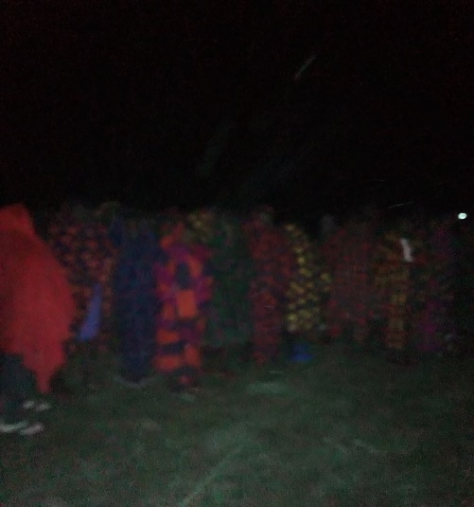
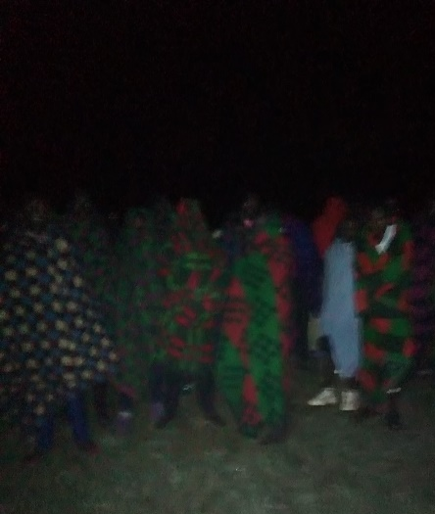
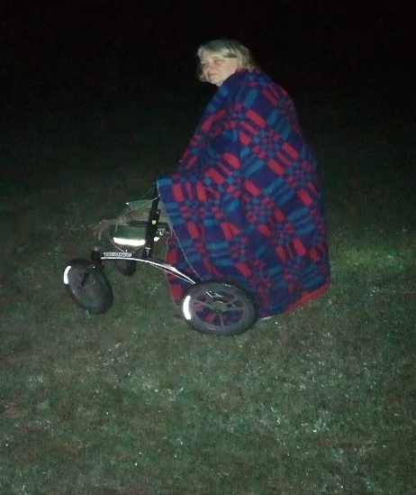

A Big Thank-You- From Living Hope
A Big thank-you to Jenny Williams, Karl Barth and the Avery Methodist Church, who donated towards Graduation, Bridge Repair and other needs. Without friends like you that truly care about Living Hope we would never make it. We still have 13 form ones from last January not sponsored, they have been on charity since they came. They will move up to form 2 in July and we will have 20 new form ones coming in. This Covid has really messed up the Educational schedule all over the country. Marilyn Uhl

If you would like to sponsor a student please contact Sandy Binotto, yashe4jc@hotmail.com 304-839-1505 she would be more than happy to talk with you. You may view students needing sponsors on the Living Hope High School website. Livinghopehighschool.org.

May the Lord continue to bless all of those who have given their commitment and heart to sponsor a Living Hope student. You are giving them a future and Hope! God Bless You!

Sharing Your Gifts and Talents- Sandy Binotto
The Bible tells us that we are all born with distinct talents and gifts that set us apart from each other. When you discover the talents that God has given you and you use them to glorify Him, you will experience a full life! Our loving Lord wants us to feel whole and complete, and it is through talents that we can find our unique calling in life!
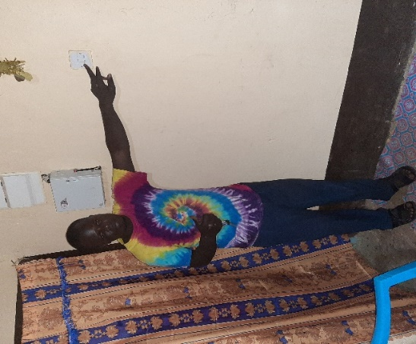
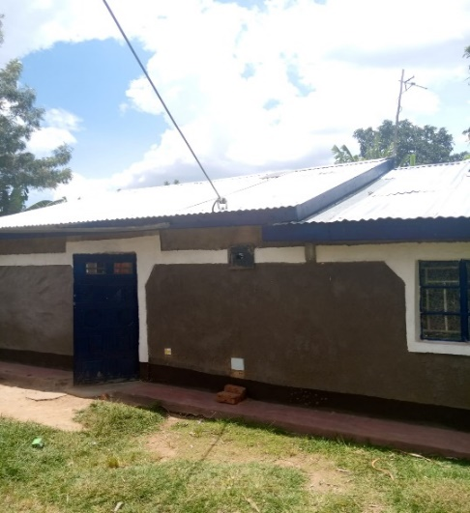
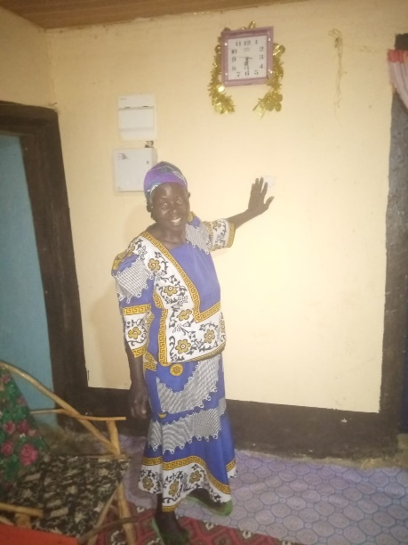
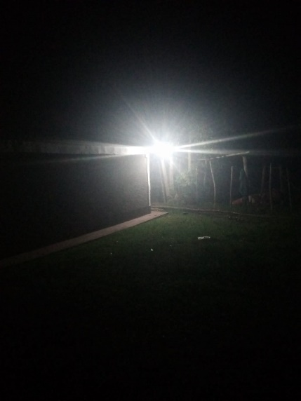
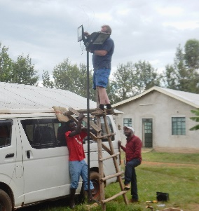
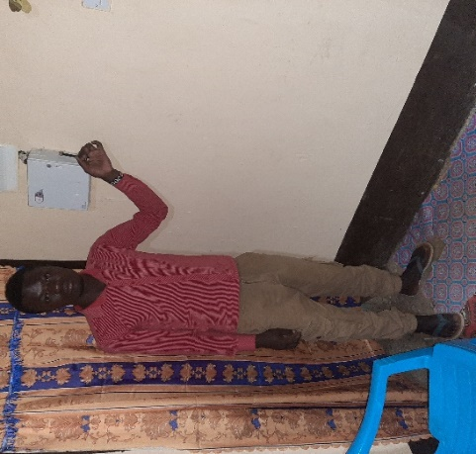
Are you willing? Are you willing to obey the Lord and go where He sends you? My husband Paul has been blessed to know how to work with electricity, installing lights, fans, and putting electricity in a school in Kenya as well as teaching students to play guitar. He has traveled there with me since 2014. He put lights in school classrooms and worked on many other electrical projects. When the light switch was flipped the students broke out in song and dance, I have never heard such joy. The oil lanterns that put off a yellowish glow and smell would not have to be used to read anymore. I heard a comment from one of the students, “We don’t live in the dark ages anymore!” When Paul works there he teaches the students who want to learn as they help him. One boy Joshua was really interested in the skill. His dream was to get electricity put in his home. Because of the Covid virus a team wouldn’t be going this year. After many emails and details, Paul and Joshua figured out how he could get electricity in his mother’s home. An item list was made, and a drawing of where everything would go and then the materials bought from Nick’s (a past graduate of Living Hope) store. The materials were donated by my husband. Joshua went to work with another helper and soon it was completed but they would have to wait until the Government would let them get the electricity brought from the pole to the house. It took a while but it finally happened. Joshua’s mom couldn’t wait to flip the switch! Now Joshua can teach others how to put electricity in their homes. Joshua is in the left top picture, his mom in the middle, and his brother Naphtal bottom left. The school is so thankful for all the volunteers who have brought their special gifts and talents to share at the School with the students over the past years!

The Bible says that if you give a man a fish, he will eat today, but teach a man to fish and he will eat forever.

Prayers and Updates

- Prayers for the students as they take their exams
- Form 4 graduates, who graduate on April 24.
- That the Government will not make any more changes in the education system that would affect Living Hope
- That the form one students who haven’t secured a sponsor will get one and that the new form ones coming in will also have someone who would like to sponsor them.
- Those who are college students who need sponsors will have someone step forth to help them.
- Marilyn, and the students and staff will remain well and healthy.

If you sponsor a graduate and would like to send a graduation monetary gift, please do so by the 15 of April. Please send your donation to Riverton UMC, P.O. Box 23, Riverton, WV. 26814

If you have any questions, or would like to talk to about sponsoring a student, please feel free to contact Sandy Binotto at yashe4jc@hotmail.com or call her at 304-839-1505

The school couldn’t operate without the prayers and wonderful sponsors and donators who help keep the school running. Each one of you are so special and the school keeps you in their prayers.
We also lift up those who work diligently, such as staff, treasurers and others who love the school and want it to continue for a long time. It is making such a wonderful difference in the lives of so many students, the community, and the volunteers who visit there. We are hoping that in the near future teams will once again be able to travel there.

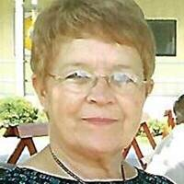
Sponsors are so special and we would like to lift up a special sponsor who passed away this past week. Linda Berg, she sponsored Mercy Injete for a long time and was committed to seeing her get through college. Please keep her husband Ernest and the family in your prayers.

Easter is nearing and this has been a challenging year for us all. Let us take a moment to thank God for our blessings and for standing beside of us during the difficult times. But also remember to rejoice and praise Him for sending His son to die for us, saving us from our sinful nature.

U.S. Coordinator/ Mission Team Leader and Newsletter
Sandy Binotto
P.O. Box 478
Augusta, WV, 26704
Yashe4jc@hotmail.com
304-839-1505

