P. O. Box 2376
Bungoma,
Kenya-50200
Email: marilynkuhl59@gmail.com
info@livinghopehighschool.org
website: www.livinghopehighschool.org

May/June Newsletter 2021

May A Tense Month

May was a tense month at Living Hope. Marilyn got ill and was taken to the hospital. She was treated for pneumonia by Nurse Catherine at Living Hope but got worse. While in the hospital she got good care and had many tests. Soon she was back at Living Hope and doing well. She sure gave us all a scare. We praise the Lord for her quick recovery and that she is doing well. Everyone took such good care of her and ran the school well while she was away.
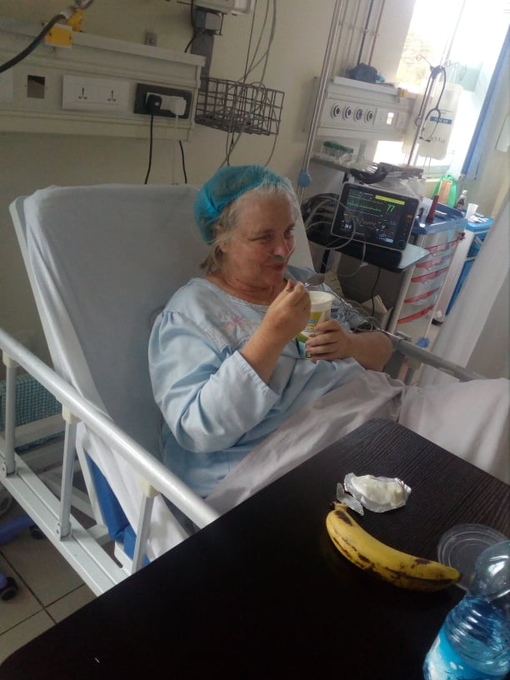

Being a Missionary, is not for the faint of heart. Every day is an adventure. So many people want your attention. You are far away from family and friends, and when you get sick it is hard to be so far from home. We praise the Lord for the good hospital where she got well and for all of those who cared for her compassionately. We know prayer works and we saw it firsthand. Please continue to pray for Mum, the school, the students and all that work there. God is doing miracles, many we don’t hear about! Please remember our missionaries. They sometimes get lonely and would love to get a note or small gift in the mail.
Her Address Above.

Graduates Gone, New Students to Arrive Soon

The Form four graduates have all left school. Many are registering and making plans for college or going onto new adventures. There were 100 new form one students that have been interview- 12 girls and 12 boys have been picked. They will start their term in July. As soon as their bios are written they will be put on the website as they will need sponsors. If you would like to sponsor a student it would be a great blessing for them and the school. If you are moved to take a student once on line, please contact Sandy Binotto, the U.S. Coordinator for information. It cost 110.00 a month for 4 years to sponsor a form one student.
Update, The Government has just issued that each school, public and private will need to have 30 students in each classroom. The school is scrambling to work on this change. It will be a great challenge for LHHS to make this happen but we are praying God will guide and direct us. Form one now has 30 students who have applied and been accepted.

Murunga, Marilyn’s Living Hope’s Manager, has been busy shopping for items needed for the school and the new students coming in.
His office has looked like a warehouse says Mum Marilyn. It takes a lot of hard work and organization to organize a new group of students who will now make Living Hope their new home

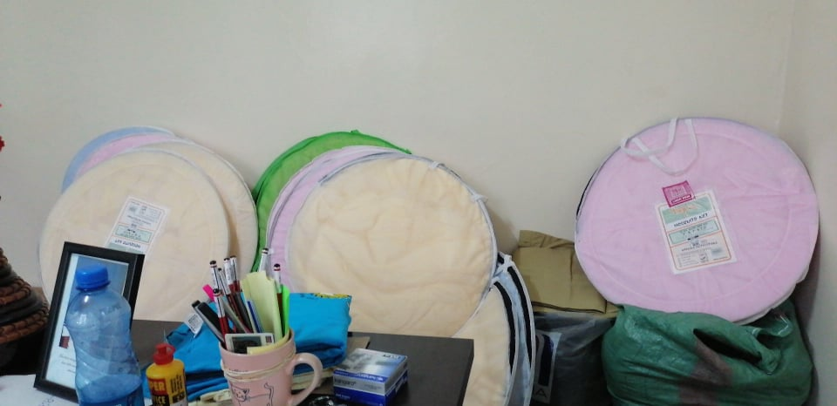
for four years. It takes team work between the students, teachers and staff. It also couldn’t run without the wonderful great sponsors who help make it all happen financially.
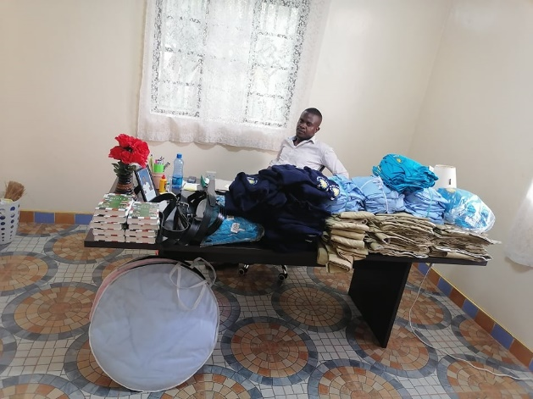
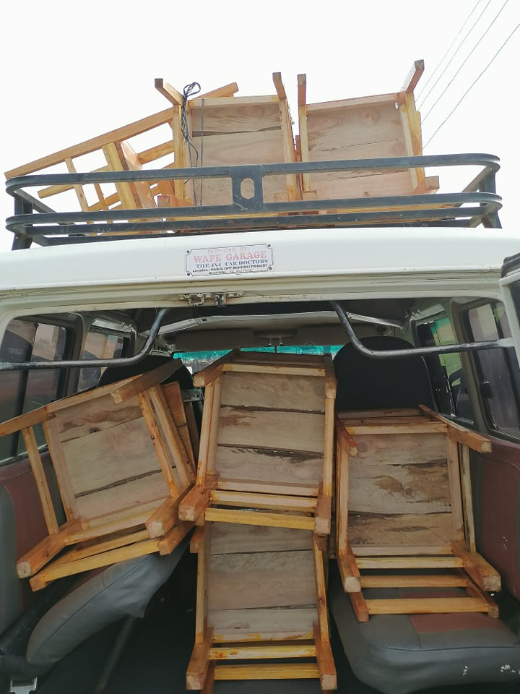

We would like to thank everyone who sent in donations to help with the purchase of items for the new school term. The school and students really appreciate it.

A Reminder!

Please remember when sending in funds to pay for sponsorship for your student or when sending in a donation for something, make sure you write what it is for on your check. Also make sure you make your check out to Riverton UMC and NOT to Living Hope High School. Please also make sure you put your students name on check or a note when sending in your funds. If it is designated for a certain thing, please note. It helps the treasurer and the U.S. coordinator to keep from having to track down the information. We would really appreciate it, also if you change your phone no. or email address, to please let us know and send in all sponsorship and donations to Riverton UMC, P.O. Box 23, Riverton, WV 26814

Riverton UMC

Two Students in need of Sponsoring

Sometimes students lose their sponsors for many reasons and we try to find them new ones as soon as possible. At the moment we have one girl Ressah Wafula who will need sponsoring for 3 years and Brian Nasong’o who will also need sponsoring for 3 years.
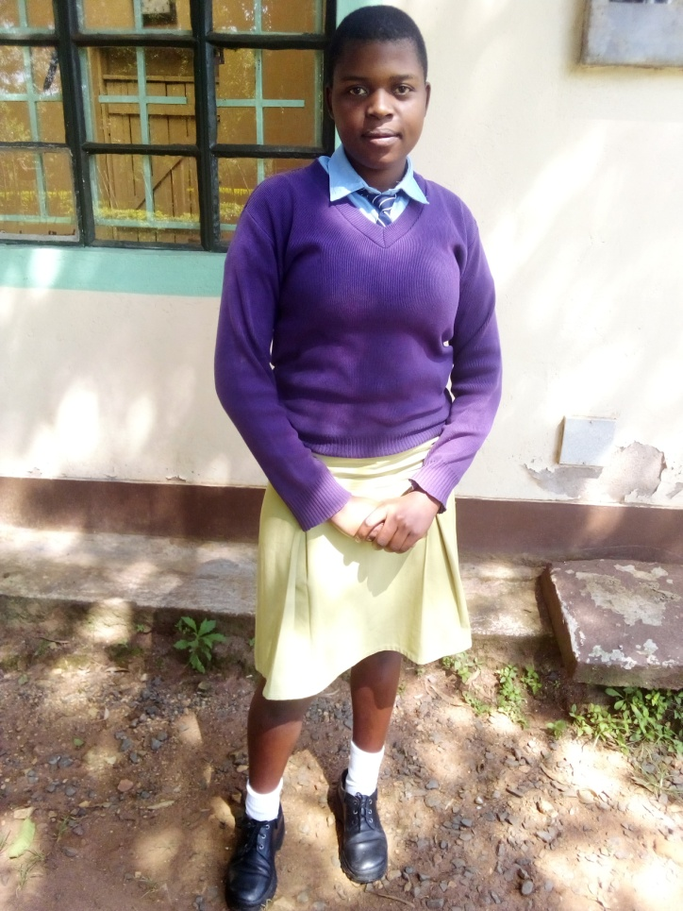
RESSAH WAFULA
Dear Future Sponsor,
My name is Ressah Wafula and I am 18 years old. My birthday is September 23, 2002. Currently, I am in form 2 at Living Hope High School. I will be promoted at the end of July to form 3. I have always been a serious student and when I took my National KCPE test at the end of Primary, I was number one in my school with 386 marks! Praise the Lord!
Last month, I was told that my current sponsor was no longer able to help me. We began the search for a new sponsor so that I can complete my high school education and be ready for college. I am still deciding what I want to do but God will help me to choose a career where I can help other kids who need help to succeed in life. Here in Kenya there are so many kids with sad stories that need help. If they don’t get support, no one will ever know they are smart and have great potential. I come from a very poor family. My parents are small scale farmers and struggle to put food on the table and buy the basic items for my one sister and two brothers. There is never enough and never any extra. Sometimes we go to bed hungry and sometime we cannot go to school because there is no money for school fees. My life got harder when my biological mother disappeared. I have never heard from her. I live with my dad and my step-mother and my brothers and sister. My brother is in form one at a public school near home. I thank God for sending me to Living Hope. Here most of my fees are paid for and I don’t have to worry about what I will eat or getting sent home for school fees. I can concentrate on my school work and living a good Christian life. God has given me this golden opportunity and I will appreciate it every day!
Life at Living Hope is really good. I have lots of good Christian friends to help keep me on the right path. The friends that I have will be my support for life. We love and help each other every day. We pray for each other and that helps a lot. God hears our prayers and answers us in many ways. We learn to trust Him and know that HE has a good plan for us.
I appreciate you and your time to read my letter. With your support, I will be able to realize my dreams of becoming a doctor and make the world a better place. If you need more information or have questions, please contact me through Mum Marilyn’s email marilynkuhl59@gmail.com If you would like to be my sponsor please contact Sandy Binotto at yashe4jc@hotmail.com 304 839 1505. My God bless you, Ressah Wafula
Brian Nasong’o
I would like to introduce myself so that we can start to get to know each other. I am Brian Nasong’o. My birthday is July 4th 1998. I finished my primary education in 2011. I passed my National KCPE test very well and scored an A- level. All was well but I was worried because I had no school fees for high school. I got a chance in Living Hope High School and I was here for two years. As I was continuing with my Form one and two, my family and my brothers and sisters were very jealous of my chance at Living Hope. Our family is, polygamous, with my father having three wives and 25 children! The whole family drove my mom out and she went back to her home in Uganda. She left with my little sister and left me with my father. This was not a good situation for me.
My brothers and sisters started harassing me whenever I came home from Living Hope. They would hide my books and my uniform. I tried my level best to overcome the abuse but finally I gave up. They would attack me and beat me up. My father didn’t know anything was going on. When my father found out, he decided to move me to another school far away and kept it a secret from the rest of my family. My father sold a piece of land to pay for my school fees to my brother with the agreement that he would pay in installments. After some time, he quit paying and I was stuck. By this time I was in Form three. The school was patient with me but there came a time where they sent me home. My father took a loan and registered me in the cheapest school he could find so that I could finish my form 4. During our KCSE test a teacher was caught giving answers to some students. He was arrested but all of the students were under marked. This means that everyone got a D. My heart was broken. I wanted to repeat but there was no money. At home the situation was unbearable. I decided to go to Uganda and be with my mom. When I got there, I found that my mom was sick with HIV/AIDS. From there I saw that my life was over and I lost hope. I knelt down and wept and asked God to take me. But HE had other plans!
God gave me the idea to go back to Living Hope and ask for help. At least maybe I could work and they would feed me. I had nothing to lose, so I hitched hiked back to Kenya. I found Mum Marilyn but she didn’t remember me. Two days before, the yardman quit and went back to school. Mom needed help since all of the kids were back in school. She took a chance and was surprised at what a good worker I was. I have been at Living Hope since February. I was very sick and the nurse helped me to get well. Out of my weekly pay, I bought some clothes and a small phone. I started saving my money. Mom Marilyn realized that I was smart and she got me into the form one class. I have been studying with them for two weeks now and I am making great progress. The school will let me take some of the tests starting next week and I can study for others while the form one takes their tests. Then I will be joining in July in Form two. God is good and he heard my prayer. Now all I need is prayer and a sponsor. I know that a good education is the only way out of poverty. God has given me a golden opportunity and I will make the most of it. I intend to graduate with excellent grades and be able to pick what I want to do with the rest of my life. I am full of hope and I Thank God that He loves me and never gave up on me. God bless you and I thank you for considering me. I will be praying for your answer.
Yours Sincerely, Brian Nasong’o.

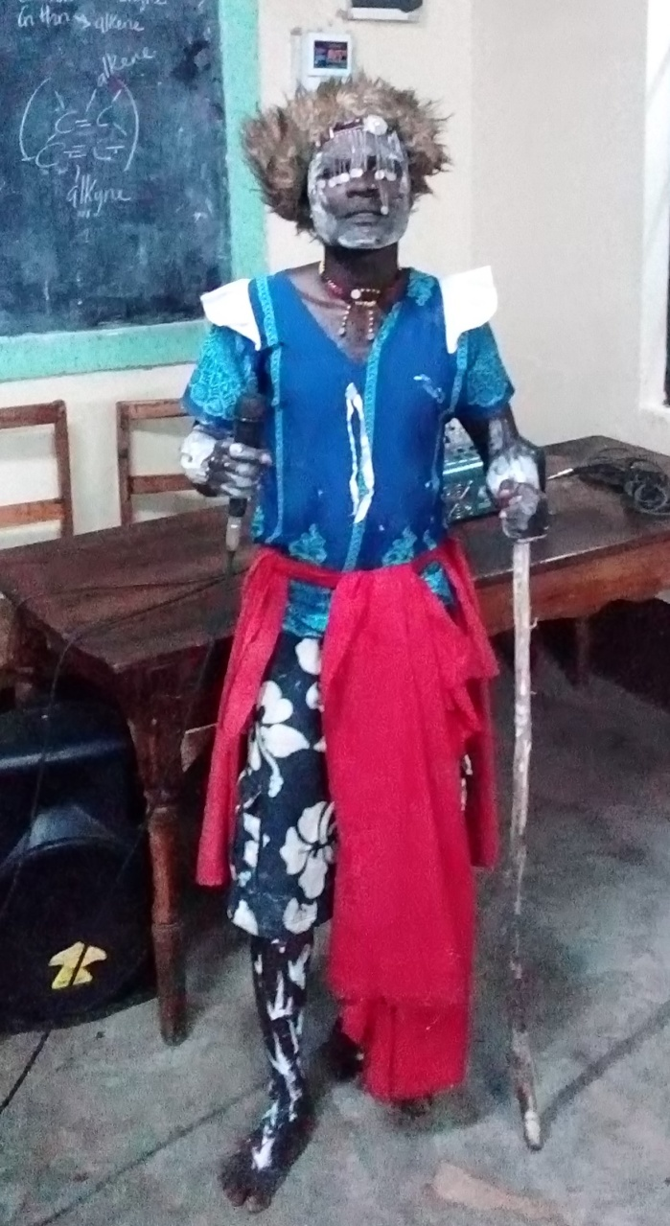
Recently Living Hope had a visit from Edwin Juma, a nationally known traditional storyteller and folk singer. It was great! They sang and danced and enjoyed his program. He taught them a traditional dance and we had a lot of fun.
Edwin and his traditional dance group have performed and won several national contests.
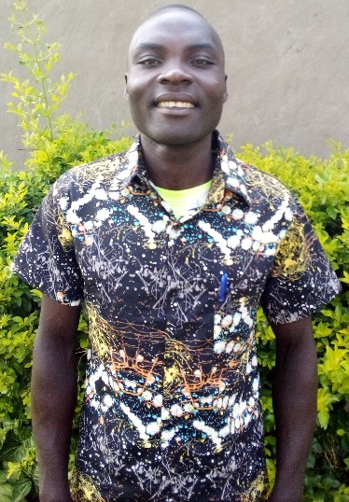
He is a P8 leaver and is a total orphan. He stayed for the service on Sunday morning and he gave a testimony that was heart wrenching. He begged for a chance to go to school at Living Hope. Since he is starving and destitute, Marilyn hired him to fill a general yardman’s position. That way he could make some money, get stable and join form one in July and will need a sponsor. He is so happy that he has not stopped smiling.
Praise the Lord!

Wish List for Living Hope

- Four new decker beds –Bunk beds $270
- Five jembe (Garden Hoe) - $25
- One pruning shears - $10
- Shelving in the staff room - $60
- Installation of WI-FI
- 2 large tarps - $30
- New heavy duty work bike - $100
- Wall clocks for dorms -$30
- Front security gate - $2000
- Small solar lights for the dorms (8)- $200
- Plastic curtains for pavilion (12 sections)- $2000 estimate
- Paint back fence and gate - $400
- New flag -$15
- Blood pressure machine - $50
- Glucometer (Blood sugar) and strips -$50

Online Fund Raiser

If you have an item, such as a quilt, painting, homemade item or a or new item that you would like to donate, please send a picture of it with information about it to Sandy Binotto- yashe4jc@hotmail.com Any questions, please contact Sandy.
We will list the items and people can bid on them, highest bidder gets the item. It will start the first of September and go for a week and half and then the highest bidder will get the item. It will be up to the item owner and bidder to get the item to the winner. We will take up to 35 items. The items will be listed on a Facebook page, more information forth coming.

Birthday Celebrations

Many of the students have never had a Birthday Celebration, celebrating their birth. It was decided that the school would once a month celebrate all those who had a birthday on that month. They would have a cake and some fun on that day. If anyone would like to donate $20.00 for this event to take place it would be greatly appreciated. Maybe the month you were born on you could celebrate with them. Can you imagine not ever having some sort of celebration on your birthday? If you would like to donate, please send the donation into Riverton UMC, P.O. Box 23, Riverton, WV 26814 and note what it is for.

Prayer List:
- The new form ones coming in July 26- that they get sponsors
- The staff, teachers and students of Living Hope stay well
- Mum Marilyn stays well
- Nick Simiyu, past graduate as he and his wife Merci get ready for the birth of their first child.
- A long time sponsor Ellen Kirby is in the hospital, we would covenant your prayers for her and if you would like to send her a card, please send it to Potomac Valley Hospital, 100 Pine Oak Ln., Keyser, WV. 26726
- Those who keep the school running, both here in the U.S. and those at the School in Kenya.
- Website will change hands and be updated soon.
- Prayers for those graduating from College and their future

U.S. Coordinator/ Mission Team Leader
and Newsletter
Sandy Binotto
198 Cape Cod Dr. –
Augusta, WV, 26704
Yashe4jc@hotmail.com
(Note my address change.
Won’t use my P.O. Box Number after next month)
304-839-1505

