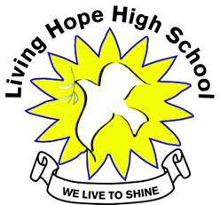
LIVING HOPE HIGH SCHOOL P. O. Box 2376
Bungoma, Kenya-50200
Email: marilynkuhl59@gmail.com info@livinghopehighschool.org
February/March Newsletter 2022

Field Trip
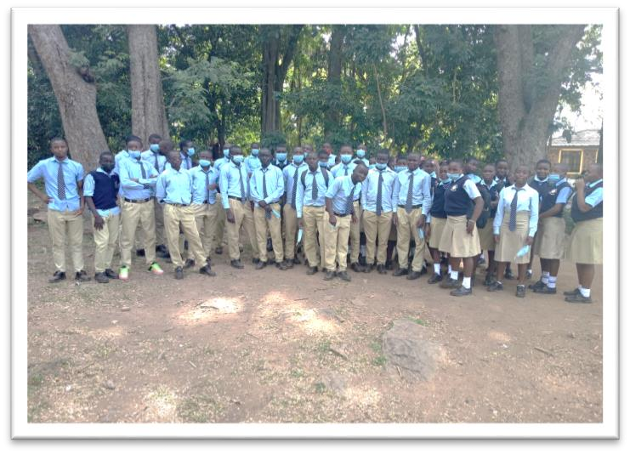
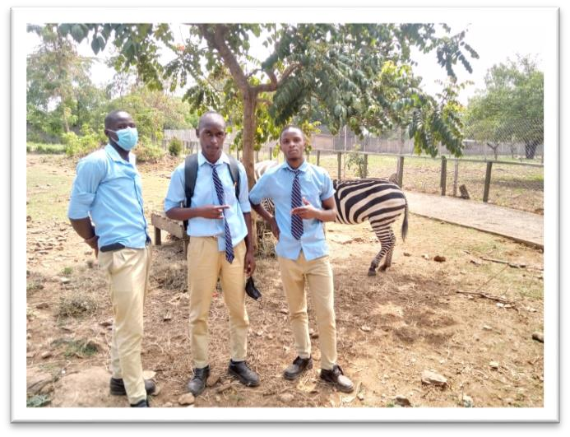
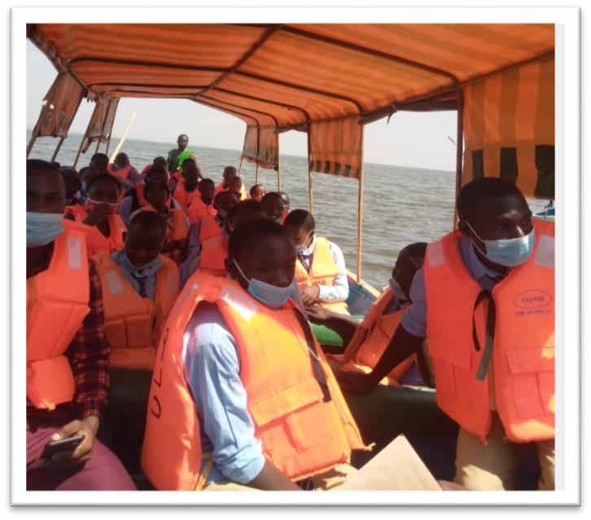
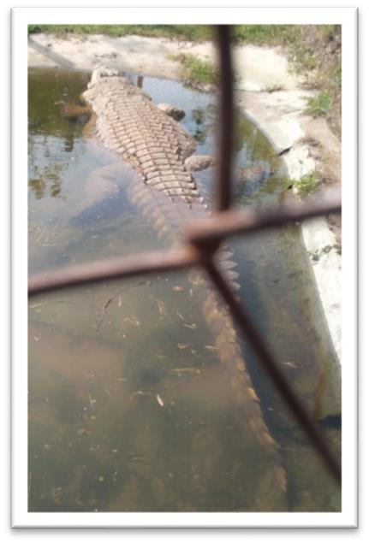
The students were very excited to go on a field trip to Kisumu, It is a big town with lots of things tosee.First the kidsvisited Impala Game Park. Theysawmanydifferentanimals andlots ofsnakes! The park is known for its birds, who live there in the wild. Next they visited the port. They saw many boats and ships loading and unloading cargo from Lake Victoria and all the countries surrounding the lake. From there they went to the Kisumu Museum. On the inside are displays of stuffed heads of all of the animals that have lived in Kenya. Some are still here and some have gone extinct. On the outside are cages of live animals. The most impressive is the 20 ft. crocodile! He gets a few rabbits to eat a week. He definitely could eat you in one gulp! Lastly the kids went to Dunga Beach. They put on their life jackets and boarded a boat and went out on the lake for about an hour. They came back at 9:30pm hungry but happy. It was a good trip!

Graduation

Form Four Living Hope High School students will be graduating on April the second. We are so proud of the students as they go onto another season in their lives. These students have come a long way. Many came from poverty and poor living conditions and only dreamt of getting an education. They studied hard and became part of a School that gave them Hope.
Some will go onto college and others will figure out what they want to do. Living Hope has given them a home for four years where they were taught the Love of Christ and what teamwork and family is all about. They also got a good education that will take them far. A great big THANK YOU goes out to all the sponsors and donors who made their dreams of an education come true. More to come about graduation in the April Newsletter.

New Students Arrive April 25

The school term started in July, 2021 and it ends on April 1, 2022. It has been a struggle for the school to get in 12 months of teaching in 9 months. The Covid lockdown messed up the schedule completely. The form fours will graduate on April 2 and the new students will report on April 25th. The new form ones will report on April 30 and start school on May 1.

Living Hope will accept 20 new form ones, 10 girls and 10 boys. They had to beg the education director to let them accept 20 instead of 30.The school will accept 7 more form fours so that they will have the required 30 in the graduatingclass. This makes 27 new students in all. The New term will begin April 25 and end in November when the form fours take their test. It will even be more stressful to teach 12 months of material in 7 months! Please Keep the School in your prayers.

This leaves 10 students who still need sponsoring from last year and the 37 new students who will need sponsoring for this year. The school knows this will be a big challenge for them and the U.S Coordinator who works to get them sponsored. There are also two students who had their sponsors drop out who also need help. Then there are several students who have applied for college but don’t have sponsors. We tell them all we can do is send up prayers and see what God does. Praying He sends all the sponsors the school needs for these students.

Will you consider sponsoring a student? Living Hope is a place where the youth can get a good start in life and the schooling they will need so they can get a good education and HOPE. If interested in sponsoring, please contact Sandy Binotto yashe4jc@hotmail.com for information and what sponsoring entails.

February Birthday’s

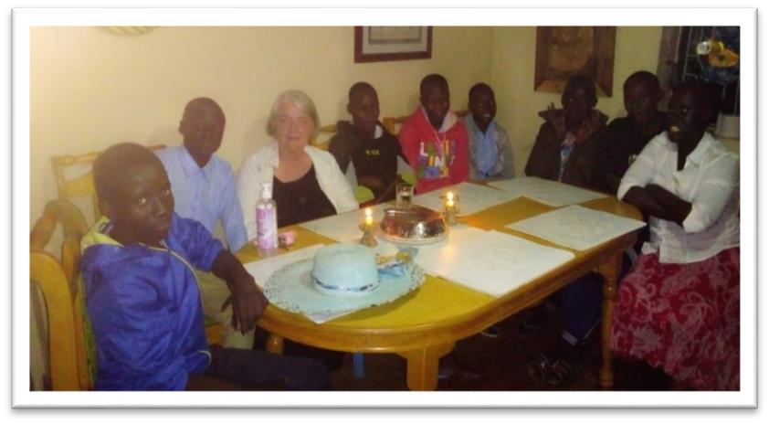
Happybirthdayto you. Happybirthdayto you. HappyBirthdaydear Februarybabies, happybirthdayto you! All of the February babies at Living hope celebrated with a birthday party on February 26, 2022. It was Carol’s Birthday too so we all had a party together! We sang, told stories, made secret wishes, blew out candles and ate some of Carol’s famous Banana cake. A
special thanks to the sponsors of the monthly birthday parties.
Alicana Wafula 01/02/2005 Evans Wasike 02/02/2004 SelphineWamalwa 02/02/2002 Joan Simiyu 02/02/2002
Linus Wanjala 09/02/2005 Augustine Konje 12/02/2006 Phanice Barasa 26/02/2002 Carol Wayoug’o 26/ 02/1986

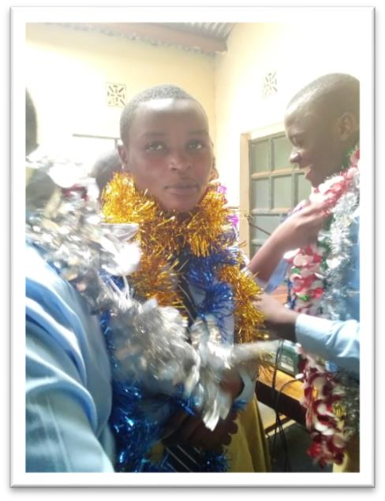
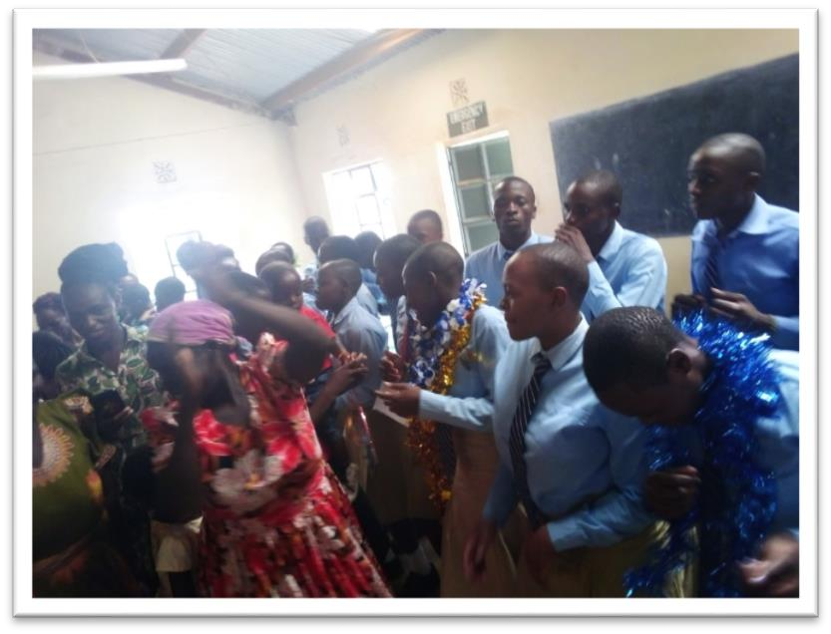
Thank You, Thank You!

A Big thank you, to all of you who have donated funds for the items listed below. We still welcome any donations for items in case more are needed.
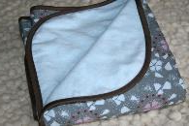
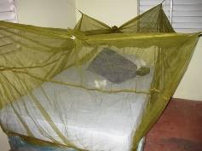
Bibles Welcome kits Blankets Pillows Mosquito nets.
Living Hope blue t-shirts. They are $8 each.
The students are asked to bring these items with them but many come and are a little short on what they are asked to bring. Wash basins, sweater vest, ties, shoes, backpacks, towels, plastic sandals and socks. The school does ask their parents to help provide the items, but because of situations, many parents can only supply some of the items. A big thank-you goes out to Donna Coblentz and her family and church that puts together the Welcome Kits and donates funds to send them to Living Hope.

PRAYER DAY

In Kenya, it is the custom to have prayer day to pray for the students’ and success on their exams. Living Hope had theirs March 5. It was a dayof prayer, dancing, singing, and thankingGod for all of the wonderful blessings that he has given them. The day started with the candidates marching in with a dance. They then had a great guest speaker who inspired all of them! Thestudents got ablessingfrom John Karioki, who has been their friend and taught them first aid for the last five years. John, donated the bamboo starts and is helping to teach them about the bees. All the students, parents, and teachers were blessed for doing such an outstanding job. Then it was time to give the candidate their “flower lays”. Theylooked like theywere readyto be Christmas trees! They certainly did sparkle! After more dancing, they went back to the new land to bless the bees, the bamboo, and the garden. The guest speaker made us take off our shoes because we were standing on “HOLY GROUND”! It was a wonderful day and we all felt closer to God!

Dancing and Singing

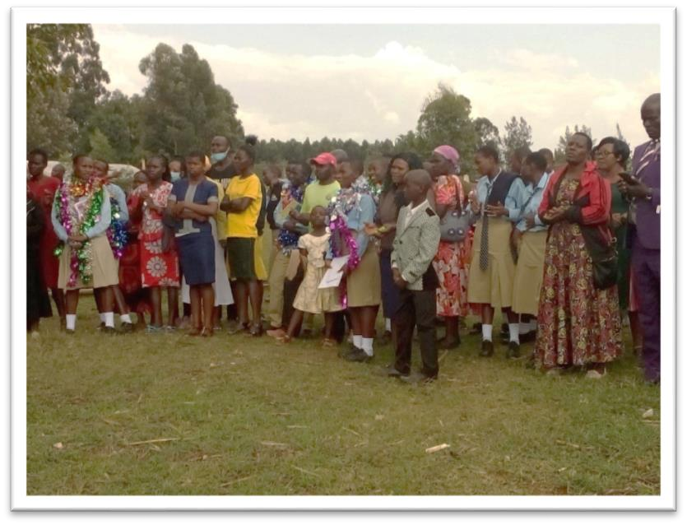

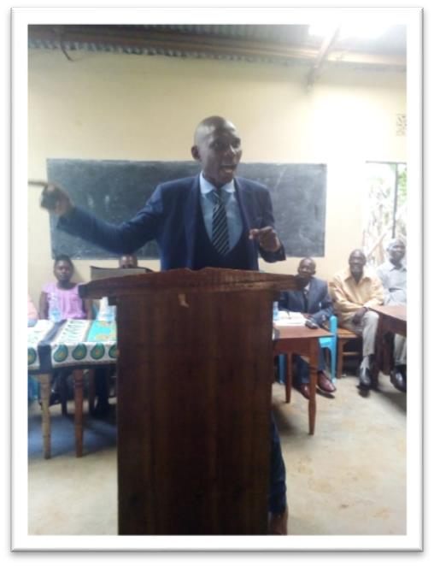
Guest Speaker Praying over the Bamboo field

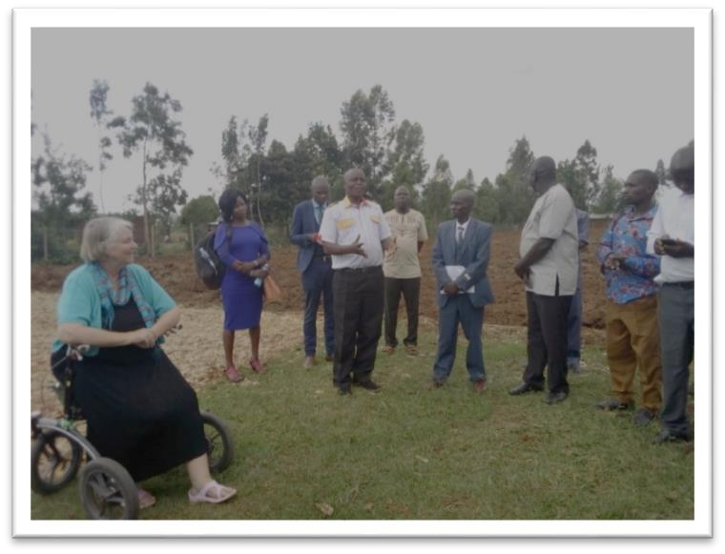
The ground for the bamboo field was plowed twice but still had lumps in it so the field workers came in and did the job to get the land smooth and ready for planting the Bamboo shoots.
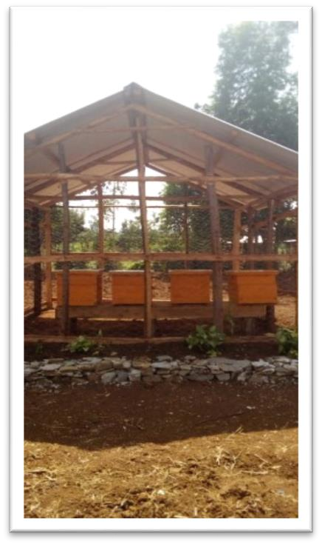
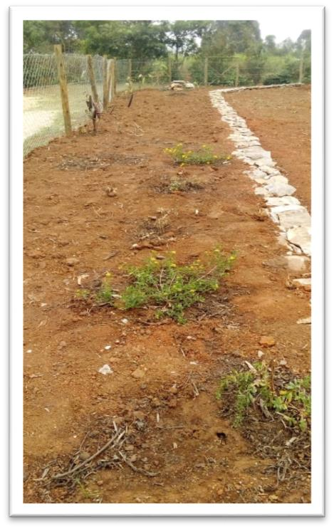
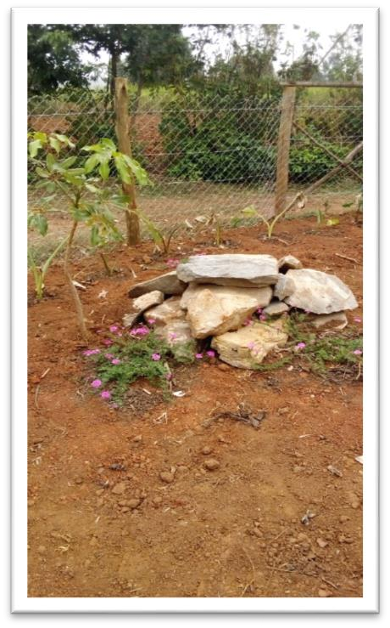
A bore hole was also dug to have water ready and available to water the trees. It was dug down 33 feet and it was at 32 feet that the soil started to get moist.

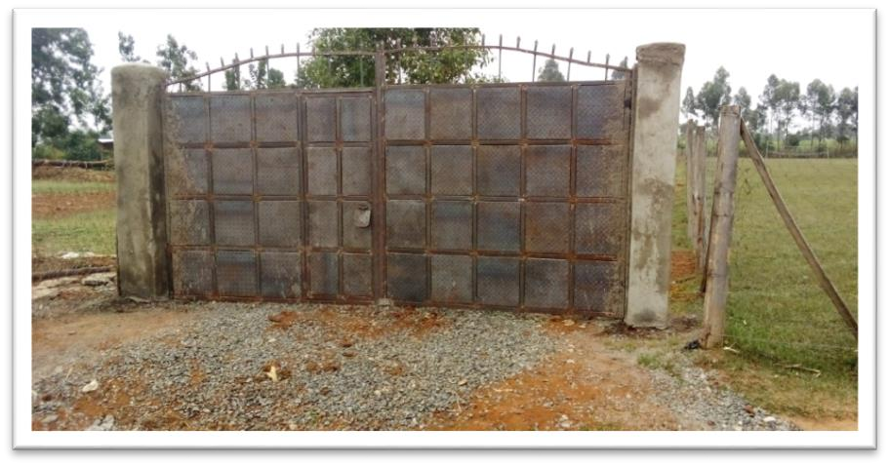

Bamboo Field and Bee Hives and Flower Garden- Marilyn

Beehouseand gardenupdate. Theschool hadto put the garden onhold becausethereis norain! Wearewatering the ones we planted twice a day but it is not doing the job. We will try to be patient. On the rocks with the pink verbena, I have saved a space for a Bamboo fountain. It will be beautiful and a peaceful place to just sit.

The gate is fixed and the side towers will be done next week. Then we can paint it and Chas, our artist is going to paint flowers on the inside panels. That way it will not look like the inside of a prison but part of a beautiful flower garden!

The bee house is done and the hives are in place. I had to put wire on the sides to keep the wild soccer balls from hitting the hives. The front rock bed is doing well. I put boucavilla to climb the fence in the middle of the greens. One died but the other two might make it. Let’s hope for the best and these bees better appreciate all the work that went into their new home!

God’s Blessings after Some Emergencies

Just as in any place in the world there are always challenges that come your way. Living Hope was thanking God when a truck ran into one of the dorms. A crew went to work to fix the damage and just as the last nail was put in it started to rain. Then there was a tornado that blew in and hit the side of the dining hall and twirled down to the new gate and did a good bit of damage to it. Through it all they praised the Lord it wasn’t worse.

Website

We want to thank Dave Rhinehart who has been our IT person for the website for quite a few years. He has decided to step down as he is busy with many projects! Kindness comes in many forms and that was a gift he gave to Living Hope! We are now looking for someone who can take his place. That person will need to have some website experience and who can work with Sandy the U.S. Coordinator to post the information that she receives from Living Hope. If you might be interested please contact Sandy Binotto for more information. We need someone ASAP!

Sammy Wakoli- Sandy Binotto

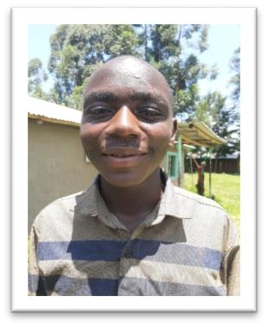
Have you seen the movie “Coming to America” with Eddie Murphy? Well soon a Living Hope High Student who will be graduating in April, Sammy Wakoli will be coming to America. Imet Sammyin 2014 duringmyfirst mission trip to Living Hope. Hewas small and carried a big sweet smile on his face. Sammy was always ready to give you a helping hand to carry your bags or help you with anything you needed. One thing he did love was our gift of a pack of crackers we would share with him for helping us, along with a few shillings. His dark blue sweater had quite a few holes in it and needed mending, so I was asked to see if I could sew it up so he could wear it to school. After doing my best to fix it, I decided to buy him a new outfit for school. That included a new sweater. He wasn’t a student at Living Hope yet but stayed at the school and attended a nearby primary
school. Several of us went to visit his school, it had 400 students and was dilapidated. At that time Rev. Larry Anderson was helping to support him.

Soon he was attending another school and did well. After sometime Sammy was old enough to attend Living Hope. He had several sponsors who had meet him when they visited Living Hope from America. Sammy studied hard and loved agriculture where he was always busy helping around the school, keeping the grounds clean and planting trees up the driveway. He had a dream of going to college. I am sure he thought will this ever happen? God does work in mysterious ways! How could this young man who came from a challenging home life, whose family lived in two rooms ever get to college, and a college in America? In 2017 Sammy met Pastor Jenny Williams who came on a mission team. He needed a new sponsor, and after visiting his home and feeling Sammy’s kindness her and another team member’s family, the Reis’s sponsored him.

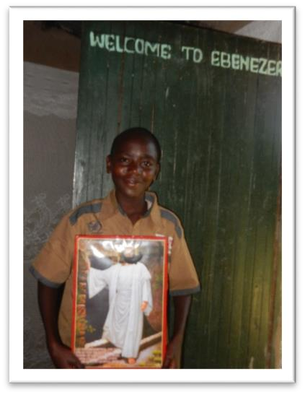
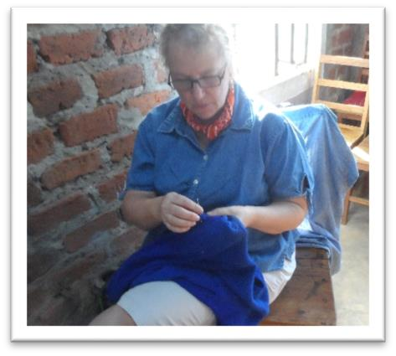
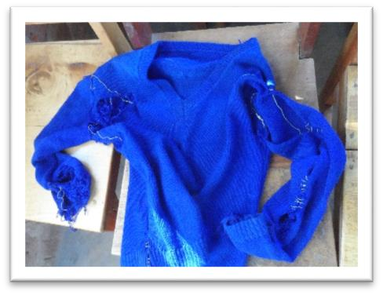
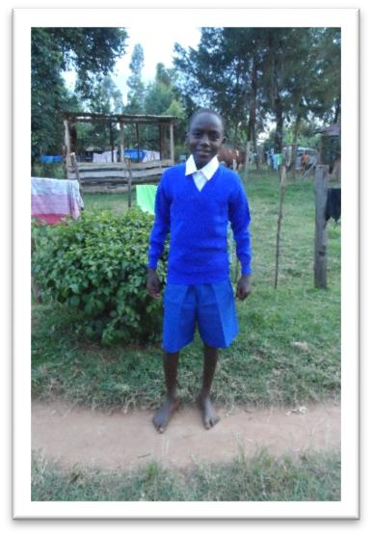
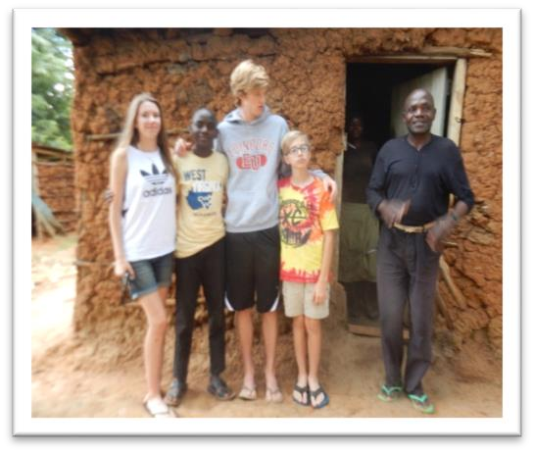
Sammy will soon be graduating from Living Hope and right after that he will be coming to America to attend Berea College in Kentucky. All due to the right people and connections working together to make a young Kenyan man have his dream come true. This will be a great experience for him and but a big culture shock, but I know he will adjust well. There is no doubt that he will work hard at the college to get the education he only dreamed of. Sammy will need some funds to help him get to his destination and all the little things he will need while there for the next four years. If your heart would be moved to donate to help him we would greatly appreciate it as would he. You can send your donations to Riverton, UMC. P.O. 23, Riverton, W.Va. 26814 Please earmark your checks for Sammy Wokoli.

Covid Vaccinations

The Kenya government gave the directive the all high schools needed to vaccinate all students over 15 years old for covid 19. The government nurses came and vaccinated all the kids who were over 15 and were not on malaria medication. They came back on March 1 to give the second shot. This will be during their exams but we will pray that they will not be affected. All of the teachers got it too.

Living Hope has been very lucky that this area has not been affected. No one never heard of anyone getting Covid accept our Alumasa who lives and works in Bungoma. The school continues to pray that God will continue to protect them and keep them safe and well.

New Projects
• Computer Lab- All computers have gotten checkups and new antivirus installed. School finally got WiFi and it is working great but the treasure’s computer is not wireless and she will have to use the modem and buy bundles for internet. Hopefully she can get a new computer soon.
• School is still getting estimates for putting in solar on the classroom roof, so when the electric goes out the students can still study. It will be a big blessing.

Prayer List
• Students all do well on their exams
• All students who need sponsoring gets a sponsor • Funds come in for all the needs
• Marilyn, students and staff all stay healthy • Graduation goes well
• Rains come for the crops and water wells, needed badly- Update! It did rain and the people and plants are very happy!
• Upcoming August election goes smooth with no problems

Reminder
• When you send in your sponsorship payment or a donation, make your checks out to Riverton UMC and earmark what it is for, and send them to Riverton UMC P.O. Box 23 Riverton, WV 26814
• If you sponsor a student please take some time to write them a note or letter, they would greatly appreciate it.
You can send them directly to the school at the address listed on the top of the first page or you can send them directly to Living Hope via email to Marilynkuhl59@gmail.com and in subject matter the name of the student you want it to go to.
The students really like to hear from their sponsors.
• Also so, if for some reason you cannot sponsor a student anymore, please let the treasurer or coordinator know. We will need to get the student sponsored so it doesn’t but a hardship on the school.

Treasurer: LaVonne Hammett 304-567-3139
lvhammett@yahoo.com

U.S. Coordinator Sandy Binotto
198 Cape Cod Dr. Augusta, WV 26704
Yashe4jc@hotmail.com 304-839-1505

STRENGTH IS WHAT KEEPS YOU HOLDING ON…….FAITH IS WHAT ASSURES YOU THAT EVERYTHING MATTERS,BUT IT IS HOPE
THAT KEEPS US MOVING ON WHEN EVERYTHING IS GOING WRONG.

